Module 1  Facilitator Guide | Focus on Instructional Shifts

Activity 7

Connecticut Core Standards for English Language Arts and Literacy

Grades K–5

Systems of Professional Learning

Session at-a-Glance

Activity 7: Reflect, Pair, Share
(20 minutes) To consolidate today’s learning, coaches will consider all the elements of today’s presentation and activities (shifts, vertical progressions, exemplars, practice lesson planning, EQuIP Rubric, and conversation on rigor) to answer the following question: What are the essential components that must be considered when planning a lesson aligned with the Connecticut Core Standards for English Language Arts and Literacy (CCS-ELA & Literacy)?

Supporting Documents:
- Directions
- Templates for capturing “take-aways” from the day

PowerPoint Slides:
- 69–70
Activity 7
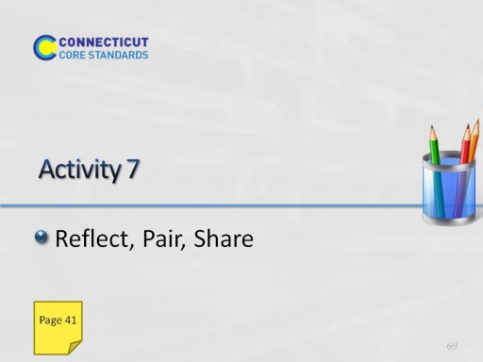
Slide 69
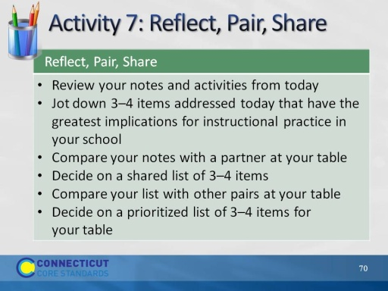
Slide 70
Allow 20 minutes for this activity.
5 minutes for individual work, 5 minutes with partner, 5 minutes with table, 5 minutes for share out. Adjust time as needed.

