Module 1  Facilitator Guide | Focus on Instructional Shifts

Activity 1

Connecticut Core Standards for English Language Arts and Literacy

Grades K–5

Systems of Professional Learning

Session at-a-Glance

Activity 1: Examining the Vertical Progressions of the CCS-ELA & Literacy
(50 minutes) Participants will listen to an overview of the CCS-ELA & Literacy expectations for grade level proficiency leading to college and career readiness. Topics in the presentation will include: aligning curriculum, instruction, and assessment to the standards; using ELA & Literacy appendices and updated supplemental information from Appendix A in making decisions regarding curriculum and instruction; and the implications of a common set of standards across the U.S.
In mixed grade table groups, pairs of coaches will select a strand to explore: Reading, Writing, Language, Speaking and Listening, or Reading Foundational Skills. Pairs will trace a standard from grade-to-grade, examine grade level expectations, think about how the grade level expectations lead to the Anchor Standard, and discuss implications for curriculum and instruction. Pairs will share what they learned at their tables, and volunteers will share with the whole group.

Supporting Documents:
- Directions
- Vertical Progressions Template
- Discussion Prompts
- Connecticut Core Standards K–5 ELA & Literacy Standards Progression document (separate handout for each participant)

PowerPoint Slides:
- 6–17

Session Implementation
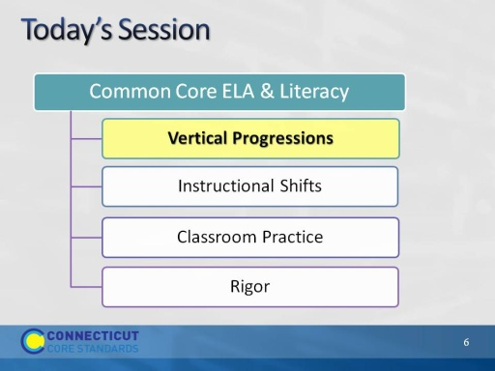
Slide 6
(Activity 1, Slides 6-17, will take about 50 minutes.)
- The purpose of the morning is to look closely at the CCS-ELA and Literacy to understand the specific skills and knowledge that students are expected to acquire in order to achieve proficiency on assessments aligned to the standards.
- Central to achieving proficiency is the nature of aligned curriculum and instructional practices.
- It is important that as coaches you understand the standards and their implications for curriculum and instruction.
- First – we will look carefully at the vertical structure of the CCS-ELA & Literacy to understand the connection between the College and Career Readiness Anchor Standards and the grade level standards.
- We will then look at the three instructional shifts associated with the CCS-ELA and related instructional practices.
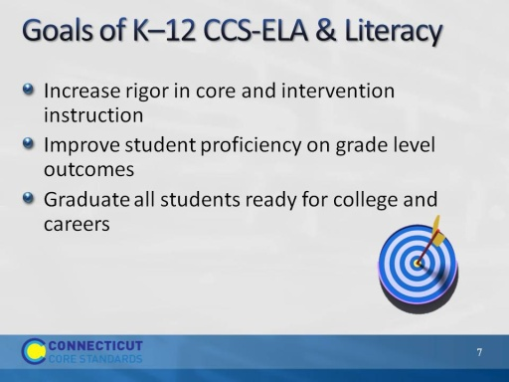
Slide 7
The overriding goals of the CCS are to:
- Increase the rigor in the academic program. While we are focusing on core instruction, the standards also have applicability for intervention as all students work toward proficiency on the CCS-ELA & Literacy. If many more students need support given the increased rigor of the standards, and intervention resources are limited, core instruction itself will need to change to support more students to meet the standards. Intervention programs will also need to be aligned.
- The goal of increasing the rigor and alignment of core instruction and intervention supports is to help all students gain proficiency on grade level and course content standards, so they will graduate from high school with the skills they need for college and careers.
(Note: Rigor = special effort toward a goal)

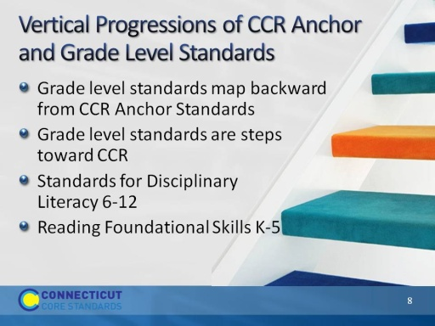
Slide 8
Let’s start by taking a closer look at the vertical progressions of the CT Core Standards for English Language Arts & Literacy.
- CCR means ‘College and Career Ready.’ A core organizing principle of the Common Core State Standards is to begin with the end; that is, a small set of critical standards for success in college and careers. CCS identifies College and Career Ready (CCR) Standards for reading and writing in ELA, History/Social Studies, Science and Technical subjects, and in ELA for speaking and listening and language.
- The CCR anchor standards identify skills necessary for success in College and Career.
- Mapping backward from the CCR, the authors of the CC identified the steps necessary to get to CCR beginning in K.
- The Common Core ELA & Literacy is a set of integrated standards, so as you become familiar with standards in one strand, e.g. reading, you will see how the same skills are cross-referenced in writing, speaking and listening, and language.
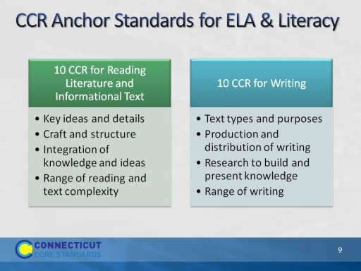
Slide 9
- CCR standards are organized by domains or strands: Reading Informational Text, Literature, Writing, Speaking and Listening, Language.
- Within domains/strands, standards are organized by clusters. For example, the reading standards are divided into four categories: 1) key ideas and details emphasizes close reading to determine meaning, drawing inferences, analyzing themes, and summarizing supporting details; 2) craft and structure emphasizes the author’s word choice, grammatical structures, and point of view as they impact text content and structure; 3) integration of knowledge and ideas emphasizes analysis of textual themes and arguments across varied media and formats; and 4) range of reading and level of text complexity emphasizes the importance of independent and proficient reading of complex text (CCS, p. 10).
- Standard R.10 can be considered the goal of the reading standards, to INDEPENDENTLY read and comprehend increasingly complex texts.
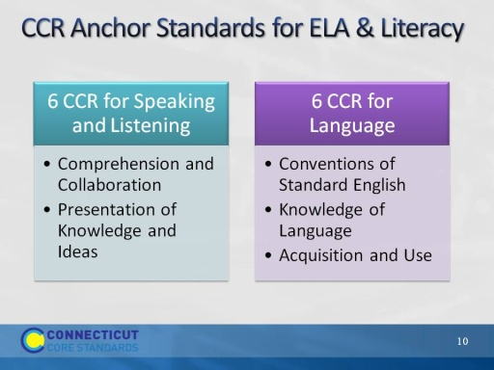
Slide 10
- The CC puts a renewed emphasis on the importance of speaking, listening, and collaboration as key to success in school and in College and Career.
- Students learn from each other as they become capable of reading and writing more complex text.
- CCR for language strongly recognizes that language acquisition is the basis for building knowledge and reading comprehension. There is a renewed emphasis on building both general and content specific vocabulary, especially as it can be defined in context.
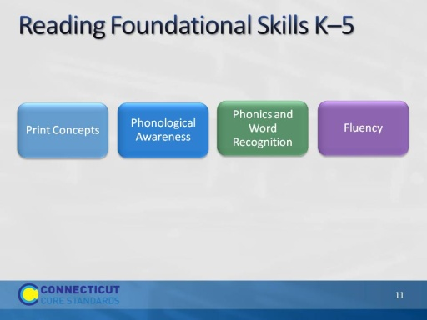
Slide 11
- These standards are directed toward fostering students’ understanding and working knowledge of concepts of print, the alphabetic principle, and other basic conventions of the English writing system.
- These foundational skills are not an end in and of themselves; rather, they are necessary and important components of an effective, comprehensive reading program designed to develop proficient readers with the capacity to comprehend texts across a range of types and disciplines.
- Instruction should be differentiated: good readers will need much less practice with these concepts than struggling readers will. The point is to teach students what they need to learn and not what they already know—to discern when particular children or activities warrant more or less attention. http://www.corestandards.org/ELA-Literacy/RF/introduction
- One way of thinking about the foundational skills is that they are the beginning standards necessary for accomplishing the CCR. They unlock the door to reading independently.
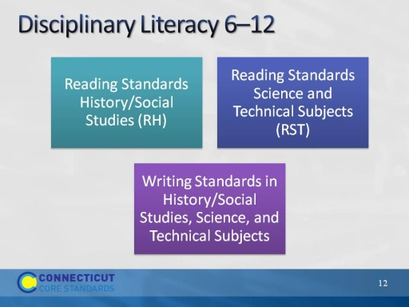
Slide 12
- The authors of the CC make the general assumption that literacy will be integrated into all subject areas in the elementary grades and will most often be taught by the same teacher who teaches ELA.
- The CCS Literacy Anchor Standards/Disciplinary Literacy standards for 6–12 are different in a few ways. There are Reading and Writing standards (10 each) for Science, Social Studies and Technical Subjects
- Only nonfiction reading and argument and explanatory writing is emphasized but no separate speaking and listening or language standards.
- Instead, vocabulary and speaking about text using evidence is integrated throughout the reading and writing standards. Disciplinary literacy standards describe the specific nature of texts and tasks demanded by the texts in those domains, as well as the nature of writing used by practitioners in the fields.

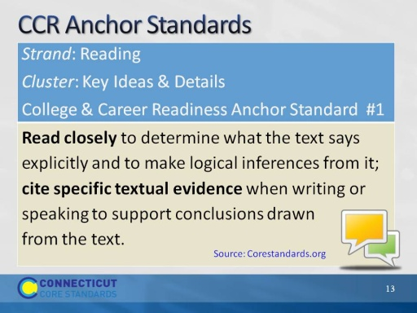
Slide 13
Here is an example of the vertical alignment structure of the CCS-ELA:
Strand: Reading
Cluster 1: Key Ideas and Details
CCR Anchor Standard for Reading 1 establishes the expectation that, by the time students graduate from high school, they should be able to engage in close reading, citing specific textual evidence in their text-based written or spoken responses. Readers use textual evidence to support their interpretation of the author’s intended meaning.
- Pay close attention to the verbs because it is the verbs that define the actions – what students should be able to do:
- Read closely
- Make logical inferences from text: CCS expect that students’ responses will reflect higher levels of thinking – analysis, synthesis, and evaluation rather than just recall.
- Note integration of reading with writing and speaking – that evidence of comprehension is articulated through spoken language and writing.
Turn-and-talk: If you were the authors of the CC, and you knew this (R.1) was the CCR goal, what do you think would be the starting point for K students?
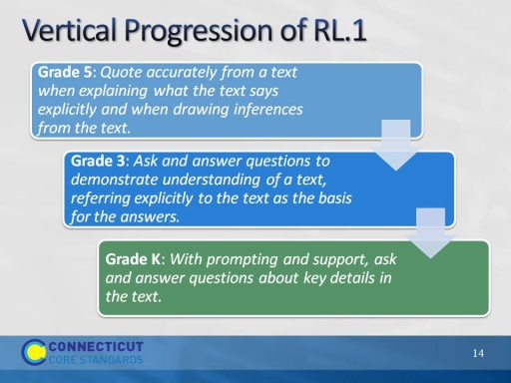
Slide 14
Here is an example of what participants will do in Activity CCCS.ELA-Literacy.RL.6.1
- Refer to CCR Anchor Standard: Cite textual evidence to support analysis of what the text says explicitly as well as inferences drawn from the text.
- Point out to participants how the standard progresses through the grades. In K, students listen to text and answer questions about text. In grade 3, they can point back to the text as the basis for their answers. In grade 5 students begin to incorporate quotes as evidence both for explicit and inferential statements.
- Looking across this standard, the students grow in both their use of explicit evidence and in their ability to look more abstractly at the text.
Activity 1
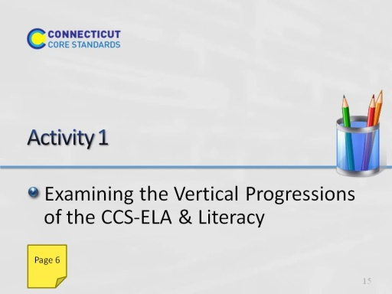
Slide 15
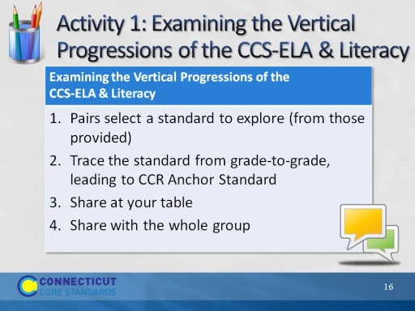
Slide 16
This slide gives a short overview of Activity 1. Before they begin, make sure everyone knows where the Activity 1 directions, template, and suggested discussion prompts are located in the Participant Guide and how they will regroup in mixed grade level pairs to examine closely the vertical alignment of the standards. Facilitate the participants getting into groups, selecting a standard and using the prompts to guide their discussion. Allow 30-40 minutes to complete Activity 1. The participant guide tells which standards they may select for this activity.
Activity Resources:
- CCS-ELA & Literacy Standards Progression, K–5 or 6–12 regrouped by CCR Anchor Standard and related grade level standards.
- Activity directions, discussion prompts, template.
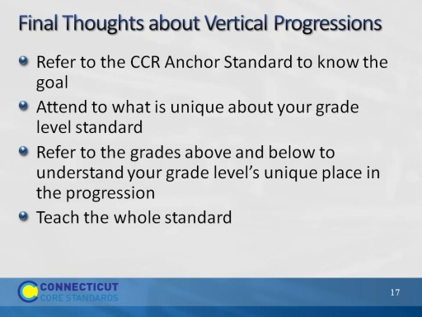
Slide 17
Use this slide to bring closure to the previous discussion. These are reminders.
- In order to see where the grade level standard is headed, look out at the CCR standard. However, you need to focus on your specific standard; otherwise you risk generalizing and teaching what actually belongs to a different grade level.
- If you “unpack” a standard, be certain that you don’t artificially break it into micro standards. The sum of all parts is not necessarily equal to the whole. Example: Characters + Plot taught separately does not equal the character’s influence on the plot and vice versa.
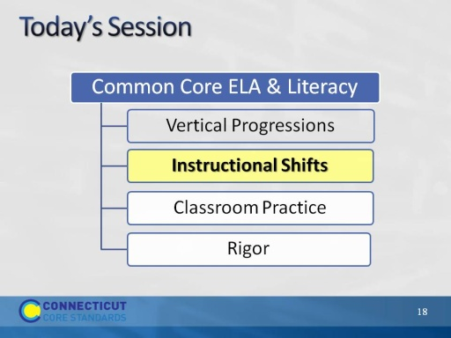
Slide 18
Explain that now we will look carefully at the three instructional shifts associated with the CCS-ELA and related instructional practices. These shifts represent the primary changes in practice from previous standards in order to achieve the CCR goals.
In the next activities participants will explore the three major instructional shifts associated with the CCS-ELA & Literacy and instructional practices associated with each.
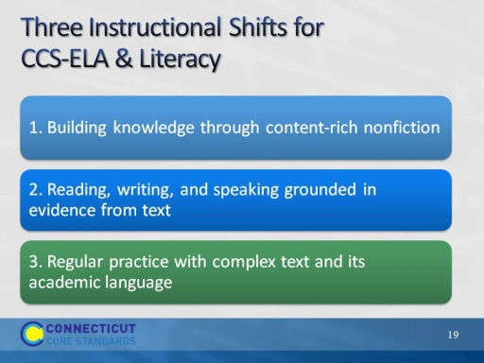
Slide 19
(Slides 19 – 26, introduction to the shifts, should take about 10 minutes.)
- These shifts are a “high level” view of the major instructional changes that are needed to actualize the standards.
- The shifts point the way toward changes in curriculum, instructional practice, and assessment to achieve alignment with the standards. Disseminating information about the shifts and helping all educators implement the standards is fundamental to achieving the goal of CCS-ELA & Literacy aligned curriculum, instruction, and assessment.
In this section of today’s workshop, participants will look at aligned instructional practices and examine how a given practices supports the shifts and, in turn, the implementation of the standards.
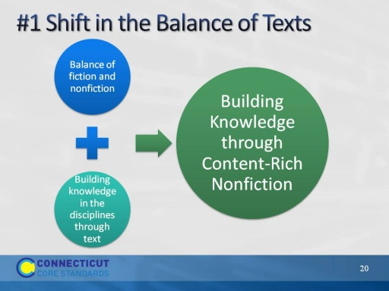
Slide 20
- We are starting with Shift 1: Building Knowledge Through Content-Rich Nonfiction. This marks a shift in terms of the types of text emphasized in ELA classes instruction also is expected to have students use texts as a primary vehicle for learning.
- Participants may have heard or seen the shifts described as 6 shifts rather than three.
- This slide shows the relationship between two of the six shifts and Shift 1. When Shift 1 is articulated as two separate shifts, it emphasizes the difference between elementary and secondary grades. In elementary school the classroom teacher is expected to strike a balance between fiction and nonfiction, using reading in the content areas to build knowledge.
- In the secondary grades, literacy is a shared responsibility of content teachers and ELA teachers. While ELA teachers increase their use of nonfiction as it pertains to their disciplines (e.g. essay, biography), each of the other disciplines is responsible for helping students build knowledge in their disciplines through texts rather than teacher talk.
- Teachers can help students understand that text is a source of knowledge and that they can use content knowledge to learn from the past and solve today’s problems around the globe.
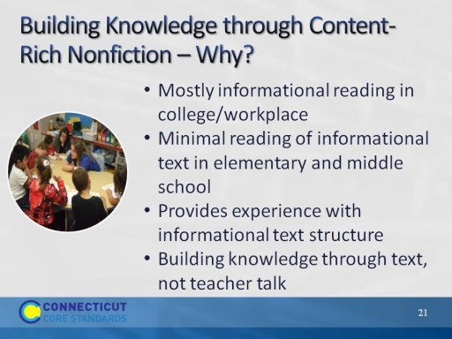
Slide 21
- The content literacy standards for grades 6–12 parallel the reading standards using discipline-specific content.
1st bullet: Even thought reading informational texts proves to be more difficult for students, it is a skill that must be developed for college and career readiness.
2nd bullet: The CCCS have followed the NAEP (National Assessment of Educational Progress) guidelines in establishing how much informational text students should read in schools. By high school, the standards call for a 30/70 split between literary texts and informational texts. The 70/30 split in grades 9-12 does not just refer to ELA/Literacy classes – it means the entire school experience for students, across the day, week, and year. This is displayed most prominently in two ways: 1) At every grade level, there are a set of standards for informational text and a set for literary standards. Each discipline has specific guidelines for the type of text to be read; 2) Reading Standard 10 calls for students to read a wide range of informational text. It is actually a standard to read informational text.
3rd bullet: Even thought reading informational texts proves to be more difficult for students, it is a skill that must be developed for college and career readiness.
4th bullet: Background knowledge has long been connected to comprehension. Reading informational text is essential in building background knowledge. Reading a coherent sequence of texts designed to develop content knowledge is also the best way to grow academic vocabulary because students have multiple exposures to words.
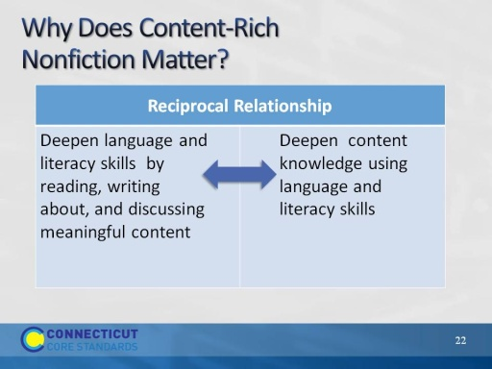
Slide 22
This slide addresses the reciprocal relationship between deepening language and literacy skills while simultaneously building content knowledge.
Build background knowledge to prepare students for post-secondary reading in college and careers.
- In ELA, blend literature and informational text in multi-modal, multi-genre text sets, so texts inform on the content knowledge that is the focus of instruction.
- In the content disciplines, read textbooks, journals, data including scientific experiments, primary source documents.
- In English, blend literature and literary nonfiction – speeches, essays, literary nonfiction, biography.
- Text is a source of knowledge.
- The stronger one’s reading skills, the easier it is to learn independently through reading text.
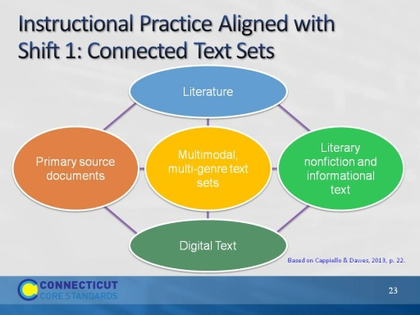
Slide 23
Instructional practice aligned with Shift 1: Texts Talking to Each Other.
To deepen students’ content knowledge, use an integrated, interdisciplinary approach in which informational and literary nonfiction informs the themes of literature and vice-versa. This slide presents one model of how text sets might be organized. (See Cappiello & Dawes, 2013, p. 22 for examples of texts:
- Literature: Realistic fiction, fantasy, historical fiction, mystery, science fiction, poetry, traditional literature, drama.
- Literary nonfiction and Informational Text: Biography, literary criticism, essays, textbooks, newspapers, journals and magazines
- Digital Text: webcasts, podcasts, photographs, websites, online government reports, works of art and music, interviews, blogs
- Primary source documents: speeches, documents, photographs, historical artifacts, newspapers
(See Cappiello & Dawes, 2013, pp. 254-257 for examples of text set structures)
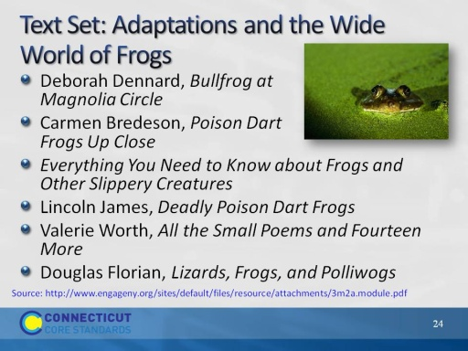
Slide 24
This is an example of a text set. This text set is used in Grade 3, Module 2A, Researching to Build Knowledge, written by Expeditionary Learning for EngageNY. Students learn about a “typical” frog in the central text, then research frogs with special adaptations in the other texts. Students will demonstrate their expertise through a “freaky frog trading card”—a research-based narrative that highlights their research and educates others about the amazing diversity of frogs, with a focus on how their freaky frog survives.
Notes:
- Not random reading – Text sets should be sequenced to build knowledge
- Students learning to read should exercise their ability to comprehend complex text through read-aloud texts.
- Reading aloud texts that are well-above grade level should be done throughout K–5 and beyond.
If time allows, participants may offer examples of text sets they use now.
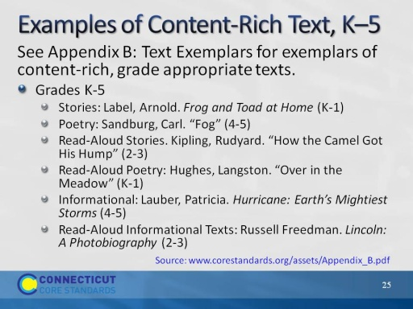
Slide 25
One source of multi-genre text exemplars (and related performance tasks) is Appendix B of the CCS-ELA & Literacy. Note: We will use excerpts from Appendix B in other Activities.
Reference:
National Governors Association Center for Best Practices & Council of Chief State School Officers (2010). Common Core State Standard for English Language Arts and Literacy in History/Social Studies, Science, and Technical Subjects. Washington, D.C.: Authors. Retrieved from http://www.corestandards.org/ELA-Literacy/; National Governors Association Center for Best Practices & Council of Chief State School Officers (2012). See Appendix B: Text Exemplars and Sample Performance Tasks. http://www.corestandards.org/assets/Appendix_B.pdf.

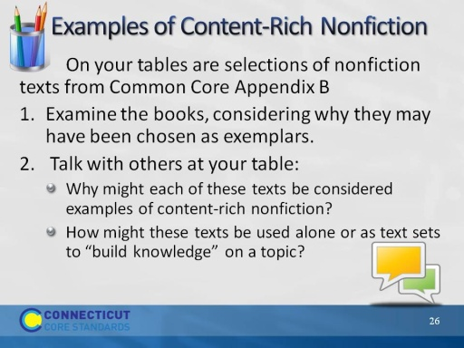
Slide 26
Prior to starting this activity, encourage participants to move to table groups of K–1, 2–3, and 4–5 coaches.
(Allow 15 minutes to examine the texts and talk about them.)
Direct participants to examine the texts on their table and then choose one (or an identified excerpt from Appendix B) to read more thoroughly (15 minutes).

