Module 1  Facilitator Guide | Focus on Instructional Shifts

Introductory Activity

Connecticut Core Standards for English Language Arts and Literacy

Grades 6–12

Systems of Professional Learning

Session at-a-Glance

Introduction
(10 minutes) The facilitator will review project goals and activities, module outcomes, and the agenda for the session. Participants will complete a Pre-Assessment.

Supporting Documents:
- Pre-Assessment

PowerPoint Slides:
- 1–5

Session Implementation
Introduction
Title Slide
Slides 1-5, including the Pre-assessment, will take about 10 minutes total.
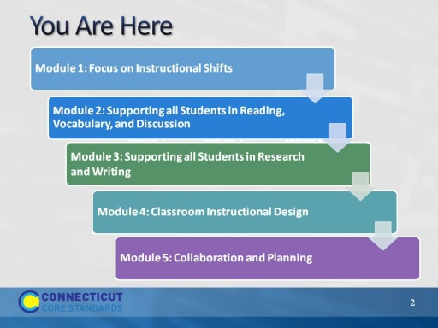
Slide 2
This slide provides a visual showing how the topics for the professional development modules fit together.
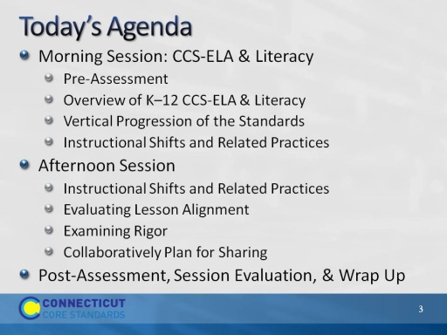
Slide 3
Review the agenda noting there will be a 45 minute break for lunch as well as a short morning and afternoon break. You may want to add the importance of coming back from breaks on time to ensure enough time to complete all the work of the day.
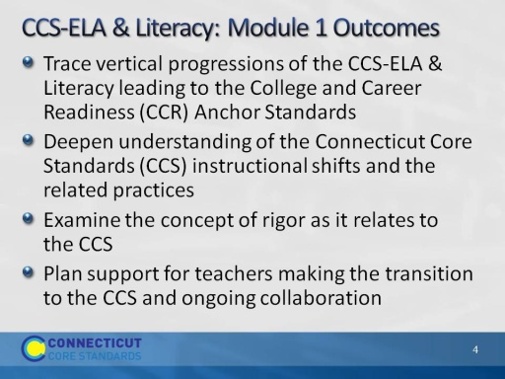
Slide 4
Review the expected outcomes. Explain that the work we do today will be a baseline for future modules where we dig more deeply into Common Core curriculum, instruction, and assessment.
This module will establish the foundation for your (coaches’) work and will focus on key outcomes such as understanding the CT Core Standards, ELA and Literacy Standards, and the instructional shifts that will support them; exploring grade level expectations of the standards leading to the CCR Anchor Standards, and examining instructional practices through video exemplars consistent with the CT Core Standards’ instructional shifts. The tools and lessons provided throughout this module will set the groundwork for your continued collaboration with other members of your school as well as increased instructional and curricular alignment to the CT Core Standards. The work we do today will be a baseline for future modules where we dig more deeply into Common Core curriculum, instruction, and assessment.
Introductory Activity
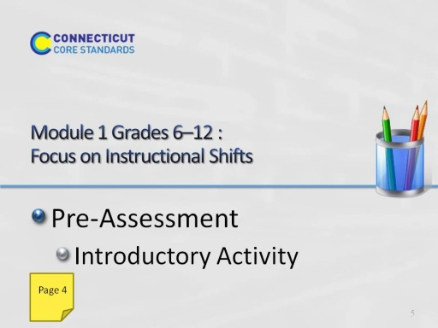
Slide 5
Direct participants: Before we begin, please take a few minutes to complete this short Pre-Assessment. This will gauge your beliefs about the CT Core Standards and related instructional shifts and practices for ELA & Literacy. Note that you will complete the same assessment again at the end of the session as a way to compare your thinking before and after the course.
(This will be a short Self-Assessment, which will be found in the Participant Guide. It will assess where they are now in their understanding the CCS-ELA & Literacy and related instructional shifts and practices. They will complete the same assessment at the end of the morning session. Allow 3-4 minutes to complete.)

