Module 1  Facilitator Guide | Focus on Instructional Shifts

Activity 7

Connecticut Core Standards for English Language Arts and Literacy

Grades 6–12

Systems of Professional Learning

Session at-a-Glance

Activity 7: Reflect, Pair, Share
(20 minutes) To consolidate today’s learning, coaches will consider all the elements of today’s presentation and activities (shifts, vertical progressions, exemplars, practice lesson planning, EQuIP Rubric, and conversation on rigor) to answer the following question: What are the essential components that must be considered when planning a lesson aligned with the Connecticut Core Standards for English Language Arts and Literacy (CCS-ELA & Literacy)?

Supporting Documents:
- Directions
- Templates for capturing “take-aways” from the day

PowerPoint Slides:
- 68–69

Session Implementation
Activity 8
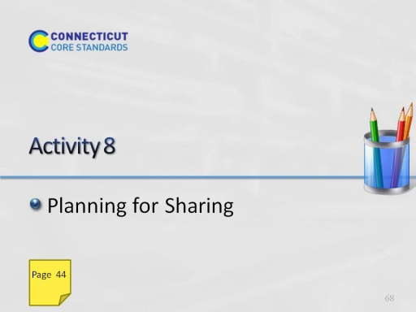
Slide 68
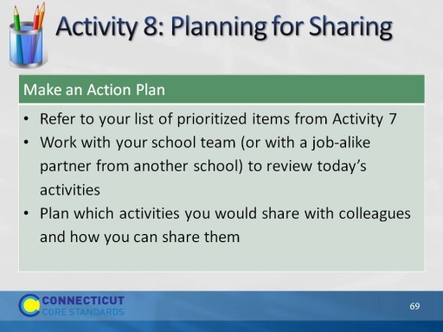
Slide 69
(Allow 15 minutes for this activity; adjust time as needed.)

