Module 1  Facilitator Guide | Focus on Instructional Shifts

Activity 6

Connecticut Core Standards for English Language Arts and Literacy

Grades 6–12

Systems of Professional Learning

Session at-a-Glance

Activity 6: Activity 6: Myths About Rigor in the Common Core Classroom
(30 minutes) Working in mixed grade groups of five, coaches take a short quiz (anticipation guide) about rigor and the Common Core. They briefly discuss their responses.
Participants read a recent post on middleweb.com by Barbara Blackburn, “Five Myths about Rigor and the Common Core” http://www.middleweb.com/12318/five-myths-rigor-common-core. Each participant reads the entire blog post and underlines information relevant to the rigor quiz. They discuss and revise responses on the quiz, using evidence from the blog post.

Supporting Documents:
- Directions
- Short Quiz
- “Five Myths about Rigor and the Common Core” (Blackburn, 2014)

PowerPoint Slides:
- 63–65

Session Implementation
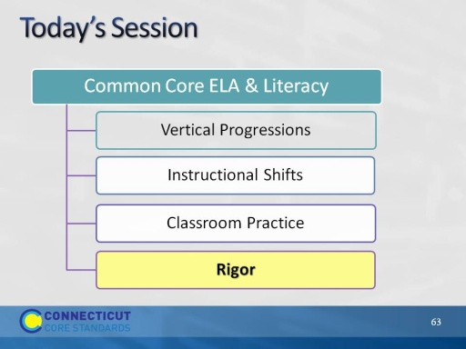
Slide 63
Explain that the CCS are often referred to as “rigorous” new standards. What does rigor mean? How does it manifest in the standards?
Activity 6
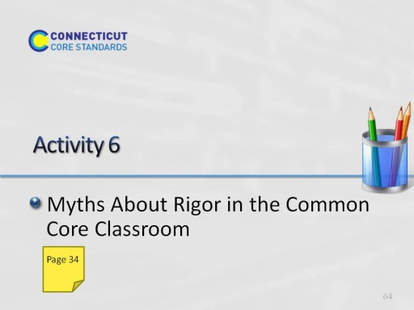
Slide 64
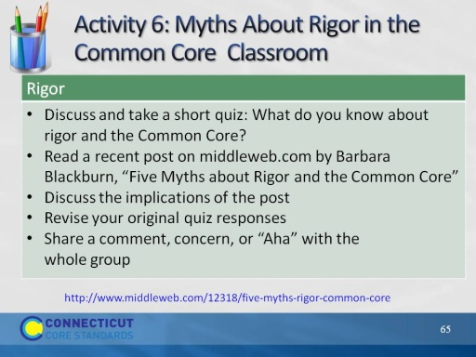Slide 65
Complete instructions and article are provided in the participant guide.

