Module 1  Facilitator Guide | Focus on Instructional Shifts

Activity 5

Connecticut Core Standards for English Language Arts and Literacy

Grades 6–12

Systems of Professional Learning

Session at-a-Glance

Activity 5: Bringing it All Together –Using the EQuIP Rubric to Assess Alignment
(50 minutes) In mixed grade table groups, coaches will view and reflect on an entire video lesson and lesson plan for evidence of alignment using the EQuIP Rubric.

Supporting Documents:
- Directions
- America Achieves instructional video and sample lesson plan
- EQuIP Rubric

PowerPoint Slides:
- 59–61

Session Implementation
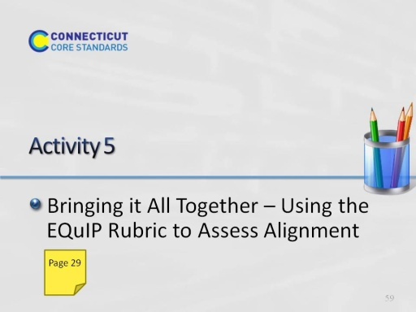
Slide 59
This slide introduces Activity 5. Before participants begin make sure everyone knows where the Activity directions are located for using the Practice Guide.
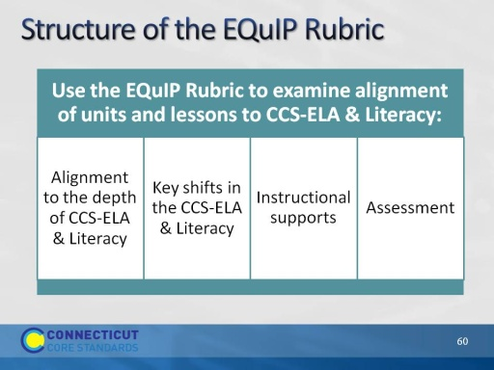
Slide 60
Participants will become familiar with the EQuIP Rubric to determine if a lesson is aligned to the CCS-ELA & Literacy. Read the information below and allow participants 10 minutes to review the rubric and become familiar with its components.
- Educators Evaluating Quality Instructional Products (EQuIP) is a collaborative of states working to increase the supply of quality instructional materials that align with the CCSS for use in elementary, middle, and high schools. This rubric was developed by Massachusetts, Rhode Island, and New York as the Tri-State Rubric, with the assistance of Achieve. The rubric is now available for use by all states.
- The rubric helps educators examine the following dimensions:
  - Alignment to the rigor of CCCS-ELA & Literacy: For example, are the standards identified and addressed? Is the purpose of instruction clear? Are appropriately complex texts used?
  - Key areas of focus: 1) content-rich text; 2) reading closely; 3) purposeful writing; 4) academic language
  - Instructional supports: engagement; variety of opportunities to engage with challenging text; scaffolding for all learners
  - Assessment: observable evidence that students are working towards proficiency on specified standards; use of aligned rubrics to assess writing
Note that we will mostly focus on 1 and 2 today.
Activity 5
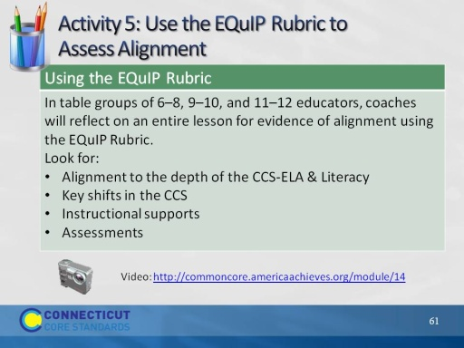
Slide 61
Participants will become familiar with the EQuIP Rubric to determine if a lesson is aligned to the CCS-ELA & Literacy. Read the information below and allow participants 10 minutes to review the rubric and become familiar with its components.
- Educators Evaluating Quality Instructional Products (EQuIP) is a collaborative of states working to increase the supply of quality instructional materials that align with the CCSS for use in elementary, middle, and high schools. This rubric was developed by Massachusetts, Rhode Island, and New York as the Tri-State Rubric, with the assistance of Achieve. The rubric is now available for use by all states.
- The rubric helps educators examine the following dimensions:
  - Alignment to the rigor of CCCS-ELA & Literacy: For example, are the standards identified and addressed? Is the purpose of instruction clear? Are appropriately complex texts used?
  - Key areas of focus: 1) content-rich text; 2) reading closely; 3) purposeful writing; 4) academic language
  - Instructional supports: engagement; variety of opportunities to engage with challenging text; scaffolding for all learners
  - Assessment: observable evidence that students are working towards proficiency on specified standards; use of aligned rubrics to assess writing
Note that we will mostly focus on 1 and 2 today.

