Module 2  Facilitator Guide | Supporting All Students in Close Reading, Academic Language, and Text-Based Discussion

Activity 8

Connecticut Core Standards for English Language Arts and Literacy

Grades 6–12

Systems of Professional Learning

Connecticut Core Standards Systems of Professional Learning
The material in this guide was developed by Public Consulting Group in collaboration with staff from the Connecticut State Department of Education and the RESC Alliance. The development team would like to specifically thank Ellen Cohn, Charlene Tate Nichols, and Jennifer Webb from the Connecticut State Department of Education; Leslie Abbatiello from ACES; and Robb Geier, Elizabeth O’Toole, and Cheryl Liebling from Public Consulting Group.
The Systems of Professional Learning project includes a series of professional learning experiences for Connecticut Core Standards District Coaches in English Language Arts, Mathematics, Humanities, Science, Technology, Engineering, Mathematics (STEM), and Student/Educator Support Staff (SESS).
Participants will have continued support for the implementation of the new standards through virtual networking opportunities and online resources to support the training of educators throughout the state of Connecticut.
Instrumental in the design and development of the Systems of Professional Learning materials from PCG were: Sharon DeCarlo, Debra Berlin, Jennifer McGregor, Judy Buck, Michelle Wade, Nora Kelley, Diane Stump, and Melissa Pierce.
Excerpts, tools, and strategies from Thinkquiry Toolkit 1 © 2011 and Thinkquiry Toolkit 2 © 2014. All rights reserved. Used with permission of Public Consulting Group. Excerpts from PCG Education White Papers Universal Design for Learning © 2013 and Making a Difference in Student Achievement © 2011. All rights reserved. Used with permission of Public Consulting Group.

Published 2014. Available online at http://ctcorestandards.org/
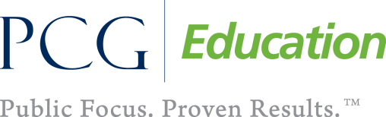 |  | 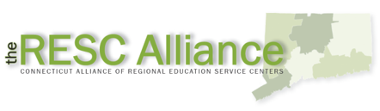

Session at-a-Glance

Activity 8: Applying UDL Supports to a Lesson (15 minutes)
In this activity, participants will revisit the UDL Wheel, UDL Framework and Guidelines, and the UDL supports in Participant Guide. Using these resources, they will review their lesson with their partner and consider the UDL supports that could be added to close reading, text-dependent questions, academic language, and discussions to support all students.

Supporting Documents:
- UDL Framework and Guidelines with examples of instructional practices that align with the CCS-ELA & Literacy and instructional shifts and include UDL Supports
- UDL Wheel http://udlwheel.mdonlinegrants.org/
- Draft close reading lesson

PowerPoint Slides:
- 93–95

Session Implementation
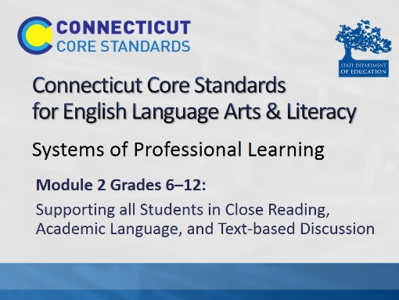Title Slide

Activity 8
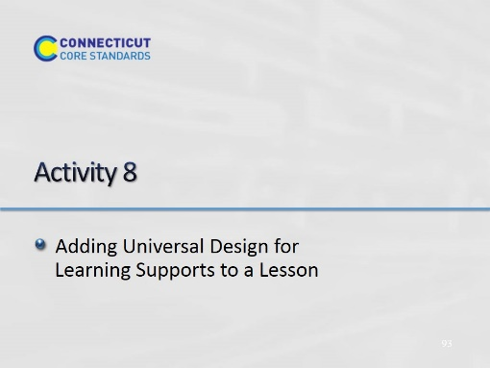Slide 93
Blank.
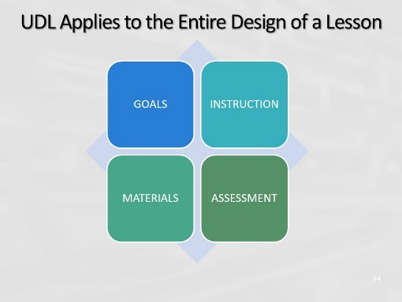Slide 94
When designing lessons, consider UDL supports and practices for the lesson goals, the materials and methods, the instruction, and how students are assessed.
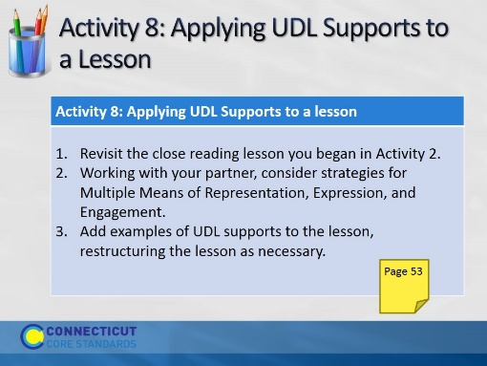Slide 95
Allow 15 minutes for this activity; adjust time as needed.

