Module 2  Facilitator Guide | Supporting All Students in Close Reading, Academic Language, and Text-Based Discussion

Activity 4

Connecticut Core Standards for English Language Arts and Literacy

Grades 6–12

Systems of Professional Learning

Connecticut Core Standards Systems of Professional Learning
The material in this guide was developed by Public Consulting Group in collaboration with staff from the Connecticut State Department of Education and the RESC Alliance. The development team would like to specifically thank Ellen Cohn, Charlene Tate Nichols, and Jennifer Webb from the Connecticut State Department of Education; Leslie Abbatiello from ACES; and Robb Geier, Elizabeth O’Toole, and Cheryl Liebling from Public Consulting Group.
The Systems of Professional Learning project includes a series of professional learning experiences for Connecticut Core Standards District Coaches in English Language Arts, Mathematics, Humanities, Science, Technology, Engineering, Mathematics (STEM), and Student/Educator Support Staff (SESS).
Participants will have continued support for the implementation of the new standards through virtual networking opportunities and online resources to support the training of educators throughout the state of Connecticut.
Instrumental in the design and development of the Systems of Professional Learning materials from PCG were: Sharon DeCarlo, Debra Berlin, Jennifer McGregor, Judy Buck, Michelle Wade, Nora Kelley, Diane Stump, and Melissa Pierce.
Excerpts, tools, and strategies from Thinkquiry Toolkit 1 © 2011 and Thinkquiry Toolkit 2 © 2014. All rights reserved. Used with permission of Public Consulting Group. Excerpts from PCG Education White Papers Universal Design for Learning © 2013 and Making a Difference in Student Achievement © 2011. All rights reserved. Used with permission of Public Consulting Group.

Published 2014. Available online at http://ctcorestandards.org/

Session at-a-Glance

Activity 4: Creating a Sequence of Text-Dependent Questions (35 minutes)
Participants create a series of text dependent questions for their selected grade level texts that scaffolds students toward general understanding of their text and the selected standards.

Supporting Documents:
- Creating Questions for Close Analytic Reading Exemplars: A Brief Guide (Student Achievement Partners) http://achievethecore.org/page/45/short-guide-to-creating-text-dependent-questions
- Lesson Template in the Appendix of the Participant Guide
- Academic Vocabulary Organizer
- Close Reading Organizer

PowerPoint Slides:
- 48–53

Session Implementation
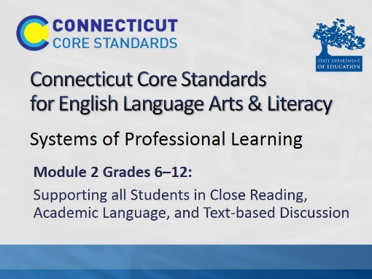Title slide
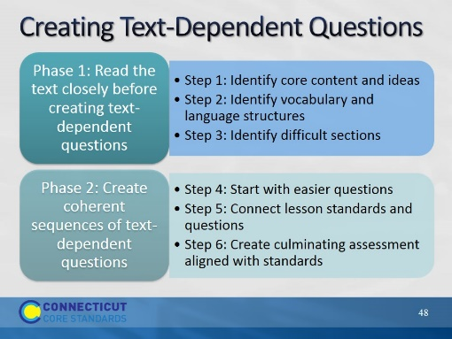Slide 48
The purpose of this slide is to remind participants of where we are in this process. They have completed Phase 1. Now we are moving on to Phase 2. Read Phase 2. Let participants know that the standards have already been selected for today.

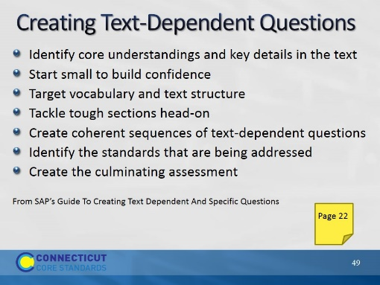Slide 49
The purpose of this slide is to review one order in which TDQ’s can be created. While there is no set process for generating a complete and coherent body of text dependent questions for a text, this process is a good guide that can serve to generate a core series of questions for close reading of any given text. Please note that this is a recursive not a straightforward process; in backward design, we may select the text to match standards or learning goals we have already determined, and we may create the assessment first. This will help guide the TDQ’s we use!
Read the details for each bullet, below:
Step One: Identify the Core Understandings and Key Ideas of the Text
As in any good reverse engineering or “backwards design” process, teachers should start by identifying the key insights they want students to understand from the text—keeping one eye on the major points being made is crucial for fashioning an overarching set of successful questions and critical for creating an appropriate culminating assignment.
Step Two: Start Small to Build Confidence
The opening questions should be ones that help orientate students to the text and be sufficiently specific enough for them to answer so that they gain confidence to tackle more difficult questions later on.
Step Three: Target Vocabulary and Text Structure
Locate key text structures and the most powerful words in the text that are connected to the key ideas and understandings, and craft questions that draw students’ attention to these specifics so they can become aware of these connections. Vocabulary selected for focus should be academic words “(Tier Two”) that are abstract and likely to be encountered in future reading and studies.
Step Four: Tackle Tough Sections Head-on
Find the sections of the text that will present the greatest difficulty and craft questions that support students in mastering these sections (these could be sections with difficult syntax, particularly dense information, and tricky transitions or places that offer a variety of possible inferences).
Step Five: Create Coherent Sequences of Text-Dependent Questions
The sequence of questions should not be random but should build toward more coherent understanding and analysis to ensure that students learn to stay focused on the text to bring them to a gradual understanding of its meaning.
Step Six: Identify the Standards That Are Being Addressed
Take stock of what standards are being addressed in the series of questions and decide if any other standards are suited to being a focus for this text (forming additional questions that exercise those standards).
Step Seven: Create the Culminating Assessment
Develop a culminating activity around the key ideas or understandings identified earlier that reflects (a) mastery of one or more of the standards, (b) involve writing, and (c) is structured to be done independently.
Refer participants to the “Creating Questions for Close Analytic Reading Exemplars: A Brief Guide” in their Participant Guide.

Activity 4
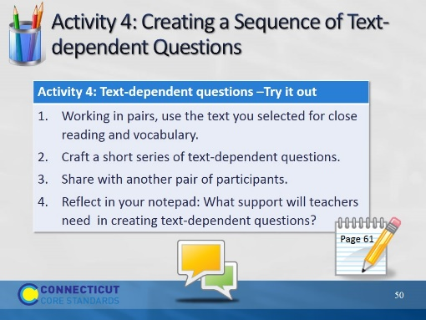Slide 50
Direct participants to write a short series of TDQ’s, based on the content and vocabulary they identified. Remind them that TDQ’s can address academic language challenges. These may go into the “work time” section of the lesson template. Remind them that this is by no means a full lesson, and that these questions could be posed in any number of ways – not necessarily as an ask and answer routine. Allow 30 minutes for Activity 4

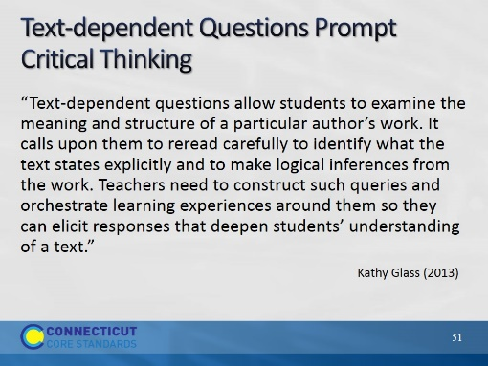Slide 51
The purpose of this slide is to address a question that has been asked by many who are concerned that close reading and TDQ’s is a very teacher directed process.
Teacher-created TDQ’s serve two purposes; they scaffold readers toward understanding complex text, and they serve as models for the kinds of questions good readers ask themselves. It is important to remember as you craft TDQ’s, that they are not always asked as a series of questions and that they deepen students’ understanding of text. They may be asked on different readings and re-readings of text. They may be asked as Quick Writes, or be structured into graphic organizers.
Adapted from: Building Text-dependent Questions to Facilitate Close Reading by Kathy Glass (2013). http://www.kathyglassconsulting.com/documents/TextDeptQuesIRA2013KATHYGLASS.pdf
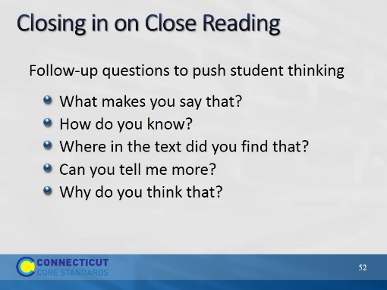Slide 52
The purpose of this slide is to suggest ways that teachers can encourage students to refer to the text and elaborate on their answers.

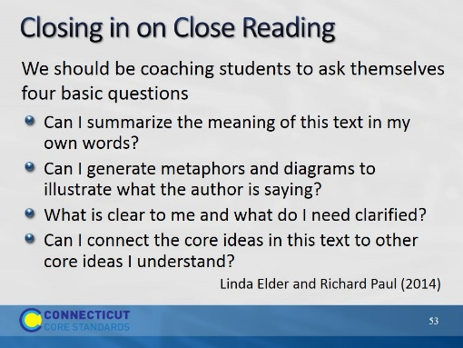Slide 53
To read closely, students must get beyond impressionist reading. They must come to see that simply deciphering words on a page and getting some vague sense of what is there does not translate into substantive learning. Instead, they must learn that to read well is to engage in a self-constructed dialog with the author of a text. Really good reading requires close reading. It requires one to formulate questions and seek answers to those questions while reading. It requires connecting new ideas to already learned ideas, correcting mistaken ideas when necessary. In other words, close reading requires specific intellectual work on the part of the reader.
This information was adapted from How to Read a Paragraph: The Art of Close Reading by Richard Paul and Linda Elder (2014).

