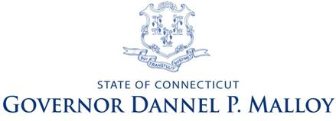

**Governor’s Cabinet on Nonprofit Health and Human Services**

**AGENDA**

**Governor’s Cabinet on Nonprofit Health and Human Services**

Monday May 6, 2013

2:00 – 4:00

State Capitol Room 310

1. Welcome (DeBiasi/ Edelstein)
2. Approval of minutes of 4/16/13 Cabinet Meeting – ACTION ITEM
3. Presentation: Legislative Partners

House Speaker’s MORE (Municipal Opportunities and Regional Efficiencies) Commission

Working Group on Regional Entities – Subcommittee on Human Services

<http://www.housedems.ct.gov/MORE/index.asp>

* State Representative Tim Bowles, 42nd House District

1. Presentations: Cabinet Partner Associations

* CT Association of Community Health Centers

1. Work Group Reports

Work Group on Contract Administration and Procurement

* Alyssa Goduti, Vice President of Business Development & Communication, Community Health Resources
* Kathleen M. Brennan, Deputy Commissioner, DSS

Work Group on Jobs

* Terry Macy, Ph.D., Commissioner, DDS
* Maureen Price-Boreland, Executive Director, Community Partners in Action

Work Group on Population Results

* Ajit Gopalakrishnan, Chief, Bureau of Data Collection, Research and Evaluation, SDE
* Yvette Bello, Executive Director, Latino Community Services

1. Meeting schedule & task review (Edelstein)
2. Other business
3. Adjournment (DeBiasi)