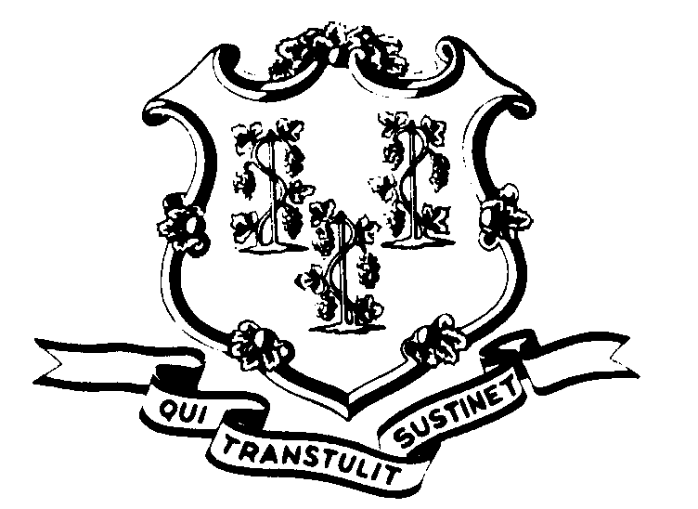
STATE OF CONNECTICUT

OFFICE OF POLICY AND MANAGEMENT

Office of Labor Relations

January 22, 2014

General Notice No. 2014-06

TO: Labor Relations Designees

SUBJECT: January 21st Snow Storm

EARLY RELEASE
On Tuesday, January 21, 2014, Governor Malloy authorized the staggered early release of non-essential State employees. This early release started at 3:00 p.m. in order to better manage the evening commute given the inclement weather conditions.
Consistent with past practice, contractual and statutory provisions, you are reminded of the following:
- Non-essential employees working on January 21, 2014 who were released early (3:00 p.m. being the earliest) are to be coded “LWGOV” for the hours following departure from work through the end of the employees scheduled work day. Essential employees will be paid in accordance with contractual and statutory provisions and are not eligible for compensatory time off unless specifically provided in their collective bargaining agreement
- Employees who were not scheduled to work January 21, 2014 or who did not come to work or departed prior to 3:00 p.m. are not covered by the Governor’s action.
- Employees absent because of illness, scheduled vacation, personal leave, or other earned time shall have the appropriate leave balance charged and are not eligible for “LWGOV” time. Employees on a leave of absence without pay (including voluntary leave), scheduled day off or pass day shall not be eligible for “LWGOV” time.
- The Governor’s actions only affected State employees who work on day shift operations and did not impact employees who work on the second or third shifts as those operations were not delayed or closed. Essential second shift employees who are covered by the 1199 contract should be paid in accordance with Memorandum of Understanding 22 contained in the 2009-2012 contract booklet (as extended).
- Employee questions about this notice should be addressed to the Agency’s Human Resources office. Agency Labor Relations Designees with questions may contact the Office of Labor Relations at 418-6447.

Linda J. Yelmini

Linda J. Yelmini
Director of Labor Relations

