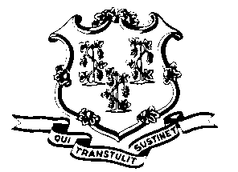
STATE OF CONNECTICUT

OFFICE OF POLICY AND MANAGEMENT

Office of Labor Relations

July 25, 2011

General Notice 2011-16

TO: Labor Relations Designees

SUBJECT: Time off with pay to discuss and vote on Revised 2011 Tentative SEBAC Agreement

Commissioners may approve limited time off from July 22, 2011 to August 15, 2011, for bargaining unit members to attend meetings intended to educate them on proposed changes to SEBAC or collective bargaining agreements. Such approvals should be as limited as possible and should not cause significant disruptions to state services. Employees should utilize the CORE code LSEBC to record time spent on such activity including voting.

As of August 15, 2011, OLR General Notice 2011-07 will be reinstituted.

Agency Labor Relations Designees with questions may contact the Office of Labor Relations at 860-418-6447. All others should contact their agency Human Resource office.

Linda J. Yelmini
Linda J. Yelmini
Director of Labor Relations

