For the LoCIP reimbursement form to appear properly, please make sure that you view the form in NORMAL workbook view.
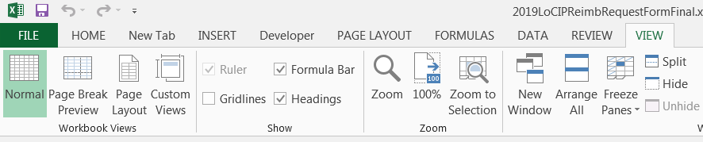
- Open the form in Excel
- Click on the VIEW tab at the top of your screen
- Then click on Normal view

For the LoCIP Project Authorization form to appear properly, please make sure that you view the form in PRINT LAYOUT view.
- Open the form in Microsoft Word
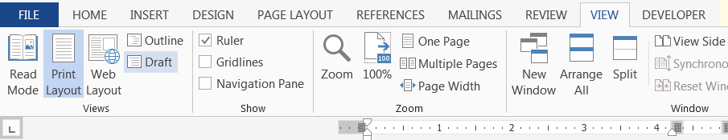
- Click on the VIEW tab at the top of your screen
- Then Click on Print Layout view

