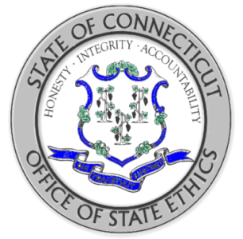
STATE OF CONNECTICUT
OFFICE OF STATE ETHICS
2020

PUBLIC OFFICIAL AND STATE EMPLOYEE TRAINING
CERTIFICATION OF COMPLETION

Employee Name:
Employee Agency:

I hereby certify that I have completed the e-learning training course on the
Code of Ethics for Public Officials and State Employees.

Date of Training Completion:
Employee Signature:

