STATE OF CONNECTICUT
DEPARTMENT OF MOTOR VEHICLES

POLICIES AND PROCEDURES MANUAL

DEALER ON-LINE REGISTRATION PROGRAM

DEPARTMENT OF MOTOR VEHICLES CORE CUSTOMER OPERATIONS DOL 3RD FLOOR ROOM 305 WETHERSFIELD, CT 06161-0001
PHONE (860)263-5708
FAX: (860)263-5566 Rev. February 2020

CHAPTER 1: INTRODUCTION 5
MISSION STATEMENT VISION STATEMENT BEFORE YOU BEGIN
TO BECOME AN ON-LINE DEALER AGENT INVENTORY AND SUPPLIES
DEALER AS AN ON-LINE REGISTRATION SYSTEM AGENT TRANSACTIONS
VOID SCHEDULE OWERSHIP DOCUMENTS
DATA THAT WAS NOT CONVERTED TO THE NEW SYSTEM REQUIRED DEALER CALLS TO DMV/CIVLS TRIAGE UNIT TRANSACTIONS WHICH CANNOT BE PROCESSED ON-LINE

CHAPTER 2: INVENTORY 10
SECURITY OF INVENTORY TERMINAL/ALLOWABLE INVENTORY SET-UPS ORDERING INVENTORY
CONFIRMATION OF INVENTORY REPORTING PROBLEMS WITH INVENTORY RECONCILIATION OF INVENTORY RETURNING UNUSED INVENTORY

CHAPTER 3: REGISTRATION ON-LINE 15
REGISTERING A VEHICLE ON-LINE
- Option 1 immediate-processing
- Option 2 pre-processing TRANSFER INFORMATION
- Vehicle transfer
- Record transfer
IN-TRANSIT REGISTRATION BATCHING AND SUBMISSION POLICY TRANSACTION DETAIL REPORT REQUIRED SUPPORTING DOCUMENTS BUSINESS/COMPANY NAME POLICY PROPERTY TAX AND SUSPENSION
- Suspension
- Property tax COURTESY DELIVERY VOID FUNCTION SYSTEM OFF-LINE REPRINTS

CHAPTER 4: TITLE INFORMATION 23
TITLE PROCEDURES AND TITLE INQUIRY FUNCTIONS
- Miscellaneous
- Lienholder
- Withdrawal
- Title suspense
- Title inquiry
- Uses of title inquiry reports
- Utilizing title inquiry report with application for duplicate title (H6-B)
- Miscellaneous title inquiry report information
- Obtaining a duplicate title over the counter
- Authorization for payoff (H-12)
- CT secure power of attorney for vehicle mileage disclosure & certification (H-117)
- Title legends

CHAPTER 5: LEASING 28
LEASE VEHICLE INFORMATION
- Registration requirements
- Vehicle transfers on lease companies

CHAPTER 6: INSPECTION AND EMISSIONS 29
VEHICLE INSPECTION
- Performing VIN verification (by dealer)
- Out of state vehicle requirements
- Quick reference chart for inspections
- Contacts for inspection EMISSIONS EXEMPTIONS

CHAPTER 7: MARINE VESSEL 33
Definitions
* Vessels to be numbered
* Vessels to be Titled
* Vessel registration fees
* Vessels exempt from fees
* Registration requirements
* Processing applications

CHAPTER 8: ENFORCEMENT 52
VIOLATION/ENFORCEMENT
- Policy of violations
- Enforcement notices & action if policies are violated

CHAPTER 9: MISCELLANEOUS INFORMATION 53
SALES TAX INFORMATION SALES TAX – DEALERS Q & A APPLICANT ADDRESS REFUND POLICY REGISTRATION TO A MINOR
CONNECTICUT INSURANCE CERTIFICATE CORRECTION AFTER TITLE ISSUANCE TAX TOWN CODES
REGISTRATION INFORMATION – PLATE TYPES AND FEES-
*Passenger
*Combination
*Commercial
*Motorcycle
*Camp Trailer
*Camper
MISCELLANEOUS TRANSACTIONS AND PLATE FEES CONTACTS & PHONE NUMBERS
CHAPTER 10: APPENDIX 67
FORMS:
- Application for duplicate certificate title (H6-B)
- Connecticut Secure POA for vehicle mileage disclosure & certification (H-117)
- Authorization for payoff (H-12)
- Supplemental assignment of ownership and/or bill of sale (Q-1)
- Certificate of parental consent (2-D)
- Application for Vessel (B-148)
- Documents required for Vessel registration and for certificate of title (B-220)
- Supplemental Assignment of ownership and/or bill of sale for a vessel (Q1V)
- Title inquiry report
- Withdrawal form (H-71) ADMINISTRATIVE FEE REQUIREMENTS REGISTRATION INFORMATION
- Combination and Commercial fee charts
TITLE & REGISTRY REQUIREMENTS FOR TRAILERS FROM OUT OF STATE
Chapter 1 INTRODUCTION
The Dealer On-Line Procedure Manual has been designed to aid your dealership when performing the duties of an On-Line Dealer. This manual will serve as a reference for your dealership. We have tried to make this manual as clear and concise as possible.

MISSION STATEMENT
The mission of the Connecticut Department of Motor Vehicles is to promote and advance public Safety, Security and Satisfaction through the regulation of drivers, their motor vehicles and certain motor vehicle-related businesses.

VISION STATEMENT
Our vision is to always evolve as an organization; to employ new and innovative measures and strategies that improve customer service, enhance the security of credentials, foster staff development and satisfaction, streamline agency procedures, and promote clear and timely communication.

BEFORE YOU BEGIN
The On-Line Dealer program was developed by, and is maintained by the Connecticut Automotive Retailers Association (CARA) by agreement with the State of Connecticut Department of Motor Vehicles.

TO BECOME AN ON-LINE DEALER AGENT
Before a dealer can become an On-Line Dealer Agent the following must be completed and/or on file with the DMV:
- Letter of Intent (Vendor Form)
- Registration Issuance Bond (A current $5,000 Dealer Issuance Bond must be on file with the Compliance Unit)
  - The bond will need to be overnighted to DMV Compliance Unit room 305
- On-Line Dealer Program Requirements (The requirement agreement must be signed by the Dealership Principal)
- Dealer License
- Training Certificate (Dealership personnel utilizing the On-Line System must be trained by CARA and Vendor) 860-293-2500, Dealertrack
- A funds account must be established with CARA
- Letter of Experience (if applicable)

INVENTORY AND SUPPLIES
All On-Line dealers will be given an inventory of plates.
If you process Boats, you will also be given Boat stickers.

DEALER AS AN ON-LINE REGISTRATION SYSTEM (OLRS) AGENT

TRANSACTIONS
The Dealer OLRS has been designed to support the following transactions for vehicles and trailers:
- NEW ISSUES: Customer is requesting a new registration and marker plate.
- VEHICLE TRANSFERS: Customer has a current registration and is requesting their marker transferred to a new vehicle. Applicant(s) information is limited with its changes.
- VOID: Dealership will have the ability to void a permanent registration that was processed On-Line, within the allotted time.
- TITLE INQUIRIES: Dealerships will be provided title information on previously titled Connecticut vehicles.
- RENEWALS: Registration renewals can be processed for customers that do not have special requirements (IRP, special insurance requirements, etc.) and for commercial vehicles up to 55,000 GVWR
- INTRANSIT: These temporary registrations can be issued for vehicles that are to be registered out of state.
- BOATS: See chapter 7

VOID TIME SCHEDULE
Listed below are the schedules which MUST be followed when registering a vehicle On-Line and performing a Void.
*All instances where the date of issue and the date of transaction are the same

Process On-Line Void Time Frame
(Date of transaction)
Monday Tuesday until 6:00PM
Tuesday Wednesday until 6:00PM
Wednesday Thursday until 6:00PM
Thursday Friday until 6:00PM
Friday Monday until 6:00PM
Saturday Monday until 6:00PM
Sunday Monday until 6:00PM

IMPORTANT-NOTE: Any transaction not VOIDED will become a permanent registration record. The paperwork for a transaction which has not been VOIDED during the given time period must be submitted within ten (10) days of issuance.

*A void for a NEW issue registration requires the plates be returned to DMV. The plates will no longer be returned to your inventory.

The following functions may also be performed while processing a Registration Transfer:

  - Conjunction change (no fee)
  - Swapping primary owner with secondary owner (no fee)
  - Swapping primary owner with secondary owner and dropping the primary owner ($20.00)
  - Dropping the secondary owner ($20.00)
  - Combination (up to 12,500 GVWR)/Commercial (up to 67,400 lbs. GVWR) transfer with increase in weight (fee charged is dependent on GVWR)

Commercial – Regular: Registration must be commercial if vehicle has permanent signage. Can be registered combination if signage is removable, if GVWR is over 7500lbs., the vehicle is not allowed on the Merritt Parkway or Wilbur Cross Parkway. NOTE: GVWR of 12,500 or more will need a Commercial plate.

THE FOLLOWING PLATE/VEHICLE USAGE TYPES MAY BE PROCESSED IN THE ON- LINE SYSTEM:
- Standard/Passenger registration: Vehicle Type: Passenger
Usage: Regular

Vehicle Type: Truck (under 8500 lbs.) Usage: Regular

- Combination registration: Vehicle Type: Passenger
Usage: Combination

Vehicle Type: Truck (under 12,500 lbs.)
Usage: Combination

- Commercial registration: Vehicle Type: Passenger
Usage: Commercial

Vehicle Type: Truck (under 67,400 lbs.)
Usage: Commercial

- Motorcycle registration: Vehicle Type: Motorcycle
Usage: Regular

- Camper registration: Vehicle Type: Motorhome
Usage: Regular

- Camp Trailer registration: Vehicle Type: Trailer (personal use only)
Usage: Regular

- Commercial Trailer registration: Vehicle Type: Trailer
Usage: Commercial

Vehicle Type: Semi Trailer
Usage: Commercial

OWNERSHIP DOCUMENTS: (i.e., Certificate of Origin and Titles). All registrations processed On-Line must have all supporting ownership documents:

- Certificate of Origin: Any Certificate of Origin that is “USED” may NOT be registered On-Line
- Title (Connecticut or Out of State): Any flood and reconstructed, Branded Title vehicles as well as a Kit Car or Out of Country Vehicle MAY NOT be processed On- Line. A release of lien must be on the title document or on letterhead attached to the title certificate.
- Application for Duplicate Title (H6B): Must be used in conjunction with a Title Inquiry Report printed from the On-Line System and a Q-1 Assignment of Ownership.
- Assignment and Authorization for Payoff by Licensed Dealer (H-12): This form must have an H117, Power of Attorney Odometer Disclosure Form attached.

REMEMBER: Any Certificate of Origin processed On-Line must be CLEAN. Any vehicle which has a certificate of origin, branded by a manufacturer stating, “vehicle– damaged in transit”, or “not to be sold as new”, etc. may not be registered On- Line.

**Data that is not being converted to the New system (will require a call to DMV (860-263-5708) for the record to be ‘recreated’ in CIVLS):
Any registrations expired over a year Title Only Titles over 20 years’ old

Call DMV Customer Contact Center at (860) 263-5708 for the following:

- Plate Transfer with Multiple Customer Records - If the dealer is processing a plate transfer and the system returns multiple customer records with the same DL# or customer information – the dealer will call DMV to look-up the registration and let the dealer know which customer # is associated with the plate they are transferring.

- Non-Driver ID, Learner’s Permit or Adult Learner’s Permit - If the dealer has a customer registering a vehicle with a Non-Driver ID or Permit that is not in the new system, the dealer will have to fax Records Update at 860-263-5566. An examiner will need to add this customer to the new system and give the new customer # to the dealer.

- Out of State Driver’s License – When a customer has dual residency, to add a customer with an OOS DL, dealer will need to fax a copy of the OOS DL and a completed H13 with the customers CT address and signature to Records Update at fax# 860-263- 5566. A customer record will be created in the new system and the new customer # will be given to the dealer.

- Any change or missing information on a Customer Record – This Includes: Name, DOB, Address, and Identification Type (i.e.; DL, US DOT#, FEIN, Non-Op ID, etc.)

- To ‘Add Ownership’ back to vehicle when a dealer VOID’s a transaction that was completed with an MCO or OOS Title as the ownership document.

Customer Contact Center will ask the dealer for the following information:

  - Contact Name and Call back phone #
  - Was this an MCO or OOS Title transaction? **If this is an OOS Title Transaction you will also be asked for the OOS Titling State and Title #.
  - VIN #
  - Customer/Owner Name on the transaction
  - Current Odometer Reading

- To add a US DOT #, as Identification Type, to a customer record - If a dealer is registering a commercial vehicle over 18,001lbs and system does not return DOT #. Customer Contact Center staff will ask the dealer for the US DOT # and enter into CIVLS.

- To fix the LW and GVWR on a vehicle - To correct LW and GVWR to actual weights (dealer to email/fax completed and signed H13 with correct weights) If a vehicle in CIVLS was originally entered and weights were ‘pre-populated’ with wrong weight (and not corrected during that transaction) the dealer will not be able to change the weight. This will be an issue if the dealer is trying to register a Pickup with a passenger plate and the GVWR in CIVLS is set at 10000lbs (when the actual GVWR is 7200lbs) the dealer will receive a hard stop stating “The GVWR must be less than 8500lbs for this type and usage”

- To add a SI (Security Interest) / LH (Lien Holder) to the system, if SI is not listed on the approved “Confirmed List of SI’s” given to the dealers. Call the DMV Customer Contact Center at (860) 263-5708

TRANSACTIONS WHICH CANNOT BE PROCESSED THROUGH THE ON-LINE DEALER PROGRAM:
- The registrant desires a plate class/usage other than the approved for this program.
- Class Transfer: From one class of registration to another (i.e., passenger to combination), must be processed at a Department of Motor Vehicle Branch with credit for existing plate equity.
- Passenger registrations in which the registrant is requesting a one year registration renewal.
- Seasonal commercial registrations (less than one (1) year)
- Doing Business As (DBA, Estate of …..., Living Trusts, etc.)
- Doing any TITLE ONLY transaction
- Combination Registrations for vehicles being registered to a non-profit organization (i.e. church, school, daycare, driving schools, etc.)
- Vehicles which will display a “carrying school children” sign
- Parental Consent for A Minor-under 18 (2D) to register any motor vehicle, with or without a parent as co-owner. Special Insurance Certificate, form #R1325-C, must be submitted for a Minor registering a motorcycle, combination or commercial vehicle.
- Types of registrations which cannot be done On-Line
- Municipal: any NO FEE registrations
- Legislative; any SUPPLEMENTAL registrations
- MD, Farm and other specialized plates that require different fees or specialized applications.
- Vehicles with less than 17 characters in the identification number for more information please contact: DMV Customer Contact Center (860) 263-5708

Chapter 2 INVENTORY
On-Line dealerships will be required to order, maintain and assign all inventories through the On-Line system. All inventories shall be sequentially assigned to each transaction processed through the On-Line System.

The following procedures will outline how inventory will be handled (i.e., security, ordering, confirming and reporting problems).

SECURITY OF INVENTORY
All DMV registration materials must be kept in a locked secured area at your licensed location. The Department will recognize a locked safe, or a locked file cabinet within a secured locked room that is accessible only by authorized administrative staff during office hours and is locked after hours.

IMPORTANT: When inventory is received at your dealership, inventory must be physically checked against the enclosed packing slip. If the inventory does not balance, you must contact the DMV Marker Room immediately at (860) 263-5433.

NOTE: Plate inventory assigned to your dealership can ONLY be utilized by your dealership and cannot be swapped between dealerships.

IMPORTANT: The DMV does not allow the On-Line system to process a transaction on multiple terminals. Once a transaction is started on a terminal it must be completed on the same terminal.

ORDERING INVENTORY:
Dealerships will be responsible for ordering the following inventory electronically through the On-Line System:

Marker Plates: Marker plates are ordered at any time. See below for minimum order increments, for each plate type:
Standard, Combination and Commercial - to be ordered in increments of twenty- five (25)
Camper, Camp Trailer and Motorcycle - to be ordered in increments of ten (10)

IMPORTANT: It is very important that your supply of plates does not run dangerously low. All plate requests will be routed through the CIVLS system and will take up to 5 business days to fill.

NOTE: Orders that are not placed electronically through the On-Line System will not be filled.

The DMV will be responsible for checking requests for inventory Monday thru Friday at 9:00AM and 1:00PM (excluding holidays). All orders will be shipped, UNLESS an email is received by the marker room stating that the dealership would like to pick up the order. If your dealership would like to pick up the plate order, the dealer will need to contact the marker room via email at: DMV.MarkerRoom@ct.gov “Subject: ‘Dealer License #’ – PICK UP” the individuals’ name responsible for picking up the inventory must be entered in the body of the email.

In addition, the person who is picking up the inventory must:

  - Have a copy of the Inventory Request
  - Provide a CT operator license for identification.
  - Sign acceptance of inventory form.
  - Be able to check the inventory prior to acceptance (physical count of items).

Inventory must be picked up at:

Department of Motor Vehicles Marker Room-Room 118
60 State Street
Wethersfield, CT 06161-5049
Phone: (860) 263-5433
Fax: (860) 263-5535

Hours of pick-up: Monday-Friday 9:00am-3:00pm (excluding holidays)

IMPORTANT: Please allow five (5) business days, Monday thru Friday, for orders to be processed before picking up an inventory order and nine (9) business days, Monday thru Friday, for all orders being shipped. Due to high volume of inventory issued, always call before sending your runner, who is picking up the inventory, to insure the readiness of your order.

THE DMV WILL NOT PROCESS ORDERS ON THE SAME DAY

CONFIRMATION OF INVENTORY:
Each inventory order will be accompanied by a packing slip which will reflect exactly what inventory has been shipped to or picked up by your dealership. You must physically check the inventory before your dealership attempts to process transactions using the new inventory. Send the signed packing slip, via email, to DMV.MarkerRoom@ct.gov “Subject: CONFIRM INVENTORY”, to confirm that the plate shipment is accurate and complete.

When confirming inventory, you must confirm that the marker plates are in sequential order (there should not be any missing plates in the sequence, unless a plate or series of plates have been deemed offensive and were not manufactured). When inventory is shipped by the DMV it will be checked to ensure all inventory is in sequential order.

The following procedures should be followed when initially confirming inventory:

- Locate the packing slip.
- Confirm that the packing slip issued contains the inventory that belongs to your dealership.
- Physically check the inventory by matching it against the packing slip.

NOTE: physically confirm inventory within 24-hours of receipt.
- If all inventory is present, submit the signed packing slip by email to DMV.MarkerRoom@ct.gov “Subject: CONFIRM INVENTORY”.

If there is inventory missing, immediately contact the DMV marker room at (860) 263-5433

The following procedures must be followed when final confirmation of inventory is done through the On-Line System:

- Sign onto the On-Line System
- Confirm that all inventory listed on the packing slip and physically present matches what is listed in the system.
- If any discrepancies are found, contact the DMV Marker Room at (860) 263-5433

IMMEDIATELY.

NOTE: Once the inventory is accepted it becomes the dealership’s responsibility. Inventory found missing after it is accepted will result in administrative action involving a fine by the DMV.

REPORTING PROBLEMS WITH INVENTORY:
Although inventory is confirmed, prior to shipping by DMV, there may be an instance when inventory is damaged or may be missing from a series. Plate inventory that is found to be defective or missing must be electronically removed from the inventory and assigned a ‘Reason’. Once the ‘Reason’ is assigned to the plate, the defective physical plate(s) must be returned to the DMV Marker Room, 60 State Street, Room 118, Wethersfield, CT 06161 with a copy of the ‘Used Inventory Report’. The ‘Used Inventory Report’ will verify that the plate(s) have been removed from your plate inventory. Failure to return defective plates to the DMV Marker Room will result in an audit.

If any license plates are discovered missing from your inventory, the DMV Marker Room staff is to be immediately contacted at (860) 263-5433. DO NOT contact your vendor for instructions. The DMV Marker Room staff will instruct you on how to proceed. An internal audit will be conducted.

RECONCILIATION OF INVENTORY:
Dealerships are required to reconcile their plate inventory on a monthly basis. The monthly reconciliation reports are to be kept on site and must be presented when physical plate audits are performed.

For the first two months after the CIVLS System is activated, (August 2015 & September 2015) Dealerships are required to submit their monthly plate reconciliation report to The Department of Motor Vehicles.

Thereafter, Dealerships will be required to submit their plate reconciliation report on a yearly basis on December 31st with the report due to DMV, Fiscal Services by the 15th day of January.

Preferred method of submission is by e-mail DMV.PLATES@CT.GOV but reports may also be mailed to DMV, Fiscal Services, 60 State Street, Wethersfield, CT 06161.

When reconciling plate inventory the following procedures are to be followed:
- Print the plate inventory report at the end of business on the last day of each month.
- Physically confirm that the plates located at your Dealership match the plates printed on the report paying close attention to:
  - Plate Type
  - Plate Quantity
  - Plate Series Numbers
- Print the Manager or Supervisor’s name on the report. The Manager or Supervisor must sign and date the report.

Should you discover a discrepancy with your plate inventory you are to contact The Department of Motor Vehicles Marker Room staff to report the discrepancy (860-263-5433).

RETURNING UNUSED INVENTORY
If your dealership will no longer be using license plates, any remaining plates must be returned to:

Department of Motor Vehicles 60 State Street
Wethersfield, CT 06161-5049 Attention: Marker Room 118

Contact the Marker Room staff prior to returning the plates to set up a day/time to drop off the plates.

The Marker Room will verify that all plates are accounted for against your Plate Inventory Report. Once all plates are verified as received, the dealer will receive a signed copy of the Plate Inventory Report. This report must be kept by the dealership for a period of two years.

Chapter 3 REGISTERING ON-LINE
Registering a Vehicle On-Line:
When a vehicle is registered on the On-Line System it is permanently registered and entered in to the DMV records.

IMPORTANT: There are two important fields in this area: date of issue and date of transaction. Your dealership will be responsible for completing this information on all On-Line transactions.

Date of issue: The date on which the actual registration is issued to the vehicle.

Date of transaction: The date the actual registration was processed On-Line.

IMMEDIATE PROCESSING:

Definition: Immediate Processing is having the ability to issue a permanent registration (New and Transfers), immediately at your dealership, while the customer is present.

The procedure for immediate processing is as follows:

- After ensuring that all necessary documents for transfer of ownership are present, enter owner and vehicle information into the On-Line registration system.

- Review the Registration and Titling Information with the customer.

- If there are any changes after review of the Registration and Titling Information, make the changes before permanently processing the registration On-Line.

- Process the permanent registration. The OLRS system will sequentially issue permanent registration and marker plate from your dealership inventory.

- The customer should be given the following paperwork:

  - The Registration Credential
  - Permanent hard marker plate which was assigned by the system (NEW ISSUES ONLY)

- Scan all documents within the transaction, with the EXCEPTION of Driver’s License or ID Cards these DO NOT get scanned.

- The On-Line Processing Unit should be sent the following documents:

  - A copy of the registration certificate and the Imaging Cover Sheet
  - All supporting documents (i.e., Title/CO, insurance documents, odometer statements, copy of Driver’s License or ID, etc.)
  - Transaction Detail Report, 1 report printed and submitted for each day’s work.
  - A completed and signed H-13B registration application.

PRE-PROCESSING:

Definition: Pre-processing allows your dealership to process a permanent registration (New and Transfer). By utilizing the pre-processing option, your dealership may place each “deal” in a “HOLD/SAVE” file or “PENDING” (depending on your vendor) until the customer arrives to take delivery of the vehicle.

- After ensuring that all the necessary documents for Transfer of ownership are present, enter owner and vehicle information into the On-Line registration system.

- Place the registration into the “HOLD” file. The registration transaction will remain there until the customer arrives to take delivery of the vehicle.

- When customer arrives to take delivery of the vehicle review the Registration and Titling Information with the customer.

- No Changes Needed: You may now process the permanent registration On-Line. Changes Needed: Before processing a permanent registration, make the necessary changes to the On-Line registration system.

- Print the permanent registration credential.

- The following documents should be given to the customer:
  - The registration credential.
  - The permanent hard marker plate assigned by the system (New Issue only)

- Scan all documents within the transaction, with the EXCEPTION of Driver’s License or ID Cards these DO NOT get scanned.

- The following documents should be sent to the On-Line Processing Unit:
  - A copy of the registration credential
  - All other supporting documents (i.e., Title/CO, insurance documents, odometer statements, copy of Driver’s License or ID etc.)
  - Transaction Detail Report, 1 report printed and submitted for each day’s work.
  - A completed and signed H-13 registration application

TRANSFER INFORMATION:

VEHICLE TRANSFERS:

Vehicle Transfer: A vehicle transfer will be processed if the owner information remains the same. The previous valid registration must be obtained from the customer and submitted as a supporting document. A VALID INSURANCE CERTIFICATE MUST BE SUBMITTED FOR ALL VEHICLE TRANSFERS.

All vehicles, except commercial registrations (1-year registration), will be issued a 2-year registration from the date of issue. *Effective January 1, 2020 all registrations that were formerly given a 2-year registration, will now be issued a 3-year registration from date of issue. For example, if your current registration expires in May 2019 and you purchase a vehicle July 2020, your next registration will be expiring July 2023. The remaining equity will be put toward the new registration fee.

RECORD TRANSFERS:

Record Transfer: A record transfer may be processed On-Line when processing a vehicle transfer on a previous registration. A twenty dollar ($20.00) fee will be charged for a record transfer. A record transfer fee will only be charged once per registration processed, regardless of how many changes are made to the registration.

IMPORTANT: A complete change of ownership may not be processed On-Line, such as a transfer between immediate family members.

In-Transit Registration

Fee and Expiration:
$21 and will expire 30 days from the Date of Issuance.

Special Restrictions:
In-Transit Registration is issued for a vehicle purchased in Connecticut for the sole purpose of driving the vehicle to another state to be registered and exclusively used. Not restricted to type of vehicle, but not to exceed Gross Vehicle Weight Rating of 26,000 lbs. The In-Transit Registration is limited to one per customer, per vehicle.

Special Requirements:
Photo copies of all ownership documents must be submitted with a copy of the temporary registration permit credential, properly assigned Certificate of Origin or Title, supplemental assignment of ownership/bill of sale, if applicable, and all other supporting documents. A photo copy of the out-of-state driver’s license, front and back, must be submitted making sure the address on the driver’s license and application for registration agree.
Dealership will process the In-Transit Transaction On-Line as normal. The temporary In- Transit plate and temporary registration permit credential will print on local printer when transaction has been completed.

Property Tax Delinquencies and Suspensions:
All applicants must be clear of any Connecticut Property Tax Delinquencies, Suspensions and/or Insurance Compliance issues.

Sales Tax:
No Connecticut Sales Tax will be collected. The Sales Tax will be collected by the customer’s home state at the time of Registration and Title.

Insurance Requirements:
A current Insurance Card is required. The Insurance Card must be in the name of the registered owner (exception: lease company: may be issued in the name of lessee). If a Connecticut Insurance Card is not submitted an out- of-state declaration page will be accepted as long as it meets the Connecticut limits ($25,000 injury per-person; $50,000 injury per accident; and $25,000 in property damage) and the Insurance Company is licensed in the State of Connecticut.

Commercial Insurance Requirements

If you are a motor carrier and conduct commercial business with motor vehicles meeting any of the following criteria, you are required to report insurance coverage to DMV once a year:

1. A vehicle that operates in intrastate commerce (within Connecticut only) with a gross weight or gross vehicle weight rating (GVWR) or gross truck/trailer weight or gross combination weight rating of 18,001 pounds or more;
2. A vehicle that operates in interstate commerce with a gross vehicle weight, or GVWR or gross truck/trailer combination weight of 10,001 pounds or more;
3. A vehicle designed to transport more than 15 passengers, including the driver;
4. A vehicle used in the transportation of hazardous materials in a quantity requiring HAZMAT “placarding” under the Hazardous Materials Transportation Act.
5. If the first four choices do not apply to you, you must complete and submit a Compliance Affidavit form to DMV for new registration transactions or renewals.
If any of above applies to any of your vehicles, Section 14-163d of the Connecticut General Statutes requires that you must file an Acord 25 Certificate Of Liability Insurance with DMV once a year that you maintain the following minimum levels of insurance coverage:
- Freight vehicles of 10,001 pounds or more GVWR, non-hazardous: $750,000
- Freight vehicles of 10,001 pounds or more GVWR, hazardous: $1,000,000 or $5,000,000 (higher liability required for certain types of hazardous material, see Federal Motor Carrier Safety Administration.
- Any vehicle with a seating capacity of more than 8 passengers: $1,500,000
- Any vehicle with a seating capacity of 16 passengers or more: $5,000,000

BATCHING AND SUBMISSION POLICY:

Submission Policy:

All OLRS transactions must be submitted to the On-Line Processing Unit within ten
- Department of Motor Vehicle business days.

Department of Motor Vehicles business days are Monday through Friday.

It is recommended that the OLRS documents be mailed via overnight (FED EX, UPS, etc.) to ensure a tracking system. IF DOCUMENTS ARE NOT RECEIVED WITHIN THE 10 (10) DMV BUSINESS DAY SUBMISSION POLICY, THE DEALERSHIP COULD BE RESPONSIBLE FOR DUPLICATING ALL OF THE DOCUMENTS.

Any dealership that has not submitted documentation within Ten (10) DMV business days is considered to be in violation of the DMV Policy and Procedures.

All OLRS documents must be submitted to:

Department of Motor Vehicles CORE Customer Operations Room 305
60 State Street
Wethersfield, CT 06161

BATCHING PAPERWORK:
All On-Line transactions must be batched in order as follows:

  - Copy of Registration Certificate on top
  - H-13 application
  - Certificate of Origin or Title document
  - All other supporting documents should be placed after Certificate of Origin or Title

Transactions must be submitted in order of issuance on Transaction Detail Report.

NOTE: Staples are not acceptable on any documentation. Please use paper clips.

TRANSACTION DETAIL REPORT: When processing the report on the OLRS System enter the

same date for the start/beginning date and finish/end date.

*DO NOT RUN MULTIPLE DAYS TRANSACTIONS ON A REPORT*

- A Transaction Detail Report is printed daily.
- All work processed daily must be shown on this report. You must verify that all transactions listed on the Transaction Detail Report are being submitted.

UNDER NO CIRCUMSTANCE SHOULD A PARTIAL DAYS WORK BE SUBMITTED.

This report should be processed after all VOIDS are made.

DOCUMENTS SUBMITTED:
The following checklist will help you to verify that the Department of Motor Vehicles requirements and procedures have been met.

MOST IMPORTANT: ASSIGNMENT OF OWNERSHIP MUST MATCH REGISTRATION IF ONE (1) OWNER ON ASSIGNMENT OF OWNERSHIP, ONE (1) OWNER ON REGISTRATION, IF TWO (2) OWNERS ON ASSIGNMENT OF OWNERSHIP, TWO (2) OWNERS ON REGISTRATION:
  - Proof of Ownership
    - Manufacturer Certificate/Statement of Origin
    - “CLEAN” Connecticut Title, Out of State Title or Application for Duplicate Certificate of Title (H6-B) along with approved On-Line title inquiry report
    - Supplemental Assignment of Ownership (Q-1) – (when applicable)
    - Authorization of Payoff (H-12) – (when applicable)
    - CT Secure Power of Attorney for Vehicle Mileage Disclosure & Certification – (H117) – (when applicable)
    - Affidavit of Repossession (H-30) (when applicable)
    - Lien release (if applicable)
  - Owner’s previous registration on a vehicle/record transfer
  - Inspection or Emissions report (if applicable)
  - Power of Attorney for lease vehicle, authorizing the dealer to sign for the registrant
  - Change of address card (when applicable)
  - Current Connecticut Insurance Certificate in Registrant(s) Name, must state “ISSUED PURSUANT TO CONNECTICUT LAW”.
  - Federal Odometer Disclosure: Do not include tenths on odometer readings.
  - Proof of identification:
- Valid CT or Out of State Driver’s License
- Valid CT or Out of State Non-Driver Identification Card
- US Military Registration cannot be registered On-Line, must be walked into a branch to process

BUSINESS/COMPANY NAMES:
Registrations processed to a business must be either a combination or commercial plate. If it’s a “car” and they want passenger plates they must submit a letter from an officer of the business stating that this vehicle will be driven by an officer of the company and it will be for personal use only.
If the registration is in the name of a corporation, incorporated business, or LLC a Power of Attorney is required, unless the person signing is the officer of the company or manager/member of the LLC. The person’s title must be printed after the signature, (i.e. John Doe, Vice President)
Proof of insurance in the name of the business must be presented at the time of registration and will serve as verification of business name.

PROPERTY TAX AND SUSPENSION:

All transactions will be affected by:
- Registration Suspension
- Registration Privilege Suspension
- Insurance Compliance
- Delinquent Property Tax

REGISTRATION SUSPENSIONS, REGISTRATION PRIVILEGE SUSPENSIONS and INSURANCE COMPLIANCE CASES CANNOT BE PROCESSED ON-LINE UNTIL THEY ARE RESOLVED/CLEARED.

DELINQUENT PROPERTY TAX - The CIVLS Web Portal will allow the Collectors to process real time put-ons and take-offs for Delinquent Tax Reporting in addition to nightly batch processing
- Real Time Put-ons / Take-offs
- CIVLS will provide Tax Collectors access to a “Portal” to do real time put-ons and take-offs (CIVLS term: Add/Remove Exceptions) so that the customer can clear their tax issues ‘real time’ and the dealer can continue processing their registration on-line

The following transactions will be affected by a Property Tax Delinquency Search:

- New Issue (all classes)
- Record Transfers
- Registration Renewals
- Vehicle Transfers

Under no circumstance shall the customer be issued the permanent registration document when property is owed.

COURTESY DELIVERY:
Courtesy deliveries for an out of state dealer may be processed On-Line.

VOID FUNCTION:
If an On-Line Registration Certificate is issued and the customer does NOT take delivery of the vehicle, the dealership will have the ability to void the registration certificate.
Under no circumstance is this function to be used if the vehicle has been plated and has left the dealership lot, (Per Connecticut General Statute 14-12). Any vehicle which has left the lot with permanent hard marker plates must have the registration transaction completed.

The void transaction will:
- Delete the original transaction
- Registration fees will be refunded into the dealerships account
- Marker plates for NEW issues, must be returned to DMV

Depending on the date of issue, the voided transaction will be allowed on the same day until 6:00PM or the next business day until 6:00PM. The voids will be counted and logged on the Transaction Detail Report. The void period is calculated from the issuance date.

If a VOID is not processed, the registration will be accepted as a permanent record by the DMV files. As a reminder there are NO WITHDRAWALS or REFUNDS on the On-Line System, once the VOID window has expired. Depending on which option (Immediate or Preprocessing) your dealership utilizes, will depend on when your dealership may VOID a transaction. Please pay close attention to the VOID schedule.

The following procedures must be followed when processing a VOID:

  - Submit the original registration certificate with VOID written on it with that day’s work to the On-Line Processing Unit within the ten (10) day period.

NOTE: The dealership will be held accountable for all voids. Failure to submit a voided On-Line registration certificate is a violation and will be dealt with administratively.

SYSTEM OFF-LINE:

PROCEDURES TO FOLLOW IF SYSTEM IS OFF-LINE

Please contact your vendor. If the vendor does not have a solution, all work will have to be walked into a DMV office.

REPRINTS:
If a transaction has been accepted by the OLRS system and a document was not printed, (printer malfunctions), it is the dealerships responsibility to process a REPRINT.

Do not go back into the system and re-register the vehicle.
A reprint may be processed until 6:00PM the next business day

Chapter 4 TITLE INFORMATION

MISCELLANEOUS INFORMATION REGARDING TITLE PROCEDURES:

- The Certificate of Origin or Title must be signed over properly. All subsequent assignments must accompany the Title and registration certificate. Title documents must show a chain of ownership.
- An Out of State Title must be accompanied by a VIN verification/emissions report (original).
- Be sure your employees verify that the VIN number matches on both the Certificate of Origin/Title and the vehicle to avoid registering the incorrect vehicle or sending the incorrect documents into the DMV.

LIENHOLDER:

- The Lien Holder listed on the reverse side of the Certificate of Origin or Title must be the same Lien Holder entered into the OLRS.
- A Lien Release will be required, if the Certificate of Origin has the incorrect information, from the Lien Holder listed on the certificate.

DEALER ONLINE REGISTRAITON PROGRAM WITHDRAWALS

WITHDRAWALS - SPECIAL ON-LINE PROCESS FOR VEHICLES THAT HAVE BEEN REGISTERED ON-LINE AND DELIVERY HAS NOT BEEN TAKEN

(VOID WINDOW HAS EXPIRED AND VEHICLE HAS NOT LEFT LOT) WITHIN 30 DAYS FROM THE DATE OF PROCESSING.

- The registration record will be processed.

IF A CT TITLE HAS ALREADY BEEN RELEASED:
If the CT title has already been released, the dealer will need to retrieve the title and return it to DMV, with lien release if applicable, along with a new completed withdrawal form via email, within 48 hours. The dealer will have to get a duplicate title/MCO once the withdrawal/void has been completed, and then process the registration for the correct vehicle online. Under no circumstance is the dealer to process another registration for the customer, until the withdrawal process is complete.

- Contact the customer contact center and put a request in for withdrawal, BE SURE TO PROVIDE YOUR CONTACT EMAIL. (860) 263-5708

*Please allow 7 to 10 days for processing. Incorrect or incomplete information can delay this process and may require completion of a new H-71 Withdrawal

- A Statement of Withdrawal/Void for a Connecticut Motor Vehicle Title (form H-71) will be emailed to you.

- Complete the H71 form according to the email instructions that will be provided to you.

- Please indicate if the transaction was a TRANSFER or NEW registration. Supply the plate number of the void/withdrawal. Indicate which vendor you currently process with on the online system. If this is a vendor ‘void failed error’, submit your email from your vendor with your case number.

- Please scan all documents (FRONT and BACK of ownership document) or submit them in the return email, with the H-71 form.

- If the work was submitted, please provide a FED EX /UPS PRE PAID slip for DMV to return original documents back to the dealer, once the void/withdrawal has been processed. (If the work has already been sent to DMV, the DMV examiner will ‘flag’ the transaction to be withdrawn. Once the work is located, the withdrawal/void can be processed and the original documents returned to the dealer- (this can delay the process)

UNDER NO CIRUMSTANCE SHALL THE VEHICLE BE RE-REGISTERED/ NOR CORRECTED FOR THE CUSTOMER WHILE THE WITHDRAWAL IS PENDING.

- WHEN THE DEALER RECEIVES ORIGINAL DOCUMENTS BACK FROM THE DMV (if applicable) the dealer is to process the correct registration, in the online system, within 48 hours.

- ANY FEES PAID WILL NOT BE REFUNDED.

TITLE SUSPENSE:

Dealer response to a Department of Motor Vehicles Title Division Suspense case/Correspondence Letter for documents is due within 15 calendar days. Any OLRS dealership that fails to provide the requested materials within 15 the days, will be removed from OLRS access until the proper documents are received by the Title division.

TITLE INQUIRY REPORTS:

The On-Line Registration System will also provide your dealership with access to Connecticut titled vehicle information. By providing the vehicle identification number and the first four characters of the titled owners’ last name your dealership can access the DMV title files. This inquiry will produce a report which will list the following information in regards to the vehicle: title number, year, make, odometer, titling date, number of owners, name of owners, number of lien holders, name and address of lien holder and whether the vehicle has any type of LEGEND attached to it.

The title inquiry reports may be utilized in the following manner:

- To obtain information regarding a vehicle which is being traded-in to your dealership (i.e., to determine if vehicle is salvaged, obtain lien holder information, etc.)

- Used in conjunction with an Application for Duplicate Title (H6-B) to transfer ownership of the vehicle On-Line along with completed Q1 with all required signatures.

UTILIZING THE TITLE INQUIRY REPORT WITH APPLICATION FOR DUPLICATE TITLE (H-6B):

The Title Inquiry Report may be used in conjunction with the Application for Duplicate Title (H- 6B) when a vehicle is being traded into your dealership and the titled owner does not have the Title. If the inquiry retrieves a title record on the Connecticut Department of Motor Vehicle files your dealership may utilize the printed copy of this Title Inquiry Report and a completed Application for Duplicate Title (H-6B), and a Q1 completed in full with all required signatures, to process an ownership transfer in the absence of Title. This report can only be used for On-Line transactions. If you need to receive a Duplicate Title manually, do not use this report.

When a vehicle is being taken in for a Trade-In, the following procedures must be followed:

- Inquire by the full VIN and the first four letters of the last name.
NOTE: When a Title Inquiry Report is utilized and a Lien Holder appears, it will be necessary to submit a Lien Release from the Lien Holder listed.

- Print the Title Inquiry Report, note any legends that may be listed (i.e., lien holder, salvaged, etc.).

- Have Titled owner complete an Application for Duplicate Title (H-6-B). In section-1 the Application for Duplicate Title (H-6B) must be marked for “Ownership Transfer”, Title Number, Vehicle ID Number, Make, Year, Owner(s), and Lien-Holder (if any). Section-2 transfer ownership to your dealership and section-3 must be notarized.

- Attach the Title Inquiry Report to a completed Application for Duplicate Title (H-6B). When the Title Inquiry Report and completed Application for Duplicate Title (H-6B) are completed, your dealership may now sell and register the vehicle On-Line. (If applicable the CT Secure Power of Attorney for Vehicle Mileage Disclosure, H-117 and Authorization for Pay-Off, H-12, must accompany the documents.)

The following procedure must be followed when the vehicle is sold:

  - Complete Supplemental Assignment of Ownership (Q-1) from dealership (seller) to the new buyer.
  - This vehicle may be registered On-Line, except in the cases when the title has been branded with a legend such as FLOOD, GLIDER KIT, etc.-any such branded title cannot be processed on this program.
  - The following documents must be submitted to the On-Line Processing Unit:
    - Copy of Registration Credential
    - On-Line Title Inquiry Report

    - Application for Duplicate Title (H-6B)
    - Supplemental Assignment of Ownership (Q-1)
    - All other supporting documents, including lien releases

MISCELLANEOUS INFORMATION ON THE TITLE INQUIRY REPORT:

Unfortunately, not all the Department of Motor Vehicle title files are complete at this time. Most of the older title files, which are numbered under twenty million, may not have all the necessary information to register the vehicle On-Line. Especially, in the case of a second owner, conjunctions (and/or) will NOT appear, which will make it difficult to determine who is authorized to sign the title documents. In these cases, you should contact the Department of Motor Vehicles at 1-800-842-8222 or (860)263-5700. Please be sure to have the VIN number or the title number, you obtained from the Title Inquiry Report, ready for the operator. The operator will authorize whether or not the Application for Duplicate Title (H6-B) and title inquiry report can be utilized. If authorized, please be sure to record the operators’ name and time the call was placed on the Application for Duplicate Title (H6-B) in the upper right hand corner.

Titles, which are numbered less than twenty million, will not list lien holders and you must contact the DMV to obtain the proper lien holder.

If a title inquiry comes back a “NO HIT” and the vehicle owner states it is a Connecticut titled vehicle, you should contact the Department of Motor Vehicles at 1-800-842-8222 or (860)263- 5700.

OBTAINING A DUPLICATE TITLE OVER THE COUNTER BY A CONNECTICUT LICENSED DEALER:

All licensed dealers are authorized to obtain a duplicate title over the counter at your local branch office. Listed below are the correct procedures to follow:

- Only an automated (must indicate a title number of 20 million or above) title system record duplicate title can be issued over the counter to a Connecticut licensed dealer.

- Only the owner, lien holder, or Connecticut licensed dealer identified in Section Two of the application will be permitted to pick up the duplicate title.

- The Connecticut Dealer must present the following when applying for a duplicate title over the counter:

  - Application for Duplicate Title (H-6B)
  - An invoice indicating that the dealership either took the vehicle in trade or purchased it from the titled owner
  - Dealer Supplemental ID Card
  - Lien release (if applicable, if there is a lien on the vehicle a release of lien must accompany the application for the duplicate)
e. $25.00 Fee

NOTE: The Application for Duplicate Title (H-6B) must be completed in detail. This includes the odometer disclosure section of the H-6B form as well as all applicable signatures and printed

names. The reason the duplicate title is being applied for must also be indicated (ownership transfer, lost, stolen, mutilated, destroyed).

- Duplicate titles that are branded SALVAGED or FLOOD will only be given to the titled owner.

AUTHORIZATION FOR PAYOFF (H-12):
If your dealership takes a vehicle in trade and it is a Connecticut titled vehicle and you are unable to obtain the title from the lien holder, an Authorization for Pay-Off (H-12) may be used in lieu of the title. Section 5 of the Authorization for Pay-off must be completed and a release of lien must be submitted with the transaction.

CT Secure Power of Attorney for Vehicle Mileage Disclosure & Certification (H-117):

The CT Secure Power of Attorney for Vehicle Mileage Disclosure & Certification (H-117) is utilized to meet the Federal Requirements for odometer disclosure when the title is in the possession of a lien holder.

TITLE LEGENDS:

Legends: Are used when a title is branded based on previous title history. Below are the different types of legends and their definition, which may appear on a title inquiry.

LIST OF LEGENDS THAT CANNOT BE PROESSED ON-LINE:

- TITLE ONLY: Issued for the purposes of recording liens on existing title

- THIS VEHICLE MAY BE SUBJECT TO UNDISCLOSED LIEN: This legend is recorded when the vehicle was either last registered in a state that does not title that model year vehicle or a state in which the title is not the exclusive means of recording a lien on a motor vehicle.

- INSPECTION REQUIRED TO REGISTER: Vehicle was titled without going through a required inspection. Applicant must have prior approval from the Title Section.

- BOND POSTED UNDER SECTION 14-176 C.G.S.: Customer did not have necessary documents for proof of ownership and a surety bond was required to protect the State of Connecticut against any ownership claims.

- GLIDER KIT: The vehicle was constructed from kit.

- TRUE MILEAGE UNKNOWN: Mileage was not submitted at time title was applied for. This may also indicate some discrepancy in the odometer reading.

- FLOOD: Vehicle has sustained flood damage and has been declared a loss by an insurance company

- ODOMETER EXCEEDS MECHANICAL LIMITS: The odometer reading reflects the amount of mileage in excess of its mechanical limits. (The odometer started at zero again).

- WARNING ODOMETER DISCREPANCY: The odometer does not reflect the actual mileage.

- MANUFACTURERS BUYBACK: Vehicle was returned to manufacturer by previous owner.

TITLE LEGENDS THAT CAN BE PROCESSED ON-LINE:

- THIS IS A DUPLICATE TITLE AND MAY BE SUBJECT TO THE RIGHTS OF A PERSON UNDER THE ORIGINAL CERTIFICATE: The customer has lost the original title and has been issued a duplicate title.
- REBUILT: This vehicle has gone through a salvage inspection after the vehicle has been declared a total loss and the title has been stamped salvage by an insurance company.
- REBUILT SALVAGE (AS OF 8/11/2015 Wording change)
This vehicle has gone through a salvage inspection after the vehicle has been declared a total loss and the title has been stamped salvage by an insurance company.

Chapter 5 LEASING

LEASE VEHICLE INFORMATION:

REQUIREMENTS TO REGISTER A LEASE VEHICLE

FINANCIAL RESPONSIBILITY CERTIFICATE INSURANCE:

Registrations may be processed On-Line for a Leasing Company which has a Blanket Insurance Policy on file at the Department of Motor Vehicles. The On-Line System will automatically check whether a leasing company has an active lease license and insurance. Failure to register lease vehicles properly is a violation of the Dealer On-Line program.

INSURANCE REQUIREMENTS:

When processing a transaction for a long-term lease, the system will automatically check if the Lessor has a valid Blanket policy on file with the DMV. If the transaction is for a daily rental vehicle, the rental company may provide the blanket insurance policy number, which is on file with the Department of Motor Vehicles.

VEHICLE TRANSFERS ON LEASE COMPANIES

When transferring a registration for a vehicle On-Line to a lease company it is imperative that the lease company name and address match the DMV lease files EXACTLY. At times a previous lease registration which is going to be transferred may not match the DMV files EXACTLY, which will cause the system to deny the registration. If you are unsure of the correct lease company, lease license # or customer # please contact the DMV Customer Contact Center unit at (860) 263-5708.

Chapter 6 INSPECTION AND EMISSIONS

VEHICLE INSPECTION:

PERFORMING THE VIN VERIFICATION (BY DEALER)

On-Line Dealers may perform VIN Verifications, on their own inventory, once their dealership is approved as an On-Line Dealer.

To become a Certified Testing Inspector (CTI), you must meet all of the requirements, attend the full day training session from 8 AM – 5 PM, and pass all of the performance-based tasks and the final classroom exam.

If you have any questions, please call the Test Center Hotline at (888) 828-8394.
VIN Verifications may only be performed on the following types of vehicles: (Branded titles cannot have VIN verified by dealer)

Twenty-five years and older vehicles Out of state vehicles

Procedure:
  - The dealer technician must locate two (2) clearly visible VIN numbers and indicate on the K-190 where the locations are.
  - Dealer must indicate whether manufacturer vehicle identification number on the vehicle corresponds to a manufacturer Certificate of Origin or Certificate of Title.
  - Dealer must indicate the Manufacturer or Title State and Title or Certificate number.
  - The technician responsible for verifying the VIN must also sign the K-190.

IMPORTANT: The VIN Verification is an essential part of the anti-theft provision of State Statute. The responsibility of verification is not to be taken lightly. It is essential that personnel who perform this function be made aware of their responsibilities in providing accurate information to the state. Only the individual actually performing the VIN Verification is authorized to sign the K-190.

OUT OF STATE VEHICLE REQUIREMENTS:

IMPORTANT-PLEASE NOTE: A VIN Verification for all Out of State vehicles must be performed prior to sale of a vehicle and issuance of On-Line registration.

An Out of State vehicle may be registered on the On-Line System when the following criteria are met:
- Vehicle has a “CLEAN” title, along with any supplemental assignments of ownership, upon which all liens have been satisfied.
- One of the following VIN verification forms for Out of State vehicles must accompany the registration:
a. K-190
3. Emissions report

VEHICLES TO BE SAFETY INSPECTED/VIN VERIFIED AT DMV DESIGNATED BRANCH OFFICES:

- All salvage/rebuilt/reconstructed vehicles
- All vehicles with abandoned vehicle paperwork
- All commercial vehicles over 18,000lbs. GVWR
- All composite, modified antique, and street rod vehicles
- Wreckers will be inspected by the Commercial Vehicle Safety Division
- Vehicles with VIN problems
- All vehicle requiring an assigned VIN
- All taxi, livery, service bus and other specialty type vehicle inspection
- Any 5th wheel style camper, camp trailer or commercial trailer over 18,000lbs GVWR by Commercial Vehicle Safety Division.
- Courtesy vehicle inspections
- Grey market vehicles

CONTACTS FOR INSPECTION: (not including Federal Annual Inspections)

Commercial Vehicle Safety Division: Commercial vehicle and trailer inspections over 18,000 lbs. GVWR will be conducted by appointment through the Commercial Vehicle Safety Division. Information regarding the process may be obtained by calling (860) 263-5446. All commercial vehicles and trailers over 18,000 lbs. GVWR will be inspected to North American
Standards

The Federal Annual Inspection
Required for Commercial vehicles over 10,000 lbs. GVWR used in INTERSTATE commerce or over 18,000 lbs. GVWR used in INTRASTATE commerce. Commercial trailers over 10,000 lbs. GVWR. Any vehicle transporting hazardous materials requiring placarding.
A Federal Annual Inspection Report along with Inspector Qualification form (form required unless inspection performed by the Original Equipment Manufacturer) will be required at the time of registration.
- Report needs to be within the last 12 months of the date of the registration.
- The applicant (registrant) must be in control of the vehicle at the time of the Federal Annual Inspection (unless inspection performed by the OEM).
- The Federal Annual Inspection Report must be completed by a licensed dealer/repairer must include the dealer/repairer’s business name and identifying license number. Federal Annual Inspection Report completed by one of the following:
• A dealer or repairer licensed in the State of Connecticut, or
• An Original Equipment Manufacturer (OEM), or
• A person or motor carrier who has completed and submitted an Inspector Qualification form stating the inspector is qualified to perform the inspection. (The Inspector Qualification form needs to be dated on or prior to the date of the inspection -- photocopies are acceptable).

Federal Annual Inspection Requirements

Required under section 14-163c of the Connecticut General Statutes, owners of the vehicles listed below are required to undergo annual inspections in accordance with 49 CFR §§396.17, and are required to maintain records of those inspections that conform to 49 CFR §396.21.

- All commercial vehicles over 10,000 pounds Gross Vehicle Weight Rating (GVWR) used in interstate commerce or over 18,000 lbs. GVWR used in intrastate commerce;
- Commercial trailers over 10,000 lbs. GVWR;
- Vehicles that are designed or used to transport more than eight (8) passengers, including the driver, for compensation;
- Vehicles that are designed or used to transport more than 15 passengers, including the driver, not for compensation; and
- Any vehicle transporting hazardous materials requiring placarding.

The Motor Transport Association of Connecticut and the Connecticut Department of Motor Vehicles agree that it is the responsibility of motor carriers to comply with state and federal law regarding annual inspections once they place into service any vehicle described above. The federal regulation cited below
describes the annual inspection report’s required contents, and how it is to be used and maintained.

§396.21 Periodic inspection recordkeeping requirements.
(a) The qualified inspector performing the inspection shall prepare a report that:
(1) Identifies the individual performing the inspection;
(2) Identifies the motor carrier operating the vehicle or intermodal equipment provider intending to interchange the vehicle to a motor carrier;
(3) Identifies the date of the inspection;
(4) Identifies the vehicle inspected;
(5) Identifies the vehicle components inspected and describes the results of the inspection, including the identification of those components not meeting the minimum standards set forth in appendix G to this subchapter; and
(6) Certifies the accuracy and completeness of the inspection as complying with all the requirements of this section.
(b)(1) The original or a copy of the inspection report shall be retained by the motor carrier, intermodal equipment provider, or other entity that is responsible for the inspection for a period of fourteen months from the date of the inspection report. The original or a copy of the inspection report must be retained where the vehicle is either housed or maintained.
(2) The original or a copy of the inspection report must be available for inspection upon demand of an authorized Federal, State or local official.
(3) Exception. If the motor carrier operating the commercial motor vehicles did not perform the commercial motor vehicle's last annual inspection, or if an intermodal equipment provider did not itself perform the annual inspection on equipment intended for interchange to a motor carrier, the motor carrier or intermodal equipment provider is responsible for obtaining the original or a copy of the last annual inspection report upon demand of an authorized Federal, State, or local official.

Wrecker Inspections:
Inspections conducted by Commercial Vehicle Safety Division (860)263-5446, from 8am-3pm in Wethersfield and Enfield.

Emissions Inspection:
All dealerships on the On-Line program must ensure that vehicles sold from their inventory and registered in the State of Connecticut have valid emissions in accordance with 14-164c(n) of the Connecticut General Statutes.

An emissions vehicle inspection report (VIR) may also be used as a Vin Verification as long as the report is signed at the bottom on both designated lines.

Emissions Exemption:
The (4) year model exemption will begin with the current calendar year. The fee for this exemption is $40.00.

Example: On January 1, 2020, the following model year vehicles will be exempt:

2020
2019
2018
2017

The exemption applies to the following types of vehicles:

- Any qualified NEW vehicle (manufacturer’s certificate of origin) applying for registration and title in Connecticut will receive an emissions exemption according to the vehicles model year and date of registration. The $40.00 exemption fee is included in the Connecticut registration fees.

- Any qualified USED vehicle with an OUT–OF–STATE Title applying for registration in Connecticut will receive a four (4) year emissions exemption. The (4) year model exemption will begin with the current calendar (model) year, and utilize the date of registration to establish the month/day of the emissions expiration. A fee of $40.00 is payable to the State of Connecticut upon registration.

CHAPTER 7 MARINE VESSEL

Definitions

VESSEL: Any description of watercraft other than a seaplane on water used or capable of being used as a means of transportation on water, exclusive of such watercraft primarily used for purposes of transporting commercial cargo
BOAT: for purposed of this manual, a term used interchangeably with “vessel”, but less preferred
MOTORBOAT: Any watercraft with propulsion machinery whether or not such machinery is the principal source of propulsion
LIVERY VESSEL: a vessel rented without a captain; If it is rented with a captain, it is not a livery vessel
MARINE DEALER: A marine dealer is a person, firm or corporation in the business of manufacturing and / or selling new and / or used vessels. A marine dealer has an established place of business for sale, trade and display of such vessels. The DEEP issues dealer numbers to demonstrate or test vessels. These numbers will end with DL (CT1234DL). Never transfer a DL #. Owner (dealer) will fill out an APPLICATION FOR MARINE DEALER CERTIFICATE OF NUMBER available from the DEEP website.
BROKER: Brokers do not own the vessel; therefore, do not collect sales tax

DMV & Department of Motor Vehicles will be used interchangeably;

Vessel transactions that can be processed online.
  - New ownership (issue a CT boat number) With or Without a title (titles issued on vessels 2017 and newer)
  - Transfer of ownership (transfer CT boat number) With or without a title (2017 and newer will be titled)
  - Remainder (transfer of equity credit from previous vessel, no ownership change (must be canceled first)
  - Renewals (all no fee transactions need to be processed at DMV)
  - Duplicates

Vessel transactions that can NOT be processed online.
- Temporary Registrations for a Homemade Boat (must go to DMV)
- Registering a Documented Vessel
- Changing Registration type to or from a Documented Vessel
- New and Renewal Registrations that have special requirements or no fees
- The following usages: Charter Fishing, Commercial Carry, Commercial Fishing, and other Commercial Ops.

To Request Vessel CT numbers to be displayed:
Fax request to the Marker Room (860)263-5535 We need a 48-hour notice
Mail delivery can take 7-10 days for delivery

Vessels to be Numbered

Every vessel upon the waters of this state shall be numbered, except as otherwise provided in Sec. 15-142 and 143 of the Connecticut General Statutes. Documented vessels will not display a number. No person shall launch, moor or operate and no owner shall permit the launching, mooring or operating of any such vessel unless the owner holds a valid, effective certificate of number awarded by this state or another state or by the United States, and unless the identification number is displayed on each side of such vessel at the bow.

All vessel numbers have the following format – 2 alphabetic characters followed by a space or hyphen, 1-4 numbers followed by a space or hyphen followed by 1-2 alphabetic characters (e.g. CT 1234 A or CT 1234 AA)

Marine dealer vessels have DL in the suffix (CT 1234 DL). These are issued by DEEP only.

Livery vessels (vessels rented without a captain) have BL in the suffix (CT 1234 BL). New vessels will be assigned a BL # to the boat, when “Livery” is chosen for usage. The system will assign a regular CT number behind the scenes and if ownership changes and/or usage changes to pleasure, the system will display that regular CT. number.

BL & DL #s are not transferred.

A vessel with a CT number will retain that number when sold or transferred to another owner. The transferee must apply for a new certificate of registration using the same CT # held by the previous owner. A vessel with an out of state # sold to a CT resident will be issued a new CT # unless the vessel had a previous CT #. The transferee (new owner) must apply for a new certificate of registration using the same CT# held by the previous owner. This requirement does not apply to vessels with OOS numbers sold to someone registering only or primarily in CT, to which a CT# will be assigned.

If you believe a vessel was previously registered in CT, please contact the Contact Center to determine the correct #. 860-263-5708 Boating dealers online number 860-263-5718 general boating questions

Vessel numbers and registration decals must be displayed on each side of the bow of the vessel. The numbers must be at least 3 inches high, of block form, painted on or attached to each side of the bow and so positioned as to be visible and legible at least 100 feet away. Registration decals must be placed in line with and 2 inches to the right of the assigned vessel # or out of state decal.

Vessels Required to Display Certificate of Decal

These will only be issued through the DMV

Each vessel with respect to which the owner holds a valid certificate of number issued by the United States Coast Guard, and each vessel with respect to which the owner holds a valid certificate awarded by another state, which vessel issued is in CT waters more than sixty (60) days in any calendar year shall be required to display a CT registration decal. No person shall permit the launching, mooring or operation of such a vessel unless the owner holds a valid, effective registration awarded by this state and the registration decal is displayed as directed by the Commissioner of Energy & Environmental Protection.

Below are listed classes of vessels exempt from the requirement that they are to be numbered by the State of Connecticut.

Vessels owned in countries other than the US, temporarily using the waters of this state; Vessels exempt from numbering requirements

- Vessels owned by the US, a state or political subdivision of a state, which are used in the performance of government functions;
- Vessels used exclusively as lifeboats for ships;
- Vessels exempted by the Commissioner of DEEP;
- Vessels less than 19 ½ feet in length, which is not a motorboat and, any vessel propelled solely by oar, paddle or sail;
- Motorboats, which have a valid Certificate of Documentation, issued by the US Coast Guard **
- Motorboats, which have a valid Foreign Certificate of Documentation **
- Vessels holding an effective certificate of number in another state **

** Decal is required on these vessels if used in CT waters for more than 60 accumulative days in a calendar year. Vessel would not be titled or receive a CT #, we would collect the registration fee and issue a certificate of decal (validation sticker) using their current number – OOS Decal.

Vessels to be Titled

As of 1/1/2016, vessels model year 2017 and newer without a documented number will be titled. There is a $25.00 titling fee and $10.00 lien fee if applicable.

$5. Aquatic Invasive Species Fee will also be added to Registration renewals and new CT vessel registrations, for the following usages:

Pleasure
Livery
Charter Fishing
Commercial Fishing
Commercial passengers Carrier
Other Commercial Operations

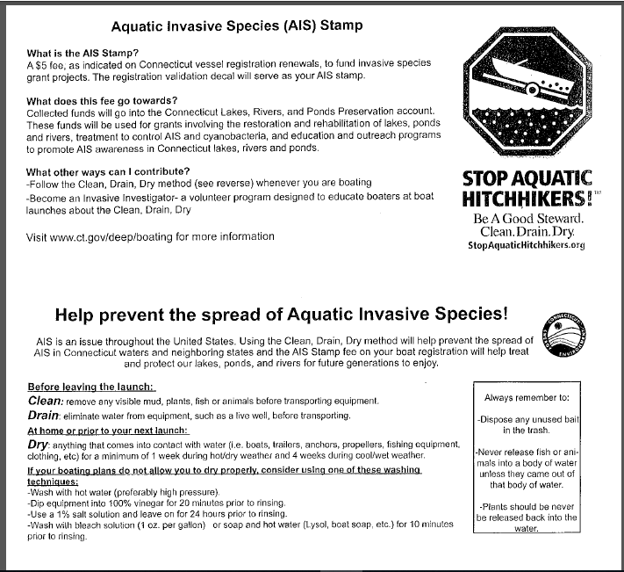
Length/feet | Fiberglass,  metal, etc.  Hull | Wood  Hull 15-24  Years Old | Wood Hull  25 years old  or Older
less than 12 | $7.50 | $3.75 | $1.88
12 | $11.25 | $5.63 | $2.82
13 | $15.00 | $7.50 | $3.75
14 | $18.75 | $9.38 | $4.69
15 | $22.50 | $11.25 | $5.63
16 | $30.00 | $15.00 | $7.50
17 | $37.50 | $18.75 | $9.38
18 | $45.00 | $22.50 | $11.25
19 | $52.50 | $26.25 | $13.13
20 | $60.00 | $30.00 | $15.00
21 | $67.50 | $33.75 | $16.88
22 | $75.00 | $37.50 | $18.75
23 | $82.50 | $41.25 | $20.63
24 | $90.00 | $45.00 | $22.50
25 | $97.50 | $48.75 | $24.38
26 | $105.00 | $52.50 | $26.25
27 | $112.50 | $56.25 | $28.13
28 | $120.00 | $60.00 | $30.00
29 | $127.50 | $63.75 | $31.88
30 | $135.00 | $67.50 | $33.75
31 | $142.50 | $71.25 | $35.63
32 | $150.00 | $75.00 | $37.50
33 | $157.50 | $78.75 | $39.38
34 | $165.00 | $82.50 | $41.25
35 | $172.50 | $86.25 | $43.13
36 | $180.00 | $90.00 | $45.00
37 | $202.50 | $101.25 | $50.63
38 | $225.00 | $112.50 | $56.25
39 | $247.50 | $123.75 | $61.88
40 | $270.00 | $135.00 | $67.50
41 | $292.50 | $146.25 | $73.13
42 | $315.00 | $157.50 | $78.75
43 | $322.50 | $161.25 | $80.63
44 | $330.00 | $165.00 | $82.50
45 | $337.50 | $168.75 | $84.38
46 | $345.00 | $172.50 | $86.25
47 | $352.50 | $176.25 | $88.13
48 | $360.00 | $180.00 | $90.00
49 | $367.50 | $183.75 | $91.88
50 | $375.00 | $187.50 | $93.75
51 | $382.50 | $191.25 | $95.63
52 | $390.00 | $195.00 | $97.50
53 | $397.50 | $198.75 | $99.38
54 | $405.00 | $202.50 | $101.25
55 | $412.50 | $206.25 | $103.13
56 | $420.00 | $210.00 | $105.00
57 | $427.50 | $213.75 | $106.88
58 | $435.00 | $217.50 | $108.75
59 | $442.50 | $221.25 | $110.63
60 | $450.00 | $225.00 | $112.50
61 | $457.50 | $228.75 | $114.38
62 | $465.00 | $232.50 | $116.25
63 | $472.50 | $236.25 | $118.13
64 | $480.00 | $240.00 | $120.00
65 & over | $525.00 | $262.50 | $131.25

Exceptions to Fees:

- Wooden Boats - Hull construction of wood:
  - 15-24 years old--fees obtained from column 2 (see chart)
  - 25 years and older--fees obtained from column 3 (see chart)
- Length less than 15 feet powered by motor less than 15 HP - $7.50
- Canoe - $7.50
- Pontoon (not houseboat) $40.00
* Commercial Fishing - Fee not to exceed $25.00 if boat is used principally for purpose of Commercial Fishing, if 50% of the owner’s adjusted gross income in the preceding tax year was obtained from Commercial Fishing. Commercial Fishing Affidavit (B-229) and a copy of approved valid OR256 or R654 (Or Farmers Tax Exemption Permit) is needed for original issue. OR256 or R654 (Or Farmers Tax Exemption Permit) obtained from and approved by the Department of Revenue Services. A Commercial Fishing Affidavit (B-229) is needed for all renewals. Computed fee based on the length of boat as usual and compare with $25.00. If computed fee is LESS than $25.00, charge computed fee. If computed fee is $25.00 or more, charge $25.00.
- * Non-profit organization - $7.50 regardless of length, year or material
  - A new application requires a Cert-119 obtained from DRS and a Letter of Determination from the Federal Government. A renewal requires an Exemption # if the organization was established prior to 1996, otherwise Letter of Determination is required.
- * Flotilla – no fee. No more than 2 vessels owned by any flotilla of the Coast Guard Auxiliary or Non-Profit Corporation acting on behalf of such Flotilla.
- * Educational – no fee. Any vessel built by students in an educational institution and used for educational or research purposes (must be registered in the name of the educational institution).
- * Operational Exemption Re: US Coast Guard Auxiliary
* If vessel is used in not less than three separate operational activities of the USCGA, the owner shall not be allowed an exemption of the applicable vessel
registration fee up to $180. The owner shall be required to pay the amount in excess of $180. To qualify for this exemption, the application for registration must be accompanied by a statement, certified by an officer of the USCG, that in the preceding year such vessel was used in not less than three separate operational activities of the USCGA.

* These may only be processed by the DMV

Other Fees
- *Change type from Certificate of Number to Certificate of Decal (CT # to US #) - $3
- *Change type from Certificate of Decal to Certificate of Number (US # to CT #) - $3
- Duplicate Registration - $20

State Agencies
State agencies do not pay registration fees when registering a vessel.

Municipalities

Towns are not required to register as long as the name of the town appears , on the sides of the vessel. If a town wishes to register a vessel full fee is due.
(they are not exempt from paying the registration fee

Expiration Date
Expiration date on all vessels is April 30. Vessels registered after January 1 will expire April 30 of the following calendar year.

Vessel Registration
A vessel registration consists of a Certificate of Number or Certificate of Decal and the registration certificate that must be carried on the vessel at all times when underway. A set of registration decals must be displayed on either side of the bow to the right of the vessel # or OOS decal.

Lost / Stolen stickers
Customers having lost or stolen stickers should proceed to their local DMV branch office with their current registration to obtain replacement stickers.

Cancellation
The owner of a vessel shall notify the Commissioner of Motor Vehicles within fifteen (15) days of sale, transfer, theft, loss, destruction or abandonment and provide information as to the fate of the vessel including to whom it was transferred. Such notification shall be in writing and shall include the Certificate of Number or Certificate of Decal if available.

Address Change
The owner of a registered vessel shall notify the Commissioner of Motor Vehicles of an address change within 48 hours. The Change of Address form (B-58) is available for download at the DMV website ct.gov/dmv.

When submitting the registration application for a customer, if their address on their driver’s license does not match the application, please have them fill in a B-58. We are only allowed to use the address on file, and if it is incorrect it will delay the processing of the registration as we have to request additional documents from the dealer.

Registration Requirements

- Acceptable Proof of Ownership for Vessels
  - Certificate of Origin from the Manufacturer
    - Similar to a certificate of origin for a vehicle;
    - Ownership must be assigned as the vessel is to be registered;
  - Title
    - Ownership must be assigned as the vessel is to be registered;
  - OOS Registration AND Letter from the state declaring they do not title vessels
    - The registration certificate must be in the same name of the registered owner. A name cannot be added or dropped without a bill of sale / Q-1V;
  - CT Registration
  - Certificate of Documentation
    - The documentation and the application must be in the same name;
    - The document must be current;
  - USCG Deletion Letter (Blue Letter) – when a person “cancels” their documentation they receive this letter
  - Notice of Assumed Ownership issued by DEEP

**** These must be accompanied by an assignment of ownership from the Last Registered Owner (LRO). This can be on the back of the MCO or Title or on a Q-1V or similar document.
*** Assignments must be original documents – photocopies are NOT acceptable

** All owners of a vessel MUST sign to transfer ownership

If the vessel is a model year 2017 or newer you will process for a Title and Registration transaction.

If the model year is 2016 or older you will apply for a registration only.

If the customer had a previous vessel registered in CT with time left on their registration period, they may use the remainder of the equity towards their new registration for the cost of $1. and any other applicable fees. The vessel registration in which the equity credit is coming from must be in the same name, and be canceled before the transfer.

- Sales Tax

- CT dealers are required to complete the AUTHORIZED DEALER OR
RETAILER section including signature and sales tax permit #
b. The FOR SALES BY DEALER OR RETAILER OF VESSELS also needs to be completed
c. If you have any specific questions related to sales tax, please contact
CT Department of Revenue Services

- Compliance
  - All owners listed must have clear property taxes in order to register a vessel
  - Registration Privilege Suspension will hold up a vessel registration
  - Insurance compliance & parking violations do not hold up a vessel registration
- Voiding / Correcting Assignments
  - All assignments must be clear and unaltered
  - Cross out wrong assignment section with a single line and/or the word VOID
    - NOTE: this applies to any assignment that is wrong, misspelled, written over, crossed out, whited out or otherwise changed
  - A correction letter must be included indicating the error
  - Provide a clear unaltered assignment
    - If there is an open space on the title or MSO, this space may be used
    - Otherwise use a Q-1V

Processing Applications for Vessel Registration

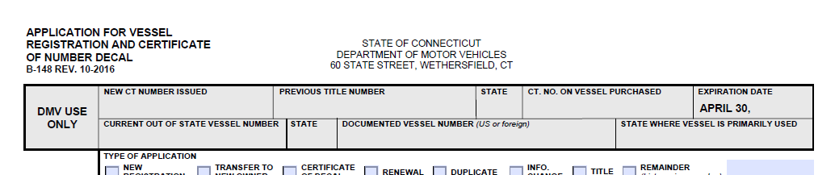
Completing the B-148 Application for Vessel Registration and Certificate of Number Decal
When assigning a NEW CT# to a vessel –
write the # here

When registering a used boat with an existing CT # -
write the # here
When writing the CT # on the application – do not write it here

The CT # the boat must be written on the top of the application. As an agent of the DMV, you must complete the top section -” DMV USE ONLY”
- Enter a new number issued in the NEW CT NUMBER ISSUED box
- Enter an existing CT # in the CT NO ON VESSEL PURCHACED box
- If the vessel was registered OOS, enter the CURRENT OUT OF STATE VESSEL NUMBER & STATE
- If the vessel has a title, enter the title # & state issuing the title in the PREVIOUS TITLE NUMBER & STATE boxes
- If the vessel is documented with the Coast Guard, enter the DOCUMENTED VESSEL NUMBER in the box
  - If it is no longer using the US #, this is not needed
- Enter the year of the EXPIRATION DATE
- Enter the STATE WHERE VESSEL IS PRIMARILY USED (usually this will be CT)
Type of Application
- New Registration – check when assigning a new CT# (vessel never registered in CT)
- Transfer to New Owner – check this when applying for a registration of a vessel with a previous CT#

Name of Owner
- Print the name(s) of all owners (Last, First, Middle)
- Full legal name
- This should match their ID
Owner’s CT Operator’s (Driver’s) License.No.
- Print applicant’s license #
- If OOS # indicate state following #
Owner’s Sex
  - Check M(ale) or F(emale)
- Companies will leave this blank
- Companies will leave this blank
Address of Owner
- Print applicant’s address (mailing)
Owner’s Date of Birth
- Print applicant’s DOB
- Companies will leave this blank
Citizenship
  - Check US or Other
  - Companies will leave this blank
Name of Co-Owner, Co-Owner’s Date of Birth, Co-Owner’s CT Operator’s Lic. No.
- Fill in the same way as the primary owner
All vessels are required to have a “AND/COMMON” conjunction as all owners are required to sign all documents to transfer ownership of a vessel. This applies to all vessels.
Owner’s residence
- Fill this in if the applicant has a different resident address from above
Length of Vessel
List total length of vessel horizontally from the foremost point of the bow to the aft most part of the stern, including swim platforms but excluding bowsprits, bumpkins, rudders, outboard motor brackets and similar fittings & attachments,

as reported on the manufacturer’s certificate of origin or builder’s certificate for the subject vessel; or absent such certificate of origin or builder’s certificate, as reported on a current or expired certificate of number or certificate of documentation for the subject vessel issued by a governmental agency; or absent such certificate of origin, certificate of number, builder’s certificate or certificate of documentation, as measured by the owner.”

Horsepower
- Whole numbers only; for electric motors use 5 hp
Principle Hull Material
- Be specific, the updated application has several choices
Model Year, Make & Model
Fuel Type
- If OTHER, be sure to indicate type – be specific
Hull Identification Number (HIN)
- Vessels constructed 1973 or later are required to have a HIN. Failure to include the HIN will result in rejection.
- HINs are typically 12-14 digits
Primary & Secondary Color of Hull

- Amethyst
- Beige
- Black
- Blue
- Brown
- Camouflage
- Cream
- Gold
- Gray
- Green
- Maroon
- Orange
- Pink
- Red
- Silver
- Tan
- Teal
- Unknown
- White
- Wood
- Yellow

Propulsion
  - Choose the option best suited to the vessel
Use
  - Charter Fishing
  - Commercial Fishing
  - Commercial Passenger Carrying
  - Livery
  - Other Commercial Operation
  - Pleasure

Lienholder Financing Vessel Purchase for Current Owner
- If there is a lienholder on the vessel, please list it here
- Be sure to fill in Date of Lien as well
Signature(s) of Owner(s) or Authorized Agent
- If more than one owner, all signatures are required
- If company, be sure agent lists title

Seller Information
- Dealer must print name & address
- Authorized representative of the dealer must sign
- New or Used must be marked
- Purchase date must be completed
This is very important & quite often forgotten
Name of Last Registered Owner
Name of last registered owner should be completed

For Sales by Dealer or Retailer of Vessels
- Section must be completed, showing Purchase Price, Trade in Value (if applicable), Net Price and amount of Sales Tax Collected
- If there was a trade-in, the Year, Make, Model & HIN must be listed in the Trade-In Information section.
Authorized Dealer or Retailer
- Section must be completed, showing Dealer Name, Authorization # (issued by Marine Vessel Unit not a N, U or V #), CT sales tax #, and signature of agent of the dealer
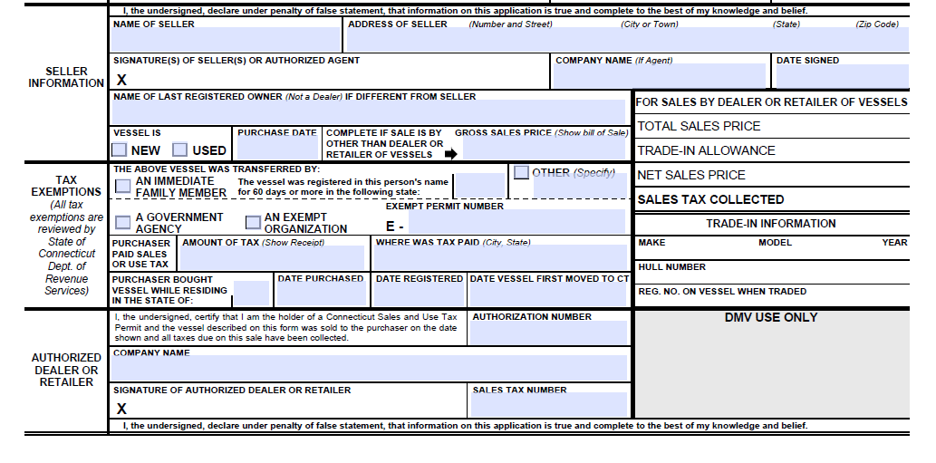
** Please be sure to fill in all sections completely so that we may efficiently and accurately complete the customer’s registration **

MSDs (Marine Sanitation Devices)

Approved MSDs: There are three different types of MSDs that can be certified by the U.S. Coast Guard to meet the requirements in 33 CFR Part 159, each having its own design, certification, and discharge criteria. For more information, see 33 CFR 159.53.
- Type I is a flow through discharge device that produces effluent having a fecal coliform bacteria count not greater than 1,000 per 100 milliliters and no visible floating solids. This type of device is typically a physical/chemical based system that relies on maceration and chlorination. Type I MSDs are issued a Certificate of Approval.
- Type II is a flow through discharge device that produces effluent having a fecal coliform bacteria count not greater than 200 per 100 milliliters and suspended solids not greater than 150 milligrams per liter. This type of device is typically a biological or aerobic digestion based system.
- Type III is a device that prevents the overboard discharge of treated or untreated sewage or any waste derived from sewage. This type of device is typically a holding tank and may include other types of technology including incineration, recirculation, and composting.

VESSEL ATTRIBUTES

Boat Type:

Airboat
Auxiliary Sail
Cabin Motorboat
Canoe
Houseboat
Inflatable
Open Motorboat
Other
Paddlecraft
Personal Watercraft
Pontoon
Rowboat
Sail Only

Hull Material:

Aluminum
Fiberglass
Other
Plastic
Rubber/Vinyl/Canvas
Steel
Wood

Propulsion Type

Air Thrust
Manual
Other
Propeller
Sail
Water Jet

Engine Type

Inboard
Other
Outboard
Pod drive
Stern Drive

Boat motor / propulsion examples

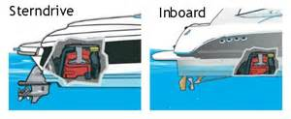
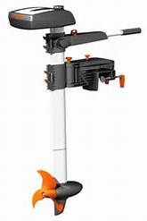
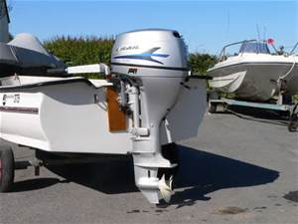
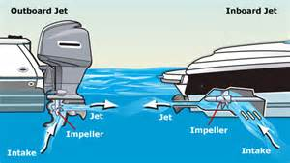
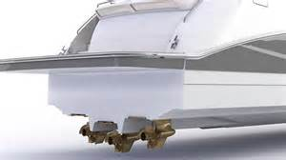
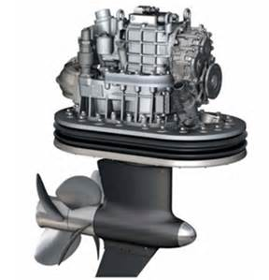
Title Issuing States
Inboard engine w/
Stern Drive (engine type)

In Board (engine type)
Propeller (propulsion)
Outboard (engine type)

Trolling motor
Propeller (propulsion)

Jet Outboard
(propulsion = Water jet
engine type = Outboard)
Jet Inboard
(propulsion = Water jet
engine type = Inboard)
Inboard engine w/
Pod Drive (engine type)

Pod Drives in use

STATE | VESSELS |  | STATE | VESSELS
Alabama | N |  | Missouri | Y
Alaska | N |  | Montana | Y
Arizona | N |  | Nebraska | Motorboats
Arkansas | N |  | Nevada | Y
California | Y |  | New Hampshire | N
Colorado | N |  | New Jersey | 12 ft. +
Connecticut | 2017 & newer * |  | New Mexico | 10 ft. +
Delaware | N |  | New York | 1987 & newer
District of Columbia | Y |  | North Carolina | Y
Florida | Y |  | North Dakota | N
Georgia | N |  | Ohio | Y
Hawaii | N |  | Oklahoma | Y
Idaho | Y |  | Oregon | Y
Illinois | Y |  | Pennsylvania | 1997 & newer
Indiana | Y |  | Rhode Island | 15 ft +
Iowa | 17 ft + |  | South Carolina | Y
Kansas | N |  | South Dakota | Y
Kentucky | Y |  | Tennessee | N
Louisiana | N |  | Texas | Y
Maine | N |  | Utah | 1985 & newer
Maryland | Y |  | Vermont | 15 years & newer
Massachusetts | 14’ + |  | Virginia | Y
Michigan | Y |  | Washington | 16 ft. +
Minnesota | Y |  | West Virginia | Motorboats
Mississippi | Optional |  | Wisconsin | 16 ft. +
 |  |  | Wyoming | Motorboats

Chapter 8 ENFORCEMENT

VIOLATIONS/ENFORCEMENT:

POLICY OF VIOLATIONS

The major violations on the OLRS System are:

- Submission of documents over the ten (10) DMV business day statutory requirement (14-63-32)
- Shortage and/or overage of documents and missing registration certificates
- Improper Title assignments or documents
- Emissions/Inspection reports omitted or inspection fees not paid
- Missing/misuse of DMV Inventory (Marker plates) – Fine assessed
- Plating of vehicles prior to registration
- Voiding (within 24 hours at dealership) or the Withdrawal of a registration for a vehicle that has left the dealer lot

- The dealership must remain in good standing with the Department at all times. This includes the dealership’s compliance with all applicable laws and Departmental policies, including, but not limited to, all requirements regarding insurance, bonding, complaints, personnel, franchises, submission of original paperwork, etc.

- Within ten (10) business days of the date on which each transaction is processed online, the dealership agrees to submit all original paperwork to the Department’s CORE Customer Operations Unit.

- The Department may conduct, as it deems necessary, an audit/investigation of any transactions, material(s) or information relating to the dealership’s online registration privileges/practices.

- Violations of ORP requirements, Skip List procedures and/or Suspense Case procedures, may result in the loss of online registration privileges.

- If the dealership’s online registration privileges are suspended and/or revoked, if it seeks to have its privileges restored, upon request, the Department’s Compliance Unit will review the dealership’s current standing with the Department prior to making a final determination regarding such restoration.

MONITORING:
The Department of Motor Vehicles may make unannounced, unscheduled visits for educational and/or monitoring purposes at any location which maintains Department of Motor Vehicles materials or records pertaining to the registrations.

Upon review of the licensed facility the Department of Motor Vehicles may suspend OLRS privileges if procedures are not adhered to as specified.

Chapter 9 MISCELLANEOUS INFORMATION

DEPARTMENT OF REVENUE SERVICE 25 SIGOURNEY STREET
HARTFORD, CT 06106 PHONE: 1-800-382-9463 (IN STATE)
PHONE: 860-541-7544

SALES TAX/CAR DEALERS:
When a new vehicle (Certificate of Origin only) or used car is sold by a car dealer the car dealer must:
- Have a sales tax permit issued by Department of Revenue Services
- Be licensed with the Department Motor Vehicles
- New Car Dealers must be franchised to sell that car.
- When sales tax is collected by the dealer; the dealer is responsible for reporting this to the Department of Revenue Services.

VEHICLE BEING REGISTERED TO CAR DEALER:
If a car dealer is registering a vehicle to themselves the 6.35% tax will be collected at DMV based on the average retail value.

CHARITABLE & RELIGIOUS ORGANIZATIONS AND CLERGY:
Please contact the Department of Revenue Services regarding the above subject for the proper procedures.

FEDERAL, STATE, LOCAL MUNICIPALITIES & POLITICAL SUBDIVISIONS:
Connecticut General Statutes provides for an exemption on all purchases of tangible personal property by Federal, State or any Political Subdivision.
There are no additional requirements, other than to confirm the identity of the transferee. This exemption qualifies on name only.

MILITARY PERSONNEL- Registrations for military personnel must be processed in a DMV branch office.

Nonresident Military Personnel which are stationed in Connecticut:
Connecticut General Statutes provide for a reduced rate of 4.5% sales tax of the gross receipt when purchased as a retail sale of any motor vehicle to any person who is a member of the armed forces of the United States and is on full-time active duty in Connecticut, but whose permanent residence is in another state. All registration and title fees DO apply.
Sales and Use Tax Reduction for Non-resident Military Personnel -Members of the United States armed forces on full-time active duty in Connecticut who are residents of another state may purchase motor vehicles from a licensed Connecticut dealer at a reduced

sales tax rate of 4.5%. Purchases can also be made jointly with a spouse. Department of Revenue Services (DRS) form CERT-135 must be completed and submitted to the Connecticut dealer with other required documentation as mentioned on the CERT-135 form.
If the military member purchases a vehicle from an out-of-state dealer the CERT-135 form and other required documents must be submitted to the DMV at the time of registration.

NOTE: The reduction in the sales tax is not applicable to personnel who are called to active duty for a portion of a year, such as National Guardsmen or Reservists.

An exemption is provided for certain Connecticut military personnel. The military personnel must be stationed outside the State of Connecticut when registering the vehicle at DMV.
Two statements are required:
- A statement from military personnel’s commanding officer, giving present location and the anticipated date of discharge is not for at least six months, and
- A statement from the military personnel stating that the vehicle is not intended to be used in Connecticut unless on authorized leave.
- Military personal are exempt from New Issue Plate fees, Clean Air Act fees and Safety Plate fees. If transfer, military personnel pay full fees.
*** A vehicle purchased in Connecticut by a Military Member whose home of record is Connecticut is taxable at a rate of 6.35% of the purchase price.

SALES TAX INFORMATION:
- Leasing or Rental requires a Connecticut Sales Tax Permit Number issued by Department of Revenue Services.
- Non-Resident Service Personnel (including Military Academy and Coast Guard Cadets) taxable at 4.5%.
- Sales tax on Vessels and Boat trailers will be accessed at 2.99%

SALES TAX INCREASES

EFFECTIVE JULY 1, 2011:
The Connecticut State Sales and Use tax increased to 6.35%.
The rental of passenger motor vehicles for 30 days or less is subject to a 9.35% sales tax.

EFFECTIVE JULY 1, 2015:
The sales of motor vehicles with a sale price exceeding fifty thousand dollars ($50,000) are subject to a sales tax rate of 7.75% (“Luxury Tax”).

**Qualifying sales to Military Personnel will remain taxable at 4.5% regardless of the sales price. **

Sales Tax Q & A

  - If a dealer purchases a vehicle from another dealer, places a dealer plate on the vehicle and applies for a title, are they subject to sales tax?

Yes, if the dealer is titling the vehicle in their name there is tax due, unless they are purchasing the motor vehicle exclusively for leasing purposes. If they are they would present a resale certificate.

  - Dealer invoice fees? Can you give us a list of fees that are taxable and what is not taxable?

    - Cap Cost Reduction – Not Taxable
    - Conveyance fees/Document Fee – Taxable
    - Credit Life Insurance – Not Taxable
    - Dealer Discount – Not Taxable
    - Disability Insurance – Not Taxable
    - Etching – Taxable
    - Extended warranty contracts – Taxable (even if the vehicle is exempt)
    - Fabric guard – Taxable
    - Gap insurance – if optional – Not taxable; if mandatory – Taxable
    - Luxury Tax (if stated separately) – Not taxable
    - Manufacturer rebates applied to the sale of the vehicle – Taxable
    - Paint Sealant – Taxable
- Rebates – Taxable
  - You will have to verify if the rebate amount is part of the selling price of the vehicle. If the rebate has not been deducted from the vehicle sale price, then you would not tax the rebate separately.
- Registration & Title Fees – Not Taxable
- Rollovers (rolling over of a loan to a new vehicle) – Not taxable
- Rust proofing – Taxable Payoffs – Not taxable
- Service warranties – Taxable (if purchased at the time of the motor vehicle)
- Trade-ins* - Not taxable
- VIN etching – Taxable

*Trade-ins are not taxable as long as they are in the same name as the purchaser.

  - How many trade-ins can be used to get a tax reduction when buying a car from a dealer?

There is no limit, but the vehicles must be titled in the name of the purchaser to reduce the taxable value.

  - How do we know if a purchase made out-of-state should be taxed again when registered in CT? (i.e.; new vehicle purchased at dealer in Michigan, tax collected by Michigan dealer, brought to CT for 1st time registration) Do we charge sales tax?

Taxes paid on sales made by Rhode Island and Massachusetts dealerships should be accepted. Sales from a New York or New Hampshire should be taxed unless the dealer entered a CT tax registration number on the H-13.

Tax exempt if the owner had the vehicle registered out-of-state for at least 60 days as an out-of-state resident (taxable if purchased using a CT address)

  - Taxes collected by an out of state dealer – who gets credit and who does not?

As a general rule we will allow credit for sales tax paid to a dealer who was required to collect tax for another state.

  - What is the rule of thumb for vehicles won in a raffle?

If the vehicle was signed over from a dealer to a tax-exempt organization that is conducting the raffle (i.e.; Foxwoods, St Mary’s Church, etc.) and then to the winner, the transaction is exempt from tax.

If the vehicle was signed over from the dealer to a taxable raffle holder (i.e.; United Technologies, Dicks Sporting Goods, etc.) and then to the winner, tax would be charged on the value of the vehicle unless a receipt showing CT taxes paid can be shown. If so, tax would only be charged on the price of the raffle ticket.

If the vehicle was signed over directly from the dealer to the raffle winner, tax is charged on the purchase invoice price.
For Further Information: Call DRS during business hours, Monday through Friday:

- 1-800-382-9463 (Ct. calls outside the Greater Hartford calling area only); or

• 860-541-7544

Forms and Publications: Visit the DRS website at www.ct.gov/DRS

CHANGE OF NAME BY MARRIAGE/DIVORCE:

Whenever a legal change of name occurs, the customer must first go to DMV and change their drivers’ license to read their new legal name before a registration and title can be processed On-Line in the new name.
A change of name by marriage or divorce cannot be processed On-Line. The name and date of birth on the Application for Registration and Certificate of Title must be the same as on the identification presented.

APPLICANT ADDRESS:
A Post Office Box is acceptable as a MAILING address only. The Connecticut resident address and tax town (domicile address), where the vehicle will be garaged for longest period during coming year”, must be listed. An incorrect tax town will result in the vehicle being taxed in the wrong town. Please be sure to inquire as to where the vehicle is “garaged overnight”, this should be the tax town entered On-Line.

NOTE: The OLRS will not allow modifications to the owner’s name, address and related fields on any transaction.

REFUND POLICY:
Refunds will not be processed for any On-Line Registration System issues.

REGISTRATION TO A MINOR:
This type of transaction will need to be walked through to a local DMV office using the form 2D.

IMPORTANT: Issuance of a registration to a minor without a Form 2-D will be addressed administratively.

CONNECTICUT INSURANCE CARD (C.G.S.14-12b):
Connecticut law requires all registered owners to maintain Liability Insurance for their vehicles. Insurance must be maintained at all times when there is an active registration on a vehicle.
Registrants are required to submit a NEW Connecticut Insurance Identification Card upon registration for both New Issue and Transfer Registrations.
The following must appear on the Connecticut Insurance Identification Card:

- Issued Pursuant to Connecticut Law
- Applicants Name: Husband & Wife: Insurance Card can be in one name only
Leasing company: Leasing Company must have a valid blanket policy on file with DMV
Parent & Child: Insurance Card can be in one name only
- New vehicle being registered, complete vehicle information, New Issue or Transfer Registration
- Policy number
- Effective date must be the same or before the issue date of the New Issue or Transfer Registration.
- Name of Insurance Company
- Insurance Cards/Civil Union: An insurance card in one name only is acceptable for a person who has been joined in Civil Union. Documentation must be submitted that a Civil Union was performed.
A Temporary Insurance Card: Valid for 60 days from the effective date
A Permanent Insurance Card: Valid for one (1) year from the effective date.

CORRECTION AFTER TITLE ISSUANCE

For Title Only Transactions –
When a vehicle is registered in the online system it is has PERMANENT registration and title assigned to it. The proper fee and a completed H13 must be sent to Title Unit for any correction.

Corrections after title issuance are processed differently than error corrections processed prior to title issuance. After a title has been issued, all errors are required to be processed as ownership transfers. These transactions are not dealer transactions (dealer section is not to be completed on the H-13) the dealer is only acting as the agent for these transactions. Example of common errors: Loan agreements not matching the current registration and title, the lease company’s name isn’t the name the lease company wanted i.e. Nissan Infiniti LT vs. NILT Inc., the customer wanted to add or drop a name on the new vehicle. These errors cannot be corrected by going back to the original application; once it has been completed and processed a new registration and title have to be applied for. The documents needed to process these transactions are as follows:

  - Application form H-13 must be completed in full (see below)
    - Odometer Reading: must be the current mileage
    - Seller: must be the name listed on the current title
    - Dealer section: must NOT be completed
    - New or Used: must be “used” **

  - Outstanding certificate of title properly assigned from seller (the name that appears on the front of the title) to buyer (how the vehicle should be registered and titled.)

  - A letter of Lien Release for Lien correction (if applicable)

  - A current Connecticut Insurance Card in the name of the applicants(s).

  - Photocopies of the current applicant’s driver license.

  - The proper fees for a record transfer, title, and lien fees (if applicable.)

  - A power of attorney is needed if the lien holder or dealer is signing paperwork for applicant, accompanied by that person’s photo ID.

  - A photocopy of the current registration.

Please mail these transactions to: Department of Motor Vehicles
60 State Street
Wethersfield, CT 06161
Attn: Specialized Registry Services
If you have any questions regarding this type of transaction, please contact the DMV Customer Contact Center (860) 263-5708.

** In order to keep the vehicle listed as “New” a letter from the dealer, on dealer letterhead, must be submitted within six months from the title issuance date. The letter must state that the lien holder/lease company has requested a new title because it was registered and titled incorrectly**

TAX TOWN CODES

Address Town | Tax Town Code | Tax Town Name | Address Town | Tax Town Code | Tax Town Name
ABINGTON | 112 | POMFRET | CENTERVILLE | 091 | NEW FAIRFIELD
ADDISON | 054 | GLASTONBURY | CENTRAL VILL | 109 | PLAINFIELD
ALLINGTOWN | 156 | WEST HAVEN | CHAFFEE VILLE | 078 | MANSFIELD
AMESVILLE | 122 | SALISBURY | CHAPLIN | 024 | CHAPLIN
AMSTON | 067 | HEBRON | CHESHIRE | 025 | CHESHIRE
AMSTON LAKE | 067 | HEBRON | CHESHIRE HGTS | 025 | CHESHIRE
ANDOVER | 001 | ANDOVER | CHESTER | 026 | CHESTER
ANDOVER CENTER | 001 | ANDOVER | CHESTERFIELD | 086 | MONTVILLE
ANDOVER LAKE | 001 | ANDOVER | CHESTNUT HILL | 030 | COLUMBIA
ANSONIA | 002 | ANSONIA | CLARKS FALLS | 102 | NORTH STONINGTON
ASHFORD | 003 | ASHFORD | CLARKSVILLE | 137 | STONINGTON
ATTAWAUGAN | 069 | KILLINGLY | CLINTON | 027 | CLINTON
AVON | 004 | AVON | CLINTONVILLE | 101 | NORTH HAVEN
BAKERSVILLE | 092 | NEW HARTFORD | COBALT | 042 | EAST HAMPTON
BALLOUVILLE | 069 | KILLINGLY | COLCHESTER | 028 | COLCHESTER
BALTIC | 133 | SPRAGUE | COLEBRK CNTR | 029 | COLEBROOK
BANKSVILLE | 057 | GREENWICH | COLEBROOK | 029 | COLEBROOK
BANTAM | 074 | LITCHFIELD | COLEBROOK RVR | 029 | COLEBROOK
BARKHAMSTED | 005 | BARKHAMSTED | COLLINSVILLE | 023 | CANTON
BEACON FALLS | 006 | BEACON FALLS | COLUMBIA | 030 | COLUMBIA
BECKLEY | 007 | BERLIN | CONANTVILLE | 078 | MANSFIELD
BELLEHAVEN | 057 | GREENWICH | CORNWALL | 031 | CORNWALL
BELL TOWN | 135 | STAMFORD | CORNWALL BRDG | 031 | CORNWALL
BERLIN | 007 | BERLIN | CORNWALL HLW | 031 | CORNWALL
BETHANY | 008 | BETHANY | CORNWALL PLN | 031 | CORNWALL
BETHEL | 009 | BETHEL | COS COB | 057 | GREENWICH
BETHLEHEM | 010 | BETHLEHEM | COVENTRY | 032 | COVENTRY
BLACK HALL | 105 | OLD LYME | CRANBURY | 103 | NORWALK
BLACK POINT | 045 | EAST LYME | CRESCENT BCH | 045 | EAST LYME
BLOOMFIELD | 011 | BLOOMFIELD | CROMWELL | 033 | CROMWELL
BOLTON | 012 | BOLTON | CRYSTAL LK | 048 | ELLINGTON
BOLTON CENTER | 012 | BOLTON | DANBURY | 034 | DANBURY
BOLTON LAKE | 012 | BOLTON | DANIELSON | 069 | KILLINGLY
BOLTON NOTCH | 012 | BOLTON | DARIEN | 035 | DARIEN
BOTSFORD | 097 | NEWTOWN | DAYVILLE | 069 | KILLINGLY
BOZRAH | 013 | BOZRAH | DEEP RIVER | 036 | DEEP RIVER
BRANCHVILLE | 118 | RIDGEFIELD | DERBY | 037 | DERBY
BRANFORD | 014 | BRANFORD | DEVON | 084 | MILFORD
BRIDGEPORT | 015 | BRIDGEPORT | DOBSONVILLE | 146 | VERNON
BRIDGEWATER | 016 | BRIDGEWATER | DURHAM | 038 | DURHAM
BRISTOL | 017 | BRISTOL | DURHAM CTR | 038 | DURHAM
BROAD BROOK | 017 | EAST WINDSOR | E BERLIN | 007 | BERLIN
BROOKFIELD | 018 | BROOKFIELD | E BRISTOL | 017 | BRISTOL
BROOKFIELD CTR | 018 | BROOKFIELD | E BROOKLYN | 019 | BROOKLYN
BROOKFIELD JCT | 018 | BROOKFIELD | E CANAAN | 100 | NORTH CANAAN
BROOKLYN | 019 | BROOKLYN | E CHESHIRE | 025 | CHESHIRE
BROOKLYN CTR | 019 | BROOKLYN | E COVENTRY | 032 | COVENTRY
BUCKINGHAM | 054 | GLASTONBURY | E DERBY | 037 | DERBY
BUCKLAND | 077 | MANCHESTER | E DEVON | 084 | MILFORD
BURLINGTON | 020 | BURLINGTON | E FARMINGTON | 052 | FARMINGTON
BURLINGTON CTR | 020 | BURLINGTON | E GLASTONBURY | 054 | GLASTONBURY
BURNSIDE | 043 | EAST HARTFORD | E GRANBY | 040 | EAST GRANBY
BURRVILLE | 143 | TORRINGTON | E HADDAM | 041 | EAST HADDAM
BYRAM | 057 | GREENWICH | E HAMPTON | 042 | EAST HAMPTON
CAMPVILLE | 066 | HARWINGTON | E HARTFORD | 043 | EAST HARTFORD
CANAAN | 021 | CANAAN | E HARTLAND | 065 | HARTLAND
CANNONDALE | 161 | WILTON | E HAVEN | 044 | EAST HAVEN
CANTERBURY | 022 | CANTERBURY | E KENT | 068 | KENT
CANTON | 023 | CANTON | E KILLINGLY | 069 | KILLINGLY
CANTON CENTER | 023 | CANTON | E LITCHFIELD | 074 | LITCHFIELD
CENTER GROTON | 059 | GROTON | E LYME | 045 | EAST LYME
CENTERBROOK | 050 | ESSEX | E MERIDEN | 080 | MERIDEN

Address Town | Tax Town Code | Tax Town Name | Address Town | Tax Town Code | Tax Town Name
E MORRIS | 087 | MORRIS | GROTON | 059 | GROTON
E NORWALK | 103 | NORWALK | GROTON LONG PT | 059 | GROTON
E PLYMOUTH | 111 | PLYMOUTH | GUILFORD | 060 | GUILFORD
E PORTCHESTER | 057 | GREENWICH | GURLEYVILLE | 078 | MANSFIELD
E PUTNAM | 116 | PUTNAM | HADDAM | 061 | HADDAM
E REDDING | 117 | REDDING | HADDAM NECK | 061 | HADDAM
E RIVER | 076 | MADISON | HADLYME | 075 | LYME
E SUFFIELD | 139 | SUFFIELD | HAMBURG | 075 | LYME
E THOMPSON | 141 | THOMPSON | HAMDEN | 062 | HAMDEN
E VILLAGE | 085 | MONROE | HAMPTON | 063 | HAMPTON
E WALLINGFORD | 148 | WALLINGFORD | HANOVERE | 133 | SPRAGUE
E WEATOGUE | 128 | SIMSBURY | HARTFORD | 064 | HARTFORD
E WILLINGTON | 160 | WILLINGTON | HARTLAND | 065 | HARTLAND
E WILSON | 164 | WINDSOR | HARWINTON | 066 | HARWINTON
E WINDSOR | 047 | EAST WINDSOR | HAWLEYVIL CTR | 097 | NEWTON
E WINDSOR HILL | 132 | SOUTH WINDSOR | HAWLEYVILLE | 097 | NEWTON
E WOODSTOCK | 169 | WOODSTOCK | HAYDEN STA | 164 | WINDSOR
EAGLEVILLE | 078 | MANSFIELD | HAZARDVILLE | 049 | ENFIELD
EASTFORD | 039 | EASTFORD | HEBRON | 067 | HEBRON
EASTON | 046 | EASTON | HIGGANUM | 061 | HADDAM
ELLINGTON | 048 | ELLINGTON | HIGH RIDGE | 135 | STAMFORD
ELM HILL | 094 | NEWINGTON | HIGHLAND PK | 077 | MANCHESTER
ELMVILLE | 069 | KILLINGLY | HIGHWOOD | 062 | HAMDEN
ELMWOOD | 155 | WEST HARTFORD | HOCKANUM | 043 | EAST HARTFORD
ENFIELD | 049 | ENFIELD | HOP RIVER | 030 | COLUMBIA
ESSEX | 050 | ESSEX | HOTCHKISS GROVE | 014 | BRANFORD
FABYAN | 141 | THOMPSON | HOTCHKISSVILLE | 168 | WOODBURY
FAIRFIELD | 051 | FAIRFIELD | HUNTINGTON | 126 | SHELTON
FAIRHAVEN | 093 | NEW HAVEN | HUNTINGTON CTR | 126 | SHELTON
FALLS VILLAGE | 021 | CANAAN | HYDEVILLE | 134 | STAFFORD
FARMINGTON | 052 | FARMINGTON | INDIAN NECK | 014 | BRANFORD
FITCHVILLE | 013 | BOZRAH | IVORYTON | 050 | ESSEX
FLANDERS | 045 | EAST LYME | IVORYTON HGTS | 050 | ESSEX
FLOYDVILLE | 128 | SIMSBURY | JEWETT CITY | 058 | GRISWOLD
FORESTVILLE | 017 | BRISTOL | KENSINGTON | 007 | BERLIN
FOXON | 044 | EAST HAVEN | KENT | 068 | KENT
FOXTOWN | 041 | EAST HADDAM | KILLINGLY | 069 | KILLINGLY
FRANKLIN | 053 | FRANKLIN | KILLINGLY CTR | 069 | KILLINGLY
GALES FERRY | 072 | LEDYARD | LAKE AMSTON | 067 | HEBRON
GAYLORDSVILLE | 096 | NEW MILFORD | LAKE HAYWARD | 028 | COLCHESTER
GEORGETOWN | 161 | WILTON | LAKESIDE | 087 | MORRIS
GILDERSLEEVE | 113 | PORTLAND | LAKEVILLE | 122 | SALISBURY
GILEAD | 067 | HEBRON | LEBANON | 071 | LEBANON
GILMAN | 013 | BOZRAH | LEDYARD | 072 | LEDYARD
GLASGO | 058 | GRISWOLD | LEESVILLE | 041 | EAST HADDAM
GLASTONBURY | 054 | GLASTONBURY | LETTES ISL | 060 | GUILFORD
GLENBROOK | 135 | STAMFORD | LIME ROCK | 122 | SALISBURY
GLENVILLE | 057 | GREENWICH | LISBON | 073 | LISBON
GOODYEAR | 069 | KILLINGLY | LITCHFIELD | 074 | LITCHFIELD
GOSHEN | 055 | GOSHEN | LONG HILL | 144 | TRUMBULL
GOSHEN CENTER | 055 | GOSHEN | LONG RIDGE | 135 | STAMFORD
GRANBY | 056 | GRANBY | LWR PAWCATUCK | 137 | STONINGTON
GRANITEVILLE | 152 | WATERFORD | LOWER STEPHANY | 085 | MONROE
GRASEMERE STA | 051 | FAIRFIELD | LYME | 075 | LYME
GREENFIELD HL | 051 | FAIRFIELD | MADISON | 076 | MADISON
GREENS FARMS | 158 | WESTPORT | MANCHESTER | 077 | MANCHESTER
GREENVILLE | 104 | NORWICH | MANCHESTER GRN | 077 | MANCHESTER
GREENWICH | 057 | GREENWICH | MANSFIELD | 078 | MANSFIELD
GREYSTONE | 111 | PLYMOUTH | MANSFIELD 4 CRNR | 078 | MANSFIELD
GRISWOLD | 058 | GRISWOLD | MANSFIELD CNTR | 078 | MANSFIELD
GRISWOLDVILLE | 159 | WETHERSFIELD | MANSFIELD DPT | 078 | MANSFIELD
GROSVENORDALE | 141 | THOMPSON | MANSFIELD HLW | 078 | MANSFIELD

Address Town | Tax Town Code | Tax Town Name | Address Town | Tax Town Code | Tax Town Name
MAPLE HILL | 094 | NEWINGTON | N THOMPSON | 141 | THOMPSON
MARBLEDALE | 150 | WASHINGTON | N THOMPSONVILL | 049 | ENFIELD
MARION | 131 | SOUTHINGTON | N WESTCHESTER | 028 | COLCHESTER
MARLBOROUGH | 079 | MARLBOROUGH | N WILLINGTON | 160 | WILLINGTON
MECHANICSVILLE | 141 | THOMPSON | N WILTON | 161 | WILTON
MELROSE | 047 | EAST WINDSOR | N WINDHAM | 163 | WINDHAM
MERIDEN | 080 | MERIDEN | N WINDSORVILLE | 047 | EAST WINDSOR
MERROW | 078 | MANSFIELD | N WOODBURY | 168 | WOODBURY
MIANUS | 057 | GREENWICH | N WOODSTOCK | 169 | WOODSTOCK
MIDDLE HADDAM | 042 | EAST HAMPTON | NAUGATUCK | 088 | NAUGATUCK
MIDDLEBURY | 081 | MIDDLEBURY | NEPAUG | 092 | NEW HARTFORD
MIDDLEFIELD | 082 | MIDDLEFIELD | NEW BRITAIN | 089 | NEW BRITAIN
MIDDLETOWN | 083 | MIDDLETOWN | NEW CANAAN | 090 | NEW CANAAN
MILBROOK | 057 | GREENWICH | NEW FAIRFIELD | 091 | NEW FAIRFIELD
MILFORD | 084 | MILFORD | NEW HARTFORD | 092 | NEW HARTFORD
MILLDALE | 131 | SOUTHINGTON | NEW HARTLAND | 065 | HARTLAND
MILLSTONE | 152 | WATERFORD | NEW HAVEN | 093 | NEW HAVEN
MILLVILLE | 088 | NAUGATUCK | NEW LONDON | 095 | NEW LONDON
MILTON | 074 | LITCHFIELD | NEW MILFORD | 096 | NEW MILFORD
MOMAUGUIN | 044 | EAST HAVEN | NEW PRESTON | 150 | WASHINGTON
MONROE | 085 | MONROE | NEWFIELD | 083 | MIDDLETOWN
MONROE CTR | 085 | MONROE | NEWINGTON | 094 | NEWINGTON
MOUNT CARMEL | 062 | HAMDEN | NEWINGTON CTR | 094 | NEWINGTON
MONTOWESE | 101 | NORTH HAVE | NEWINGTON JCT | 094 | NEWINGTON
MONTVILLE | 086 | MONTVILLE | NEWTOWN | 097 | NEWTOWN
MOODUS | 041 | EAST HADDAM | NIANTIC | 045 | EAST LYME
MOOREVILLE | 162 | WINCHESTER | NICHOLS | 144 | TRUMBULL
MOOSUP | 109 | PLAINFIELD | NO HAVEN | 101 | NORTH HAVEN
MORRIS | 087 | MORRIS | NOANK | 059 | GROTON
MORRIS COVE | 093 | NEW HAVEN | NORFOLK | 098 | NORFOLK
MYSTIC | 137 | STONINGTON | NOROTON | 035 | DARIEN
N ASHFORD | 039 | EASTFORD | NOROTON HGTS | 035 | DARIEN
N BLOOMFIELD | 011 | BLOOMFIELD | NORTHFIELD | 074 | LITCHFIELD
N BRANFORD | 099 | NORTH BRANFORD | NORTHFORD | 099 | NORTH BRANFORD
N CANAAN | 100 | NORTH CANAAN | NORTHVILLE | 096 | NEW MILFORD
N CANTON | 023 | CANTON | NORWALK | 103 | NORWALK
N COLCHESTER | 028 | COLCHESTER | NORWICH | 104 | NORWICH
N COLEBROOK | 029 | COLEBROOK | NORWICHTOWN | 104 | NORWICH
N COLLINSVIL | 023 | CANTON | OAKDALE | 086 | MONTVILLE
N CORNWALL | 031 | CORNWALL | OAKVILLE | 153 | WATERTOWN
N COVENTRY | 032 | COVENTRY | OCCUM | 104 | NORWICH
N CROMWELL | 033 | CROMWELL | OLD GREENWICH | 057 | GREENWICH
N FRANKLIN | 053 | FRANKLIN | OLD LYME | 105 | OLD LYME
N GRANBY | 056 | GRANBY | OLD MYSTIC | 137 | STONINGTON
N GREENWICH | 057 | GREENWICH | OLD SAYBROOK | 106 | OLD SAYBROOK
N GROSVNORDLE | 141 | THOMPSON | ONECO | 136 | STERLING
N GUILFORD | 060 | GUILFORD | ORANGE | 107 | ORANGE
N KENT | 068 | KENT | ORCUTTVILLE | 134 | STAFFORD
N LYME | 075 | LYME | ORONOQUE | 138 | STRATFORD
N MADISON | 076 | MADISON | OSWEGATCHIE | 152 | WATERFORD
N MANCHESTER | 077 | MANCHESTER | OXFORD | 108 | OXFORD
N MIANUS | 057 | GREENWICH | OXFORD CENTER | 108 | OCFORD
N MOODUS | 041 | EAST HADDAM | PACHAUG | 058 | GRISWOLD
N NEWINGTON | 094 | NEWINGTON | PACKER | 022 | CANTERBURY
N NORWALK | 103 | NORWALK | PACKERSVILLE | 022 | CANTERBURY
N PLAIN | 041 | EAST HADDAM | PAWCATUCK | 137 | STONINGTON
N PLYMOUTH | 111 | PLYMOUTH | PEMBERWICK | 057 | GREENWICH
N RIDGEFIELD | 118 | RIDGEFIELD | PEQUABUCK | 111 | PLYMOUTH
N SOMERS | 129 | SOMERS | PHOENIXVILLE | 039 | EASTFORD
N STAMFORD | 135 | STAMFORD | PINE MEADOW | 092 | NEW HARTFORD
N STERLING | 136 | STERLING | PLAINFIELD | 109 | PLAINFIELD
N STONINGTON | 102 | N STONINGTON | PLAINVILLE | 110 | PLAINVILLE

Address Town | Tax Town Code | Tax Town Name | Address Town | Tax Town Code | Tax Town Name
PLANTSVILLE | 131 | SOUTHINGTON | S WINDSOR | 132 | SOUTH WINDSOR
PLEASANT VAL | 005 | BARKHAMSTED | S WOODSTOCK | 169 | WOODSTOCK
PLYMOUTH | 111 | PLYMOUTH | SACHEMS HEAD | 060 | GUILFORD
POMFRET | 112 | POMFRET | SALEM | 121 | SALEM
POMFRET CTR | 112 | POMFRET | SALISBURY | 122 | SALISBURY
POMFRET LNDG | 112 | POMFRET | SANDY HILL | 081 | MIDDLEBURY
POQUETANUCK | 114 | PRESTON | SANDY HOOK | 097 | NEWTOWN
POQUONOCK | 164 | WINDSOR | SAUGATUCK | 156 | WEST HAVEN
POQUONOCK BDG | 059 | GROTON | SAYBROOK MANOR | 106 | OLD SAYBROOK
PORTLAND | 113 | PORTLAND | SAYBROOK POINT | 106 | OLD SAYBROOK
PRESTON | 114 | PRESTON | SCANTIC | 047 | EAST WINDSOR
PROSPECT | 115 | PROSPECT | SCITICO | 049 | ENFIELD
PUTNAM | 116 | PUTNAM | SCOTLAND | 123 | SCOTLAND
PUTNAM CTR | 116 | PUTNAM | SEYMOUR | 124 | SEYMOUR
PUTNAM HGTS | 116 | PUTNAM | SHARON | 125 | SHARON
PUTNEY | 138 | STRATFORD | SHARON VALLEY | 125 | SHARON
QUAKER HILL | 152 | WATERFORD | SHELTON | 126 | SHELTON
QUINEBAUG | 141 | THOMPSON | SHERMAN | 127 | SHERMAN
RAINBOW | 164 | WINDSOR | SHIPPEN POINT | 135 | STAMFORD
REDDING | 117 | REDDING | SHORT BEACH | 014 | BRANFORD
REDDING CTR | 117 | REDDING | SILVERMINE | 103 | NORWALK
REDDING RDGE | 117 | REDDING | SIMSBURY | 128 | SIMSBURY
REYNOLDS BRDG | 140 | THOMASTON | SOMERS | 129 | SOMERS
RIDGEBURY | 034 | DANBURY | SOMERSVILLE | 129 | SOMERS
RIDGEBURY CTR | 034 | DANBURY | SOUND VIEW | 105 | OLD LYME
RIDGEFIELD | 118 | RIDGEFIELD | SOUTHBURY | 130 | SOUTHBURY
RIVERSIDE | 057 | GREENWICH | SOUTHFORD | 130 | SOUTHBURY
RIVERSVILLE | 057 | GREENWICH | SOUTHINGTON | 131 | SOUTHINGTON
RIVERTON | 005 | BARKHAMSTED | SOUTHPORT | 051 | FAIRFIELD
ROBERTSVILLE | 029 | COLEBROOK | SPRAGUE | 133 | SPRAGUE
ROCKFALL | 082 | MIDDLEFIELD | SPRING GLEN | 093 | NEW HAVEN
ROCKLAND | 076 | MADISON | SPRINGDALE | 135 | STAMFORD
ROCKVILLE | 146 | VERNON | STAFFORD HLW | 134 | STAFFORD
ROCKY HILL | 119 | ROCKY HILL | STAFFORD SPRNGS | 134 | STAFFORD
ROGERS | 069 | KILLINGLY | STAFFORD | 134 | STAFFORD
ROUND HILL | 057 | GREENWICH | STAFFORDVILLE | 134 | STAFFORD
ROWAYTON | 103 | NORWALK | STAMFORD | 135 | STAMFORD
ROXBURY | 120 | ROXBURY | STEPNEY | 085 | MONROE
ROXBURY STA | 120 | ROXBURY | STEPNEY DEPOT | 085 | MONROE
ROXBURY CNTR | 120 | ROXBURY | STERLING | 136 | STERLING
S BERLIN | 007 | BERLIN | STEVENSON | 085 | MONROE
S BOLTON | 012 | BOLTON | STONINGTON | 137 | STONINGTON
S BRITAIN | 130 | SOUTHBURY | STONY CREEK | 014 | BRANFORD
S CANAAN | 021 | CANAAN | STORRS | 078 | MANSFIELD
S CHAPLIN | 024 | CHAPLIN | STRATFORD | 138 | STRATFORD
S CHESHIRE | 026 | CHESHIRE | SUFFIELD | 139 | SUFFIELD
S COVENTRY | 032 | COVENTRY | TACONIC | 122 | SALISBURY
S FARMS | 083 | MIDDLETOWN | TAFTVILLE | 104 | NORWICH
S GLASTONBURY | 054 | GLASTONBURY | TALCOTVILLE | 146 | VERNON
S KENT | 068 | KENT | TAFTVILLE | 104 | NORWICH
S KILLINGLY | 069 | KILLINGLY | TALCOTVILLE | 146 | VERNON
S LITCHFIELD | 074 | LITCHFIELD | TARIFFVILLE | 128 | SIMSBURY
S LYME | 105 | OLD LYME | TERRYVILLE | 111 | PLYMOUTH
S MANCHESTER | 077 | MANCHESTER | THOMASTON | 140 | THOMASTON
S MERIDEN | 080 | MERIDEN | THOMPSON | 141 | THOMPSON
S MIDDLEBURY | 081 | MIDDLEBURY | THOMSONVILLE | 049 | ENFIELD
S NORFOLK | 098 | NORFOLK | TOLLAND | 142 | TOLLAND
S NORWALK | 103 | NORWALK | TORRINGTON | 143 | TORRINGTON
S WETHERSFIELD | 159 | WETHERSFIELD | TRACY | 148 | WALLINGFORD
S WILLINGTON | 160 | WILLINGTON | TRUMBULL | 144 | TRUMBULL
S WILTON | 161 | WILTON | TWIN LAKES | 122 | SALISBURY
S WINDHAM | 163 | WINDHAM | TYLERVILLE | 061 | HADDAM

Address Town | Tax Town Code | Tax Town Name | Address Town | Tax Town Code | Tax Town Name
UNCASVILLE | 086 | MONTVILLE | WHIGVILLE | 020 | BURLINGTON
UNION | 145 | UNION | WHITNEYVILLE | 062 | HAMDEN
UNION CITY | 088 | NAUGATUCK | WILLIMANTIC | 163 | WINDHAM
UNIONVILLE | 052 | FARMINGTON | WILLINGTON | 160 | WILLINGTON
UPPER STEPNEY | 085 | MONROE | WILSON | 164 | WINDSOR
VERNON | 146 | VERNON | WILSON STA | 164 | WINDSOR
VERNON CENTER | 146 | VERNON | WILSONVILLE | 141 | THOMPSON
VERSAILLES | 133 | SPRAGUE | WILTON | 161 | WILTON
VOLUNTOWN | 147 | VOLUNTOWN | WINCHESTER | 162 | WINCHESTER
W ASHFORD | 003 | ASHFORD | WINCHESTER CTR | 162 | WINCHESTER
W AVON | 004 | AVON | WINDHAM | 163 | WINDHAM
W BANTAM | 074 | LITCHFIELD | WINDHAM CTR | 163 | WINDHAM
W BLOOMFIELD | 011 | BLOOMFIELD | WINDSOR | 164 | WINDSOR
W CHESHIRE | 025 | CHESHIRE | WINDSOR LOCKS | 165 | WINDSOR LOCKS
W CORNWALL | 031 | CORNWALL | WINDSORVILLE | 047 | EAST WINDSOR
W CROMWELL | 033 | CROMWELL | WINSTED | 162 | WINCHESTER
W GOSHEN | 055 | GOSHEN | WINTHROP | 036 | DEEP RIVER
W GRANBY | 056 | GRANBY | WOLCOTT | 166 | WOLCOTT
W HADDAM | 061 | HADDAM | WOLCOTT CTR | 166 | WOLCOTT
W HARTFORD | 155 | WEST HARTFORD | WOODBRIDGE | 167 | WOODBRIDGE
W HARTLAND | 065 | HARTLAND | WOODBURY | 168 | WOODBURY
W HAVEN | 156 | WEST HAVEN | WOODMONT | 084 | MILFORD
W MORRIS | 087 | MORRIS | WOODSTOCK | 169 | WOODSTOCK
W MYSTIC | 059 | GROTON | WOODSTOCK HL | 169 | WOODSTOCK
W NORFOLK | 098 | NORFOLK | WOODSTOCK VAL | 169 | WOODSTOCK
W NORWALK | 103 | NORWALK | WOODVILLE | 150 | WASHINGTON
W PLANTSVILLE | 131 | SOUTHINGTON | YALESVILLE | 148 | WALLINGFORD
W REDDING | 117 | REDDING | YANTIC | 104 | NORWICH
W ROCKY HILL | 119 | ROCKY HILL
W SIMSBURY | 128 | SIMSBURY
W STAFFORD | 134 | STAFFORD
W STAMFORD | 135 | STAMFORD
W STRATFORD | 138 | STRATFORD
W SUFFIELD | 139 | SUFFIELD
W THOMPSON | 141 | THOMPSON
W TORRINGTON | 143 | TORRINGTON
W WAUREGAN | 019 | BROOKLYN
W WILLINGTON | 160 | WILLINGTON
W WOODSTOCK | 169 | WOODSTOCK
WALLINGFORD | 148 | WALINGFORD
WAPPING | 132 | SOUTH WINDSOR
WAREHOUSE PT | 047 | EAST WINDSOR
WARREN | 149 | WARREN
WARRENVILLE | 003 | ASHFORD
WASHINGTON | 150 | WASHINGTON
WASHINGTON DPT | 150 | WASHINGTON
WASHINGTON GR | 150 | WASHINGTON
WATERBURY | 151 | WATERBURY
WATERFORD | 153 | WATERFORD
WATERTOWN | 152 | WATERTOWN
WATERVILLE | 151 | WATERBURY
WAUREGAN | 109 | PLAINFIELD
WEATOGUE | 128 | SIMSBURY
WEQUETEQUOCK | 137 | STONINGTON
WESTBROOK | 154 | WESTBROOK
WESTCHESTER | 028 | COLCHESTER
WESTFIELD | 083 | MIDDLETOWN
WESTFORD | 003 | ASHFORD
WESTON | 157 | WESTON
WESTPORT | 158 | WESTPORT
WESTVILLE | 093 | NEW HAVEN
WETHERSFIELD | 159 | WETHERSFIELD

REGISTRATION PLATE TYPES AND FEES
STANDARD (PASSENGER) PLATE

Vehicle Type: Passenger (vehicles that come over as SUV would need to be changed to Type: Passenger in order to be issued a Standard/Passenger plate) Usage: Regular
FEE: $80.00 Expiration: 2 years from date of issue by the dealer
Effective 1/1/2020: FEE: $120.00 Expiration: 3 years from date of issue by the dealer

Vehicle Type: Truck Usage: Regular
Body Style: Pickup truck - if GVWR does not exceed 8,500 lbs. and the vehicle is
not being used for commercial purposes.
FEE: Determined by Declared Weight Expiration: 2 years
Effective 1/1/2020: Expiration: 3 years from date of issue by the dealer

COMBINATION
Vehicle Type: Passenger Usage: Combination i.e.; (2DR SED, 4DR SED)
FEE: $88.00 Expiration: 2 years from date of issue by the dealer.
Effective 1/1/2020: FEE: $132.00 Expiration: 3 years from date of issue by the dealer.

Vehicle Type: SUV, Truck, Van Usage: Combination
FEE: Determined by Declared Weight. Expiration: 2 years
Effective 1/1/2020: Expiration: 3 years from date of issue by the dealer

COMMERCIAL (Electric vehicles being registered as Commercial cannot be processed on line, these must be walked in to a DMV office for processing)

Vehicle Type: Passenger Usage: Commercial
FEE: Determined by Declared Weight. Expiration: 1 year

Vehicle Type: SUV, Truck, Van Usage: Commercial
FEE: Determined by Declared Weight. Expiration: 1 year

Vehicle Type: Truck Tractor Usage: Commercial
FEE: Determined by Declared Weight. Expiration: 1 year

COMMERCIAL TRAILER
Vehicle Type: Trailer Usage: Commercial
FEE: Determined by Declared Weight. Expiration: 1 year

Vehicle Type: Semi Trailer Usage: Commercial
FEE: $35.00 Expiration: 1 year

MOTORCYCLE
Vehicle Type: Motorcycle Usage: Regular
FEE: $42.00 Expiration: 2 years from date of issue by dealer
Effective 1/1/2020: FEE: $63.00 Expiration: 3 years from date of issue by dealer
**Dealer must enter number of CC’s and wheels.

CAMPER
Vehicle Type: Motorhome Usage: Regular
FEE: $75.00 Expiration: 2 years from date of issue by the dealer.
Effective 1/1/2020: FEE: $112.50 Expiration: 3 years from date of issue by the dealer.

NOTE: 17 Digit VIN decoder will fill in year, make and model of the cab and chassis which may differ once the body style is changed. Therefore, the year, make and model may be changed by the dealer at the time of registration to reflect completed vehicle. Vehicles over 10,000 GVWR are exempted from emission testing. Light Weight and GVWR are required. Dealer must fill in number of axles, fuel type, feet, and cylinders.

CAMP TRAILER
Vehicle Type: Trailer Usage: Regular
FEE: $19.00 Expiration: 2 years from date of issue by the dealer
Effective 1/1/2020: FEE: $28.50 Expiration: 3 years from date of issue by the dealer

Title Requirements: Title fee applied to all trailers over 3000 lbs. Trailer with weight of 3000 lbs. GVWR or less is exempt from title fee.
Greenhouse Gas Fee/CAA: None

NOTE: May only process trailer with regular usage. Trailer with less than a 17digit VIN cannot be processed On-Line. Body style must be entered as “TRAILER”. Light Weight and GVWR are required.

MISCELLANEOUS TRANSACTIONS AND PLATE FEES
Safety Plate fee $5.00
Duplicate Registration Fee $20.00
Federal CAA (Pass, Comb, M/C, MH) $10.00
Federal CAA (Commercial) $5.00
Greenhouse Gas (GHG) $5.00 NEW vehicles with MCO *
Greenhouse Gas Effective 1/1/2020 $10.00 NEW vehicles with MCO *
Greenhouse Gas (GHG) $5.00 Registration Renewals/New
Registrations (no MCO)
$2.50 one-year renewals
Administrative fee $10.00 fee
Transfer $21.00 fee
Record Transfer $20.00 fee
Emission Exemption Fee $40.00 (reference pg. 31)
Renewal Late Fee $10.00
Register Lien Holder $10.00
Title Application $25.00
Duplicate Title Fee $25.00
Inspection Fee $25.00

- NEW” vehicle means the vehicle has never previously been transferred by the manufacturer to a consumer (Original Certificate of Origin is present). This includes motor vehicles as defined in CGS 14-1 that are 10,000 or less and includes demo vehicles, and vehicles that have their Certificate of Origins stamped “USED”. This GHG fee is a one-time fee that is charged the first time the NEW vehicle is registered. Vehicle with OUT-OF-STATE titles are not charged the Greenhouse Gas (GHG) fee.

NOTE: Effective January 1, 2020, the fee for transactions that include a trade-in vehicle will increase from $35.00 to $100.00

The GHG fee does not apply to:
Special Mobile Equipment
Motorcycles
Trailers of any kind
Vehicles not suitable for operation on the highway: e.g. snowmobiles, ATVs, golf carts, etc.
Vehicles exempt from the payment of registration fees pursuant to Section 14-49(o) of the CGS
Vehicles with Commercial usage Effective January 1, 2020

ANY TITLE QUESTIONS SUCH AS DUPLICATE TITLES, TITLE ONLY, and ABA STOLEN CAR CASE- MUST BE DIRECTED TO THE CUSTOMER CONTACT CENTER AT 860-263-5708

DMV GENERAL INFORMATION: 860-263-5700 or 1-800-842-8222

CONTACT PEOPLE:

Customer Contact Center DOL:
(860)263-5708 Online Registration Processing questions only

DEALERS & REPAIRERS DIVISION:
(860) 263-5056 D-47 Registration Issuance, Bond/Licensing, Dealer Plate issues, Leasing

COMMERCIAL VEHICLE SAFETY DIVISION:
(860)263-5446 Enforcement Questions

MARKER ROOM:
(860) 263-5433 Plate Inventory/Shipping

CONNECTICUT AUTOMOTIVE RETAILERS ASSOCIATION:
(860) 293-2500 Financial Issues DealerTrack:(formerly known as TriVin) 1-800-374-GSS1 Software/Hardware Problems CVR:1-800-333-6995 Software/Hardware Problems
Vanguard Phone Number:
1-800-369-0570 or 860 563-1054

OBTAINING SUPPLIES FOR THE REGISTRATION:

FORM | FORM NUMBER | OBTAINED FROM
Application for Registration | H-13 | Vanguard
Supplemental Assignment | Q-1 | Vanguard
Application for Duplicate Title | H-6B | Vanguard

NOTE: Do not contact your vendor with questions relating to DMV policy and procedures, a DMV representative must be contacted.

Chapter 9 APPENDIX

Application for Duplicate Certificate of Title (H6-B)

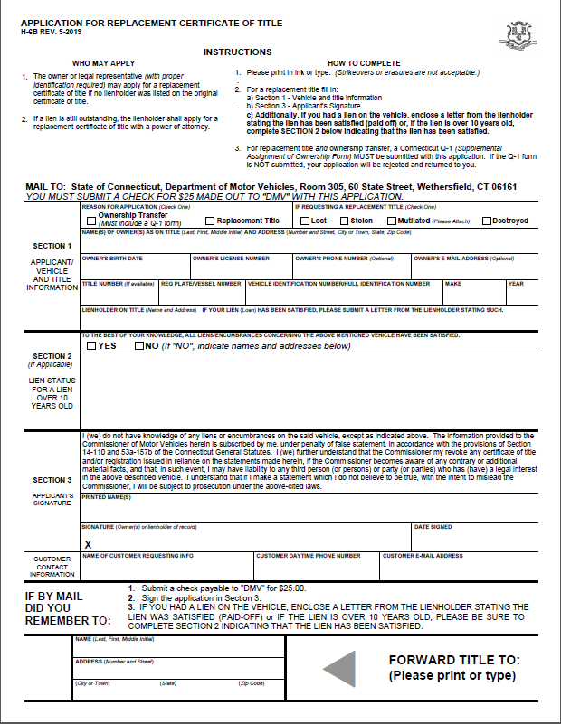

H-117
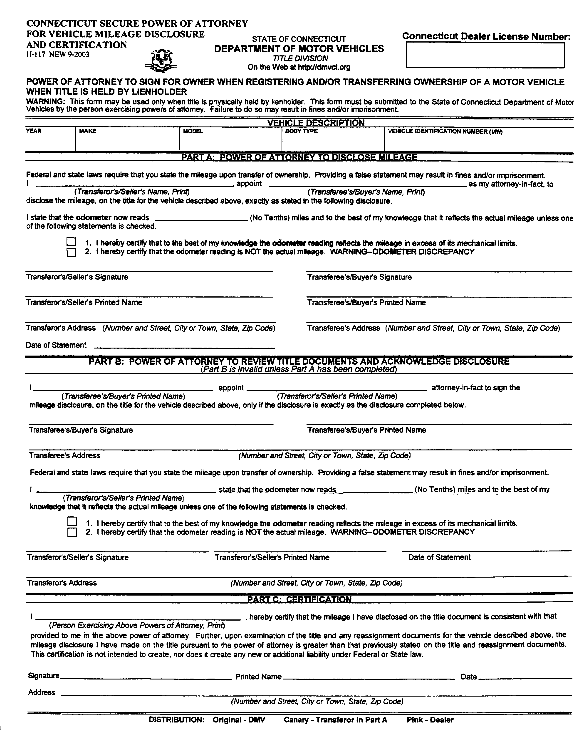

Authorization for Pay-off (H-12)
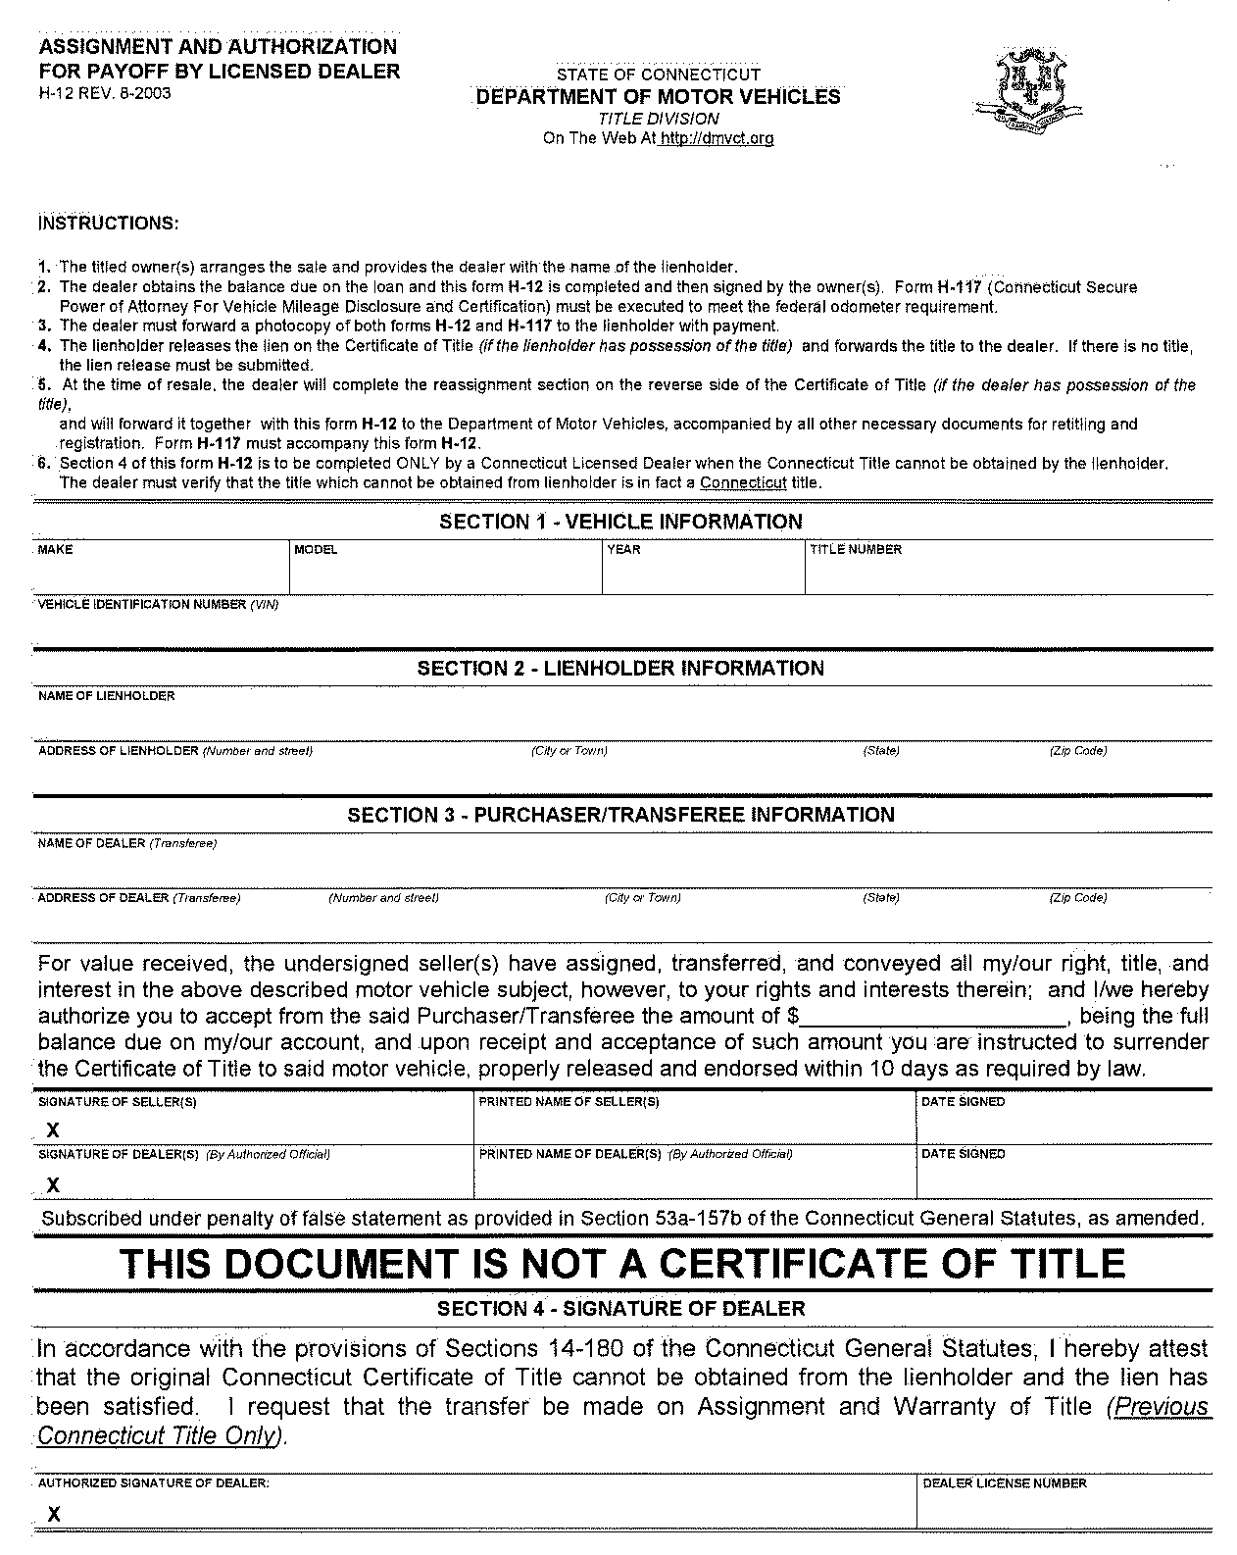

Supplemental Assignment of Ownership and/or Bill of Sale (Q-1)
VEHICLE side

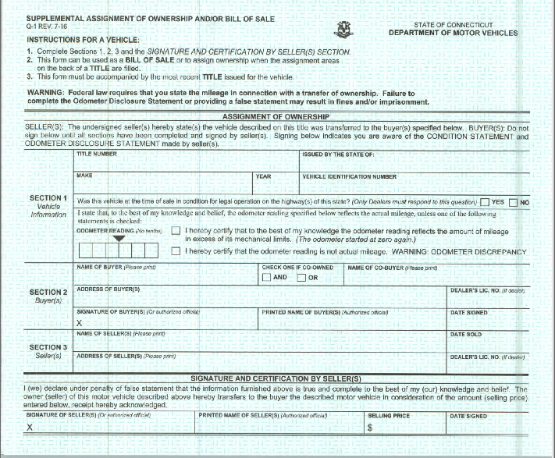

Certificate of Parental Consent (2-D)

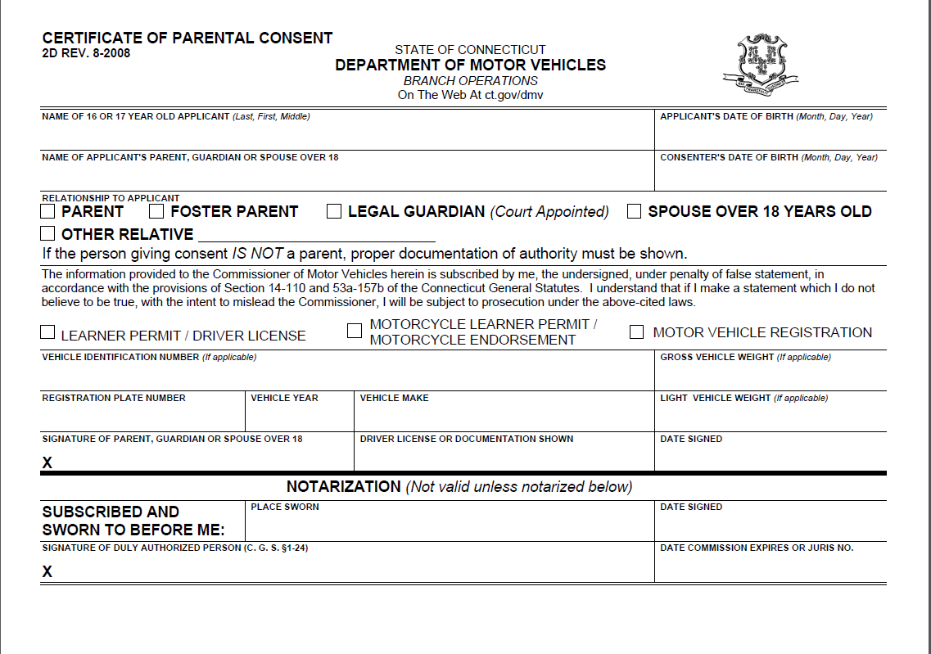

Application for a Vessel registration and Certificate of title (B-148)
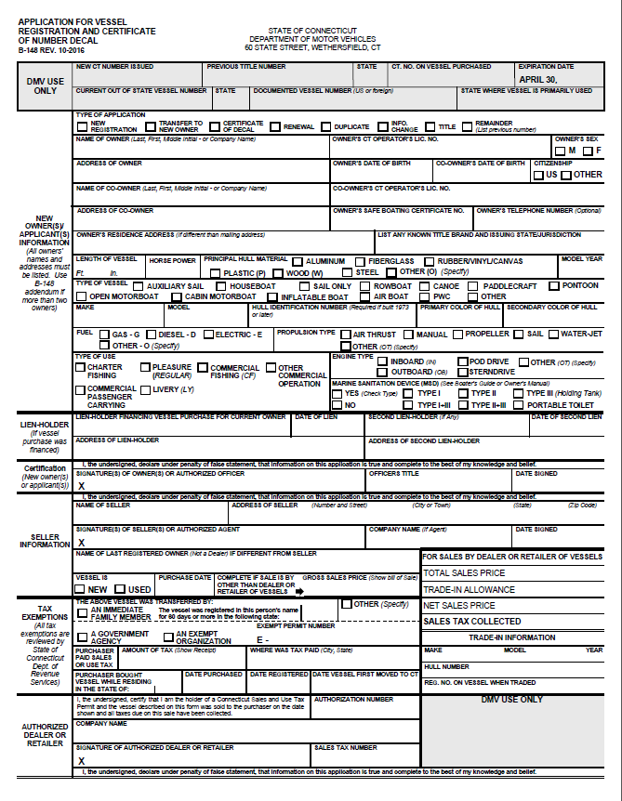

Documents required for Vessel Registrations and Certificate of Title (B-220)
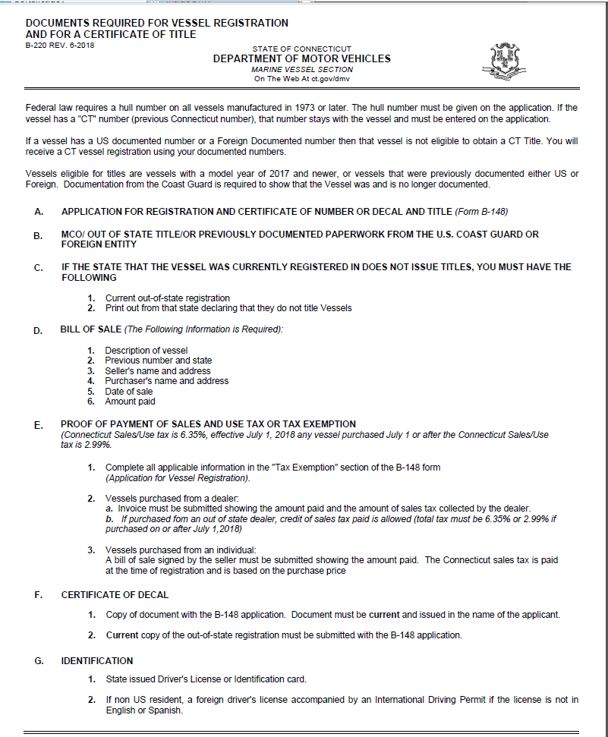

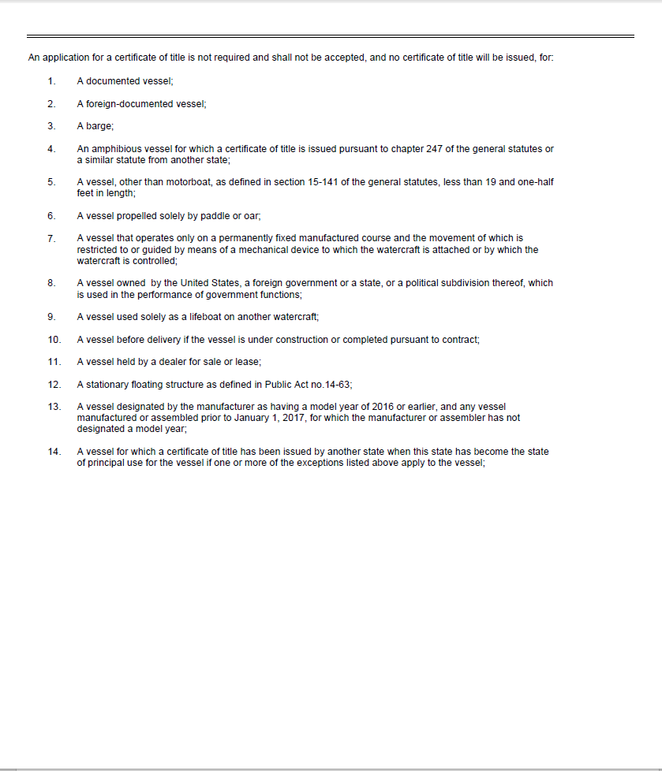

Supplemental Assignment of Ownership for a Vessel (Q1V)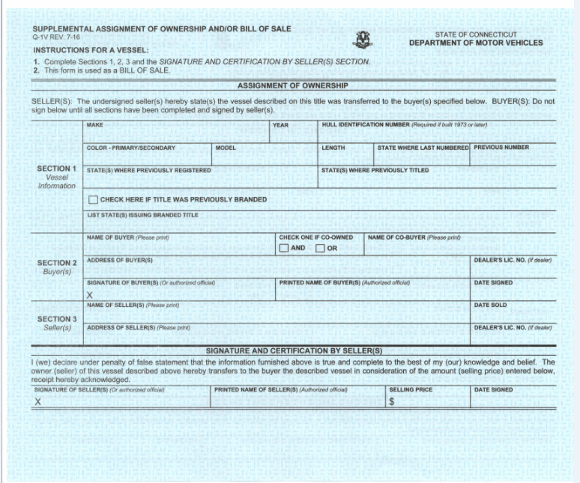
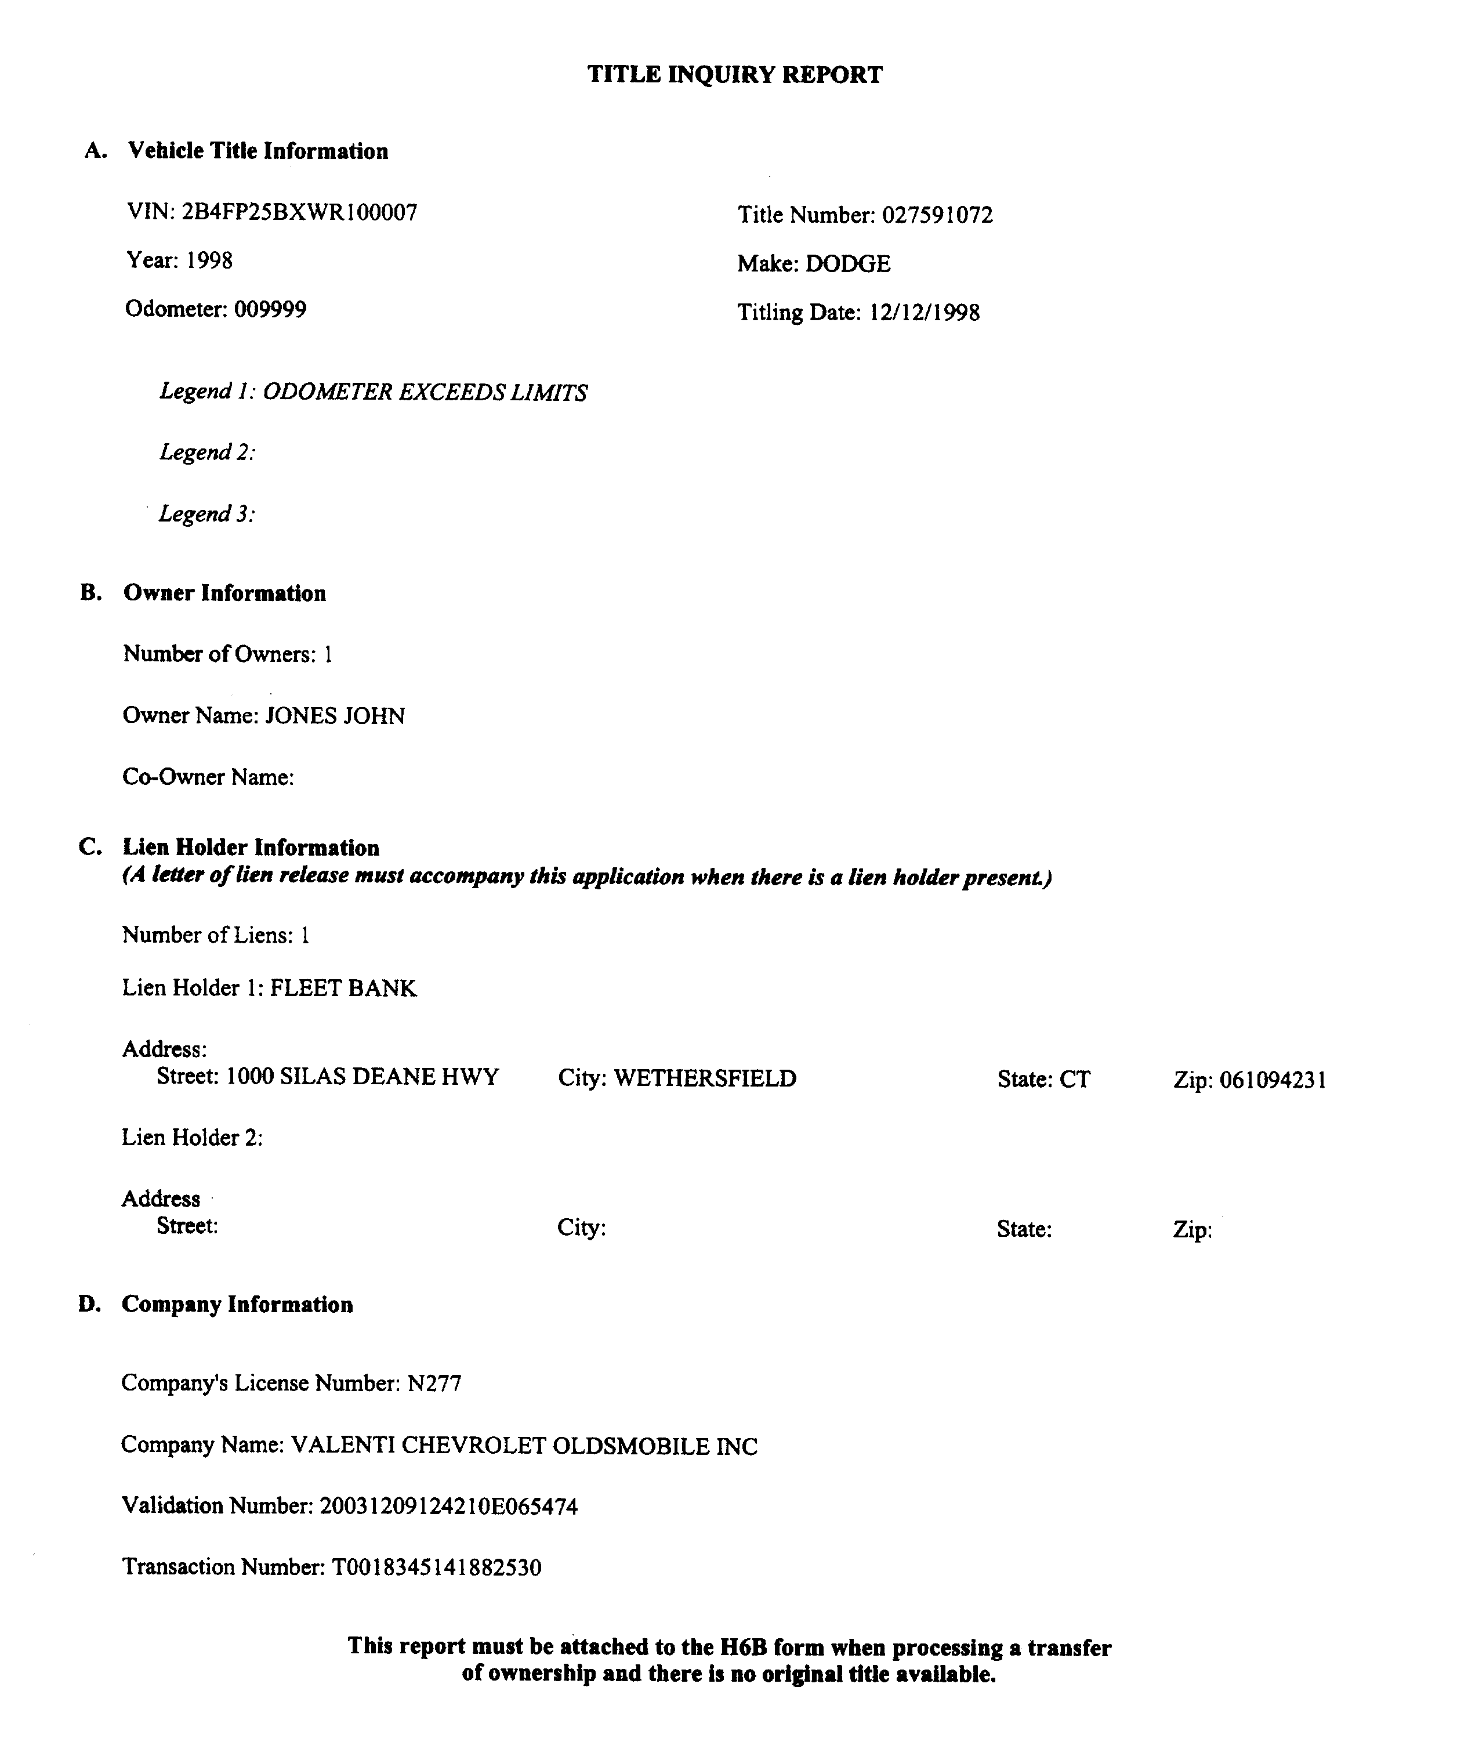

Administrative Fee Requirements

Policy No. R-10 – 01R Administrative Fees (REVISED)

Revision Date: 06/29/2011 Effective Date: 07/01/2011

Subject: Standard for collection of Administrative Fees authorized under CGS 14-12s.

Purpose: To establish uniform guidelines for collection of Administrative $10 Fee.

Scope: This standard applies to each motor vehicle transaction that involves an electronic inspection of a manufacturer’s vehicle identification number for all vehicle types being registered and /or titled in CT.

Description: Administrative Fee will be collected at the time of initial application for title or registration transactions- except transactions listed below:

All Boat Transactions Sub-Registration
Renewals (including seasonal) Duplicates
Changes (vehicle description or name changes) on current registrations. All State or Municipal owned vehicles (title fee exempt)
Temporary registrations Duplicate titles
Corrections due to DMV error

STANDARD/PASSENGER REGISTRATION INFORMATION:

Vehicle Type: Passenger | Usage: Regular
Vehicle Type: Truck | Usage: Regular *Must be 8500 GVWR or less
Fees: | Passenger Style Vehicles: $80.00 Registration fee  Passenger Style Vehicles: $120.00 Effective January 1, 2020  Pickups: Fees determined by declared weight
Greenhouse Gas Fee: | $5.00 Greenhouse Gas Fee (new and renewal registrations)  $10.00 for new vehicles w/MCO Effective January 1, 2020
Safety Plate Fee: | $ 5.00 Safety Plate Fee
Clean Air Act Fee: | $5.00 for 1yr  $10.00 for 2yr  $15.00 for 3yr Effective January 1, 2020
Passport to Parks Fee: | $5.00 for 1yr  $10.00 for 2yr  $15.00 for 3yr Effective January 1, 2020
Administrative Fee: | $10.00 (Collected at the time of initial application for title)
Expiration Date: | Expires two years from date of issue  Expires three years from date of issue Effective January 1, 2020  Example: Vehicle registered 1/8/2020 will expire on 1/7/2023.
Special Requirements: | CT Insurance Card
Definition: | C.G.S. 14-1 (72) “Passenger motor vehicle” means a motor vehicle used for the private transportation of persons and their personal belongings, designed to carry occupants in comfort and safety, with a capacity of carrying not more than ten passengers including the operator thereof;

NOTE: Registrations processed to a business must be either a Combination or Commercial plate. If it is a passenger vehicle and they want passenger/standard plates they must submit a letter stating that this vehicle will be driven by an officer of the company and it will be for personal use only.

Registering a Pick-up Truck with Standard/Passenger Plates:

Effective September 10, 2004, a pickup truck can be registered with passenger plates if the Gross Vehicle Weight Rating does not exceed 8,500 lbs. and the vehicle is not being used for commercial purposes.

The registration will be assigned a Standard/Passenger plate – the ‘Usage’ will be Regular. The registration fee will be collected based on the GVWR of the vehicle. Combination fees will be charged in addition to other required fees for registration.

CLASS TRANSFER:
If a customer has a current combination plate and is requesting to transfer the equity from the previous registration to a passenger marker plate a Class Transfer must be processed. A CLASS TRANSFER WILL NOT BE PROCESSED ON-LINE. It must be processed OVER THE
COUNTER at a local DMV branch office.

  - Bring the current registration, marker plates and insurance information to your local DMV and request a class transfer to passenger plates.

  - Applicable Fees: You will pay a $45.00 class transfer fee at that time.

  - Important: You will be given credit for the unused portion of your current registration and will have to pay an additional fee for the new expiration period of the passenger plates. This fee is based on the expiration of your current registration and the gross weight of the vehicle. The additional fee will be determined at the time the class transfer is processed.

  - The light weight and gross weight of the vehicle will remain the same as on the combination registration.

  - You will receive new passenger plates

Please keep in mind that vehicles with a registered gross weight of more than 7500 lbs are prohibited from using the limited access state highways designated as parkways (Merritt Parkway, Wilbur Parkway).

COMBINATION REGISTRATION INFORMATION
NOTE: The GVWR cannot exceed 12,500 pounds for a Combination registration.

Vehicle Type: Passenger | Usage: Combination
Vehicle Type: Truck, Van, SUV | Usage: Combination *Must be 12,500 GVWR or less
Fees: | Passenger vehicle: $88.00 Registration fee increase to $132.00 Effective January 1, 2020  Truck, Suv, Van: Fee determined by Declared Weight
Safety Plate Fee: | $ 5.00 Safety Plate Fee
Greenhouse Gas Fee: | *NOTE: Fee charged on vehicles with a 10,000 GVWR or less  $5.00 Greenhouse Gas Fee (paid on new and renewal registrations)  $10.00 for new vehicles w/MCO Effective January 1, 2020
Clean Air Act Fee: | $5.00 for 1yr  $10.00 for 2yr  $15.00 for 3yr Effective January 1, 2020
Passport to Parks Fee: | $5.00 for 1yr  $10.00 for 2yr  $15.00 for 3yr Effective January 1, 2020
Administrative Fee: | $10.00 (Collected at the time of initial application for title)
Special Requirements: | CT Insurance Card
Expiration Date: | Expires two years from date of issue  Expires three years from date of issue Effective January 1, 2020  Example: Vehicle registered 1/8/2020 will expire on 1/7/2023.
Annual Fee: | The cost of a one-year registration.  Example: For vehicle with a GVWR of 4,000 lbs., the annual fee factor would be $53.40.
Definition: | C.G.S. 14-1-10: “Combination registration” means the type of registration issued to a motor vehicle used for both private and commercial purposes if such vehicles does not have a gross vehicle weight rating in excess of twelve thousand five hundred pounds
Special Notes: | - Vehicle can be registered combination if signage is removable  - Vehicle must have a GVWR of 12,500 lbs or less.  - Section 8 on H13B application must be completed for the following types of vehicles: Station Wag, SUV, Truck, Van  - Used when registering a passenger style vehicle to a business entity

SEC 14-137-10 (Regulation of State Agencies) Registration: Effective January 1, 1973, any motor vehicle registered as a camper or combination motor vehicle or for which “camper” or “combination” registration is renewed shall be issued a registration listing the gross vehicle weight of such vehicle. The gross vehicle weight indicated on a “camper” or “combination” registration shall not exceed the maximum as established by the manufacturer.

TRANSFER COMBINATION WITH INCREASE IN WEIGHT:

The system will calculate the amount of equity, if any, can be used toward the new registration. The equity is determined by the previous registrations fee, expiration date and GVWR or Declared weight (if initially registered in new system) of vehicle.

The system will use the GVWR or DW fee factor and expiration date on the previous registration to determine the new fee.

The calculations by the system are as follows:

Previous registration fee divided by 25 (for 2 yr. reg) or 13 (for 1 yr. reg)
Multiplied by the # of months remaining on previous registration (up to current month) Subtract the above total from the New registration fee
This is your new total registration fee

Example: Previous registration expires 7/1/2016 and previous registration fee is $106.80 (based on a 3600lb GVWR)

Today’s date – 6/16/2015
New Vehicle – Declared weight is 5000lbs / $130.00 total 2yr reg fee

$106.80/25 months= $4.27
$4.27 * 14 (months remaining on previous reg from current date) = $59.78
$130.00 – 59.78 = 70.22
Your new registration fee is $70.22

Note: The system will calculate all fees.

Combination Fee Chart

Combination registrations are issued to a motor vehicle which is used for both private passenger and commercial purposes if that vehicle does not have a gross vehicle weight in excess of 12,500 pounds. Fees are based on the declared GVWR that the vehicle will be registered for.

To Use The Chart Below:
•Determine the maximum gross vehicle weight rating of the vehicle (the registered gross weight cannot be more than the manufacturer’s gross weight rating of the vehicle).
•Find the corresponding weight in the first column and read across to the column labeled "2-Year Fee". The fee in this column is the amount charged for a new registration that is issued.
•If the gross vehicle weight rating falls between two figures go to the next higher weight for the correct fee.

These fees are in addition to any other applicable fees such as Title, Plate fee, Sales Tax, etc.

The column labeled "Equity" is the amount of credit that is allowed when a registration is being transferred to another vehicle or when the class of registration is being changed. Determine how many months are remaining on the registration, and then use the appropriate equity column. Do not count the current month.

Registered Gross Vehicle Weight Rating | 2-Year Fee  19 - 24 Months  Equity | 13 - 18 Months  Equity | 7 - 12 Months  Equity | 1 - 6 Months  Equity | 3-Year Fee  Effective 1/1/2020
Less than 3001 | $88.00 | $66.00 | $44.00 | $22.00 | $132.00
3001-4000 | $106.80 | $80.10 | $53.40 | $26.70 | $160.20
4001-5000 | $130.00 | $97.50 | $65.00 | $32.50 | $195.00
5001-6000 | $153.20 | $114.90 | $76.60 | $38.30 | $229.80
6001-7000 | $176.40 | $132.30 | $88.20 | $44.10 | $264.60
7001-8000 | $199.60 | $149.70 | $99.80 | $49.90 | $299.40
8001-9000 | $222.80 | $167.10 | $111.40 | $55.70 | $334.20
9001-10000 | $246.00 | $184.50 | $123.00 | $61.50 | $369.00
10001-11000 | $269.20 | $201.90 | $134.60 | $67.30 | $403.80
11001-12000 | $292.40 | $219.30 | $146.20 | $73.10 | $438.60
12001-12500 | $315.60 | $236.70 | $157.80 | $78.90 | $478.40

COMMERCIAL REGISTRATION INFORMATION

Vehicle Type: Passenger | Usage: Commercial
Vehicle Type: Truck, Van, SUV | Usage: Commercial
Vehicle Type: Truck Tractor | Usage: Commercial
Fees: | Fee determined by declared weight according to commercial fee chart.
Greenhouse Gas Fee: | *NOTE: Fee charged on vehicles with a 10,000 GVWR or less  $ 5.00 Greenhouse Gas Fee (when registering a vehicle with a MCO)  - No charge regardless of GVWR when usage is commercial Effective January 1, 2020
Safety Plate Fee: | $5.00 Safety Plate Fee
Clean Air Act Fee: | $5.00 (only collected on new issues and renewals)
Administrative Fee: | $10.00 Collected at the time of initial application for title
Expiration Date: | 1 year from date of issuance
Special Requirements: | Inspection: Federal Annual Inspection  Heavy Highway Vehicle Use Tax (IRS 2290):  - If over 55,000 lbs. GVWR and after 60 days of purchase date
Definition: | C.G.S. 14-1-(20) “Commercial registration” means the type of registration required for any motor vehicle designed or used to transport merchandise, freight or persons in connection with any business enterprise, unless a more specific type of registration is authorized and issued by the commissioner for such class of vehicle  14-1 (97) “Tractor” or “truck tractor” means a motor vehicle designed and used for drawing a semitrailer;
Special Notes: | Weights to Appear on Application:  LW (Light Weight): Appears as shipping weight on MCO or NADA reference.  GVWR (Declared Weight): Registration fees are determined by this weight

Note: Dealers can register Commercial vehicles, up to 67,400 lbs on-line.

** If the system returns a “stop” that states the following: “US DOT # is required” for vehicles with a GVWR of 18,001lbs or more, the dealer will need to call the DMV and have the US DOT # added to the customer’s record **

DOT Numbers Required:
1. Engaged in intrastate commerce and has a gross vehicle weight rating or gross combination weight rating or gross vehicle weight or gross combination weight of eighteen thousand one (18,001) or more pounds; or,
2. Used in the transportation of hazardous materials in a quantity requiring placarding.
FEDERAL ANNUAL INSPECTION REQUIREMENTS:
- All commercial vehicles over 10,000 lbs. GVWR used in INTERSTATE COMMERCE
- All commercial vehicles over 18,000 lbs. GVWR used in INTRASTATE COMMERCE
- All commercial trailers over 10,000 lbs. GVWR
Must submit a Federal Annual Inspection Report (49 CFR 396.17) that has been completed by a dealer or repairer licensed in the State of CT, an Original Equipment Manufacturer (OEM) or a person or motor carrier qualified to perform the inspection in accordance with 49 CFR 396.19. The Federal Annual Inspection report shall be dated within the preceding 12 months of the date of registration and the registrant must be in control of the vehicle at the time of the Federal Annual Inspection unless the inspection was performed by the OEM. The Federal Annual Inspection report completed by a licensed dealer/repairer shall include the dealer/repairer’s business name and identifying license number. The inspector Qualifications form, if required, shall be dated on or prior to the date of the inspection.

Heavy Vehicle Use Tax (IRS 2290):
IRS 2290 required over 55,000 lbs. Vehicles registered at 55,000 lbs. and over must pay a special federal highway use tax to the Internal Revenue Service (IRS) by filing form No. 2290. DMV requires proof of payment (copy of IRS form 2290 receipted for payment by IRS listing the vehicle ID number (VIN) for which tax was paid) to register or renew vehicles registered at 55,000 lbs. Gross Vehicle Weight and above. Proof of such payment is required by DMV at each renewal. The vehicle may be registered 60 days from the date of purchase without presenting the 2290.

Sec. 14-12(f)(6) The commissioner shall not register any motor vehicle which is subject to the federal heavy vehicle use tax imposed under Section 4481 of the Internal Revenue Code of 1954, or any subsequent corresponding internal revenue code of the United States, as from time to time amended, if the applicant fails to furnish proof of payment of such tax, in a form prescribed by the Secretary of the Treasury of the United States.
Sec. 14-267a. Weight restrictions for vehicles, trailers or other objects. Highway weighing procedure. Penalties for overweight violations. Fines for failure to comply. Regulations. (a) A vehicle or combination of vehicle and trailer or semitrailer or any other object may be operated upon any highway or bridge, subject to the provisions of section 13a-151, provided such vehicle or combination of vehicle and trailer or semitrailer or other object meets all the applicable requirements of this section or has been granted a permit under section 14-270.
(b) The axle weight on any axle and the gross weight of any vehicle or combination of vehicle and trailer or vehicle and semitrailer or any other object, including its load, may not exceed the lesser of the manufacturer's axle weight rating, the manufacturer's gross vehicle weight rating or the following axle and gross weight limits: (1) The weight on any single axle shall not exceed twenty-two thousand four hundred pounds or, in the case of axles spaced less than six feet apart, eighteen thousand pounds on each axle; (2) a two-axle vehicle shall comply with the axle requirements specified in subdivision (1) of this subsection, and shall not exceed a maximum gross vehicle weight of thirty-six thousand pounds; (3) a three-axle vehicle shall comply with the axle requirements specified in subdivision (1) of this subsection and shall not exceed a maximum gross vehicle weight of fifty-three thousand eight hundred pounds; (4) a three-axle combination of vehicle and trailer or vehicle and semitrailer shall comply with the axle requirements specified in subdivision (1) of this subsection and shall not exceed a maximum gross vehicle weight of fifty-eight thousand four hundred pounds; (5) a four-or-more-axle vehicle or combination of vehicle and trailer or vehicle and semitrailer shall comply with the axle requirements specified in subdivision (1) of this subsection and shall not exceed a maximum gross vehicle weight of sixty-seven thousand four hundred pounds;
Weight distribution formula. W = 500 ( ( LN / (N-1) ) + 12N + 36 )
Where W = overall gross weight on any group of two or more consecutive axles to the nearest five hundred pounds, L = distance in feet between the extreme of any group of two or more consecutive axles, and N = number of axles in group under consideration, except that two consecutive sets of tandem axles may carry a gross load of sixty-eight thousand pounds, provided the overall distance between the first and last axles of such consecutive sets of tandem axles is thirty-six feet or more. As used in this subsection, “agricultural commodity” means inputs limited to feed, seed and fertilizer and products of agriculture, as described in subsection (q) of section 1-1.

** If the system returns a “stop” that states the following: “Minimum liability amount is not met by the insurance policy entered…...” the dealer will need to contact the DMV Insurance Compliance Unit at (860) 263-5725**

Motor carriers conducting commercial business with vehicles meeting the following criteria are required to report insurance coverage to DMV once a year:
1. A vehicle that operates in intrastate commerce (within Connecticut only) with a gross weight or gross vehicle weight rating (GVWR) or gross truck/trailer weight or gross combination weight rating of 18,001 pounds or more;
2. A vehicle that operates in interstate commerce with a gross vehicle weight, or GVWR or gross truck/trailer combination weight of 10,001 pounds or more;
3. A vehicle used in the transportation of hazardous materials in a quantity requiring HAZMAT “placarding” under the Hazardous Materials Transportation Act.
4. If the first four choices do not apply to you, you must complete and submit a Compliance Affidavit form to DMV for new registration transactions or renewals.
5. If any of the above apply, the customer must file an Acord 25 Certificate of Liability Insurance with DMV with the following coverages:
• Freight vehicles of 10,001 pounds or more GVWR, non-hazardous: $750,000
• Freight vehicles of 10,001 pounds or more GVWR, hazardous: $1,000,000 or $5,000,000 (higher liability required for certain types of hazardous material, see Federal Motor Carrier Safety Administration).
• Any vehicle with a seating capacity of more than 8 passengers: $1,500,000
• Any vehicle with a seating capacity of 16 passengers or more: $5,000,000

Commercial Fee Chart

Commercial registration fees based on the declared gross vehicle weight rating (GVWR) that the vehicle will be registered for.
To Use the Chart Below:
•Determine the maximum GVWR of the vehicle.
•Find the corresponding weight range in the first column and read across to determine the registration fee.
•The fee in the column labeled “Annual Fee” is the amount charged for a new registration.

These fees are in addition to any other applicable fees such as Title, Plate fee, Sales Tax, etc.

Note: If the Declared Weight/DW falls between two figures go to the next higher weight for the correct fee. Example: If the DW of the vehicle is 4957 lbs., the fee for 5000 lbs. is charged.

The columns labeled “Equity” is the amount of credit that is allowed when a registration is being transferred to another vehicle. Determine how many months are remaining on the registration, and then use the appropriate equity column.

Gross Weight | Annual Fee | 7 - 12 Months  Equity | 6 Month  Fee | 1 - 6 Month Equity
Less than 3001 | $47.00 | $34.00 | $28.50 | $17.00
3001-4000 | $56.40 | $46.40 | $33.20 | $23.20
4001-5000 | $68.00 | $58.00 | $39.00 | $29.00
5001-6000 | $79.60 | $69.60 | $44.80 | $34.80
6001-7000 | $91.20 | $81.20 | $50.60 | $40.60
7001-8000 | $102.80 | $92.80 | $56.40 | $46.40
8001-9000 | $114.40 | $104.40 | $62.20 | $52.20
9001-10000 | $126.00 | $116.00 | $68.00 | $58.00
10001-11000 | $137.60 | $127.60 | $73.80 | $63.80
11001-12000 | $149.20 | $139.20 | $79.60 | $69.60
12001-13000 | $160.80 | $150.80 | $85.40 | $75.40
13001-14000 | $172.40 | $162.40 | $91.20 | $81.20
14001-15000 | $184.00 | $174.00 | $97.00 | $87.00
15001-16000 | $195.60 | $185.60 | $102.80 | $92.80
16001-17000 | $207.20 | $197.20 | $108.60 | $98.60
17001-18000 | $218.80 | $208.80 | $114.40 | $104.40
18001-19000 | $230.40 | $220.40 | $120.20 | $110.20
19001-20000 | $242.00 | $232.00 | $126.00 | $116.00
20001-21000 | $308.20 | $298.20 | $159.10 | $149.10
21001-22000 | $322.40 | $312.40 | $166.20 | $156.20
22001-23000 | $336.60 | $326.60 | $173.30 | $163.30
23001-24000 | $350.80 | $340.80 | $180.40 | $170.40
24001-25000 | $365.00 | $355.00 | $187.50 | $177.50
25001-26000 | $379.20 | $369.20 | $194.60 | $184.60
26001-27000 | $393.40 | $383.40 | $201.70 | $191.70
27001-28000 | $407.60 | $397.60 | $208.80 | $198.80
28001-29000 | $421.80 | $411.80 | $215.90 | $205.90
29001-30000 | $436.00 | $426.00 | $223.00 | $213.00
30001-31000 | $558.70 | $548.70 | $284.35 | $274.35
31001-32000 | $576.40 | $566.40 | $293.20 | $283.20
32001-33000 | $594.10 | $584.10 | $302.05 | $292.05
33001-34000 | $611.80 | $601.80 | $310.90 | $300.90
34001-35000 | $629.50 | $619.50 | $319.75 | $309.75
35001-36000 | $647.20 | $637.20 | $328.60 | $318.60
36001-37000 | $664.90 | $654.90 | $337.45 | $327.45
37001-38000 | $682.60 | $672.60 | $346.30 | $336.30
38001-39000 | $700.30 | $690.30 | $355.15 | $345.15
39001-40000 | $718.00 | $708.00 | $364.00 | $354.00
40001-41000 | $735.70 | $725.70 | $372.85 | $362.85
41001-42000 | $753.40 | $743.50 | $381.70 | $371.70
42001-43000 | $771.10 | $761.10 | $390.55 | $380.55
43001-44000 | $788.80 | $778.80 | $399.40 | $389.40
44001-45000 | $806.50 | $796.50 | $408.25 | $398.25
45001-46000 | $824.20 | $814.20 | $417.10 | $407.10
46001-47000 | $841.90 | $831.90 | $425.95 | $415.95
47001-48000 | $859.60 | $849.60 | $434.80 | $424.80
48001-49000 | $877.30 | $867.30 | $443.65 | $433.65
49001-50000 | $895.00 | $885.00 | $452.50 | $442.50
50001-51000 | $912.70 | $902.70 | $461.35 | $451.35
51001-52000 | $930.40 | $920.40 | $470.20 | $460.20
52001-53000 | $948.10 | $938.10 | $479.05 | $469.05
53001-54000 | $965.80 | $955.80 | $487.90 | $477.90
54001-55000 | $983.50 | $973.50 | $496.75 | $486.75
55001-56000 | $1,001.20 | $991.20 | $505.60 | $495.60
56001-57000 | $1,018.90 | $1,008.90 | $514.45 | $504.45
57001-58000 | $1,036.60 | $1,026.60 | $523.30 | $513.30
58001-59000 | $1,054.30 | $1,044.30 | $532.15 | $522.15
59001-60000 | $1,072.00 | $1,062.00 | $541.00 | $531.00
60001-61000 | $1,089.70 | $1,079.70 | $549.85 | $539.85
61001-62000 | $1,107.40 | $1,097.40 | $558.70 | $548.70
62001-63000 | $1,125.10 | $1,115.10 | $567.55 | $557.55
63001-64000 | $1,142.80 | $1,132.80 | $576.40 | $566.40
64001-65000 | $1,160.50 | $1,150.50 | $585.25 | $575.25
65001-66000 | $1,178.20 | $1,168.20 | $594.10 | $584.10
66001-67000 | $1,195.90 | $1,185.90 | $602.95 | $592.95
67001-68000 | $1213.60 | $1203.60 | $611.80 | $601.80

COMMERCIAL TRAILER REGISTRATION INFORMATION

Vehicle Type: Trailer | Usage: Commercial (not used with Truck Tractor)
Vehicle Type: Trailer | Usage: Semi Trailer (used with Truck Tractor)
Fees: | Fee determined by declared weight according to commercial fee chart.  Semi Trailer: $35.00 per year
Safety Plate Fee: | $5.00 Safety Plate Fee
Administrative Fee: | $10.00 Collected at the time of initial application for title
Expiration Date: | 1 year from date of issuance
Special Requirements: | Inspection: over 10,000 lbs. GVWR requires Federal Annual Inspection report (49 CFR 396.7) and Inspector Qualifications form
Definition: | 14-1 (22) “Commercial trailer registration” means the type of registration issued to any commercial trailer;  14-1 (21) “Commercial trailer” means a trailer used in the conduct of a business to transport freight, materials or equipment whether or not permanently affixed to the bed of the trailer;  14-1 (85) “Semitrailer” means any trailer type vehicle designed and used in conjunction with a motor vehicle so that some part of its own weight and load rests on or is carried by another vehicle;
Special Notes: | - Must have brakes on all wheels if 3,000 GVWR or more.  - Title required on 3,001 GVWR or more  - Section 8 on H13B application must be completed

CAMP TRAILER REGISTRATION INFORMATION

Vehicle Type: | Trailer
Usage: | Regular
Fees: | $19.00 Registration fee increase to $28.50 Effective January 1, 2020
Safety Plate Fee: | $5.00 Safety Plate Fee
Administrative Fee: | $10.00 (Collected at the time of initial application)
Expiration Date: | Expires two years from date of issue  Expires three years from date of issue Effective January 1, 2020
Special Requirements: | None
Definition: | C.G.S. 14-1-(10) “Camp trailer registration” means the type of registration issued to any trailer that is for nonbusiness use and is limited to camp trailers and utility trailers
Special Notes: | - Must have rear light for any weight  - Must have brakes on all wheels if 3,000 GVWR or more.  - Title required on 3,001 GVWR or more  - Section 8 on H13B application must be completed

Requirements to register

New Manufactured Trailer:
    - Bill of Sale: must include buyer, seller, purchase price, year, make, body style and VIN
    - Certificate of Origin (if gross weight of trailer over 3,000 lbs.)
    - Application for Registration and Certificate of Title (H-13)
    - Federal Annual Inspection (when applicable)

Used Manufactured Trailer
    - Bill of Sale: must include buyer, seller, purchase price, year, make, body style and VIN
    - Proof of previous CT registration (if gross weight is 3,000 lbs. or less)
    - Title properly assigned (if gross weight is over 3,000 lbs.)
    - Application for Registration and Certificate of Title (H-13)
    - Safety inspection or VIN Verification required (if applicable)
      - Previously registered out of state- VIN Verification required
      - Federal Annual Inspection (when applicable)
New Homemade Trailer (see additional information on homemade trailers)
- Receipts for the parts/items that were used to make trailer
- Application for Registration & Certificate of Title (H-13)
- Safety inspection

Used Homemade Trailer
- Bill of Sale: must include buyer, seller, purchase price, year, make, body style and VIN
- Proof of previous CT registration (if gross weight is 3,000 lbs. or less)
- Title properly assigned (if gross weight is over 3,000 lbs.)
- Safety inspection
  - Federal Annual Inspection (when applicable)

TITLE & REGISTRY REQUIREMENTS FROM OTHER STATES ON TRAILERS

 | Registration not required on boat trailers 1975 and subsequent years. Travel Trailers are exempt
Alaska | Title required
Arizona | Title required
Arkansas | Title optional for GVWR under 3,001 lbs.
California | Title required on 3,000 lbs. or more
Colorado | Title required on 3,000 lbs. or more
Connecticut | Title required on 3,000 lbs. or more
Delaware | Title required
District of Columbia | Title required
Florida | Title not required on GVWR less than 2,000 lbs. Farm trailers exempt from registration.
Georgia | Boat Trailers, Pole Trailers and homemade trailers exempt as well as utility trailers under 2,000 lbs. Exempt
Hawaii | No title
Idaho | Title required except trailers with unladen weight less than 2,000 lbs.
Illinois | Title required
Indiana | Title required
Iowa | Trailer under 2,000 lbs. Exempt. Farm trailers also exempt from registration.
Kansas | Title and registration optional on weight less than 2,000 lbs. Farm trailers with a load under 6,000 lbs. Exempt
Kentucky | Title required. Boat trailers exempt from registration
Louisiana | Title required. Farm exempt
Maine | Trailers with an unladen weight of 3,000 lbs. or under are exempt. Ten year old trailers are exempt
Maryland | Title required
Massachusetts | Title not required on trailers having gross weight of 3,000 lbs. or less
Michigan | Trailers with empty weight under 2,500 lbs. are exempt
Minnesota | Title required
Mississippi | Boat Trailers are exempt
Missouri | Title required
Montana | Title required
Nebraska | Noncommercial trailers with a gross weight of 9,000 lbs. or under are exempt
Nevada | Title required
New Hampshire | Trailers with gross weight
New Jersey | Title required
New Mexico | Title required
New York | Trailers under 1,000 lbs. are exempt. Vehicles with model years prior to 1973 are exempt.
North Carolina | Title required unless implement of husbandry.
North Dakota | Boat, utility and luggage trailers are exempt. Registration not required for utility trailers, boat trailer, and trailers with a GVWR 1,500 lbs. or less and not “for hire” or commercial use.
Ohio | Commercial trailers, semi-trailers and utility trailers weighing under 4,000 lbs. are exempt. Boat or utility trailer used or personal use are issued a non- commercial plate.
Oklahoma | Registrations not required on small trailers unless used for commercial purposes. Luggage, boat trailers and privately-owned trailers not used commercially and farm trailer not in excess of 6,000 lbs. are exempt
Oregon | Title required except for farm trailers
Pennsylvania | Title required
Rhode Island | Trailer with a capacity of 3,00 lbs. or less is exempt. Vehicles over 10 years old are exempt

South Carolina | Title required over 2,500 lbs. Except for implements of husbandry and pole trailers. Title optional and registration not required if GVWR of boat trailer is less than 2,500 lbs. GVWR. Over 2,500 lbs. GVWR, title and registration is mandatory.
South Dakota | Title required
Tennessee | Registration not required on farm, boat or utility trailers. Title not required.
Texas | Title required unless used solely for transportation of farm products. Titles issued on travel trailers and camper trailers designed for human habitation, commercial trailers having empty weight in excess of 4,000 lbs. and semi-trailers having gross weight in excess of 4,000 lbs.
Utah | Title required except for privately owned trailers 750 lbs. or less that are not used on highway
Vermont | All 1972 and later models, title required except for trailers with unladen weight of 1,500 lbs. or less
Virginia | Title required
Washington | Title required
West Virginia | Title required
Wisconsin | Title required. A trailer, semi-trailer or camping trailer with a GVWR of 3,000 lbs. or less is exempt from registration. Title optional and exempt from registration for trailer, semi-trailer or camping trailers with GVWR of 3,000 lbs. or less. Title required per 3,000 lbs. GVWR.
Wyoming | Title Required. Trailers weighing one thousand (1,000 ) pounds or less unladen are exempt
Puerto Rico | Title required all trailers registered after July 1, 1987

TRAILERS BEING REGISTERED OUT OF STATE:
Many customers who purchase trailers from dealerships or individuals may choose to register their trailer out of state. Many states have different title laws and requirements; the customer may be refused registration in another state because they do not hold title to a trailer. The statute below will assist these customers in registering trailers which have weight less than three thousand pounds:

Sec. 14-166. Exempt vehicles. (a) The acquisition of a certificate of title shall not be required and the issuance of a certificate of title by the Commissioner of Motor Vehicles shall not be required for the following: (1) A vehicle owned by the United States, unless it is registered in this state; (2) a vehicle owned by a manufacturer or dealer and held for sale, even though incidentally moved on the highway or used for purposes of testing or demonstration; or a vehicle used by a manufacturer solely for testing; (3) a vehicle owned by a nonresident of this state and not required by law to be registered in this state; (4) a vehicle regularly engaged in the interstate transportation of persons or property for which a currently effective certificate of title has been issued in another state; (5) a vehicle moved solely by animal power; (6) an implement of husbandry; (7) special mobile equipment; (8) a self-propelled wheel chair or invalid tricycle; (9) any trailer having a gross weight not in excess of three thousand pounds; (10) any vehicle for which a temporary registration has been issued pursuant to section 14-12 for the purpose of permitting a nonresident owner who purchases a vehicle in Connecticut to transport such vehicle to such owner's home state; (11) a motor vehicle owned by the state or any town, city or borough within the state; (12) a motor vehicle registered temporarily for inspection purposes pursuant to section 14-12. The acquisition of a certificate of title for any vehicle manufactured prior to 1981 shall not be required. The commissioner, in his discretion, may issue such certificate of title for such a vehicle.
- Part III of this chapter does not apply to: (1) A vehicle moved solely by animal power; (2) an implement of husbandry; (3) special mobile equipment; (4) a self-propelled wheel chair or invalid tricycle; (5) any trailer having a gross weight not in excess of three thousand pounds.

HOMEMADE TRAILERS:
A homemade trailer composed or assembled from the parts of two or more used trailers will need proof of ownership of or receipts for the purchase of the trailers. In order to verify that any one of the previously listed five (5) classifications (qualifying measures) has been accomplished, the following evidence shall be considered acceptable:

  - The receipt for an entire purchased complete component.
  - A receipt for purchased assemblies necessary to rebuild a complete component or a repair order indicating the rebuilding of a complete component.
  - The receipt for the fabrication of or the materials for a complete component.
  - Proof of ownership or the receipt for purchase of a used trailer obtained for its parts or to be rebuilt.
  - Photographs of a rebuilt trailer prior to being rebuilt which clearly show the conditions of complete components replaced.
  - For any components fabricated from materials on hand for which no receipt is generally available, the person shall sign under penalty of false statement an affidavit attesting to the type and source of the individual pieces of material.

All homemade trailers are required to be inspected and a Connecticut Vehicle Identification Number assigned at a DMV Safety Inspection location.
REASSIGNMENT OF MISSING TRAILER VIN

Trailers with a GVWR 10,001 or higher must contact the Anti-Theft Unit at (860)263-5098 for VIN assignment.

CAMPER REGISTRATION INFORMATION

Vehicle Type: | Motorhome
Usage: | Regular
Fees: | $75.00 Registration fee increase to $112.50 Effective January 1, 2020
Safety Plate Fee: | $5.00 Safety Plate Fee
Greenhouse Gas Fee: | *NOTE: Fee charged on vehicles with a 10,000 GVWR or less  $5.00 Greenhouse Gas Fee (paid on new and renewal registrations)  $10.00 for new vehicles w/MCO Effective January 1, 2020
Administrative Fee: | $10.00 Collected at the time of initial application for title
Expiration Date: | Expires two years from date of issue  Expires three years from date of issue Effective January 1, 2020
Special Requirements: | CT Insurance Card
Definition: | C.G.S. 14-1-(12) “Camper” means any motor vehicle designed or permanently altered in such a way as to provide temporary living quarters for travel, camping or recreational purposes
Special Notes: | Vehicles in this category are:  - Manufactured Campers  - Vehicles converted from a bus, truck or other vehicles equipped for living purposes.  - House on Wheels  - Beach Wagon  - Camper  - Vehicles on which a “CAMPER module” is permanently mounted on or in the motor vehicle.  - Should a registrant want to use such a vehicle commercially, combination plates for registration must be issued, charging combination fee according to declared weight, plus additional fees  Gross Weight, Axles, and Light Weight  Light and Gross weight of the vehicle fully equipped. Gross weight cannot exceed the manufacturers GVWR listed in reference books for make and model of vehicle. Gross weight cannot exceed statutory limits.  14-49(t) limits in correction are:  2 axle, 36,000  3 axle, 53,800  4 axle, 67,400  5 axle, 73,000  To register a vehicle, which is used as a camper when, a “camper module” is mounted temporarily and commercially when “camper module” is removed registration must be:  - Combination, if under 10,000 GVWR  - Commercial, if over 10,000 lbs. GVWR

MOTORCYCLE REGISTRATION INFORMATION

Vehicle Type: | Motorcycle
Usage: | Regular
Fees: | $42.00 Registration fee increase to $63.00 Effective January 1, 2020
Safety Plate Fee: | $5.00 Safety Plate Fee
Administrative Fee: | $10.00
Expiration Date: | 2 years from date of issuance  3 years from date of issuance Effective January 1, 2020
Special Requirements: | CT Insurance Card
Definition: | C.G.S. 14-1(59) “Motorcycle” means (A) an autocycle, as defined in this section, or (B) a motor vehicle, with or without a side car, that has (i) not more than three wheels in contact with the ground, (ii) a saddle or seat which the rider straddles or a platform on which the rider stands, and (iii) handlebars with which the rider controls the movement of the vehicle. “Motorcycle” does not include a motor-driven cycle or an electric bicycle
Special Notes: | Limitation Section 14-80I(b): No person shall operate a motorcycle on a highway or in any parking area for ten or more motor vehicles if the motorcycle is equipped with handlebars that are more than the height of the operator's shoulders.

