When submitting DUI kits via US Mail:
- Seal and initial the DUI kit.
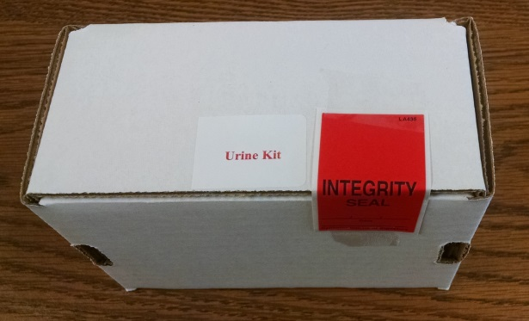
- Fill out BOTH forms completely (Request for Analysis & DPS-9-C) and place them in the packing slip. *Remember to match the case number of both forms. Remember to fill out the submitting officer and requesting officer. Remember to check whether it is an accident or fatality. Remember that for FATALITIES, we need the name and DOB of the deceased on the victim line.
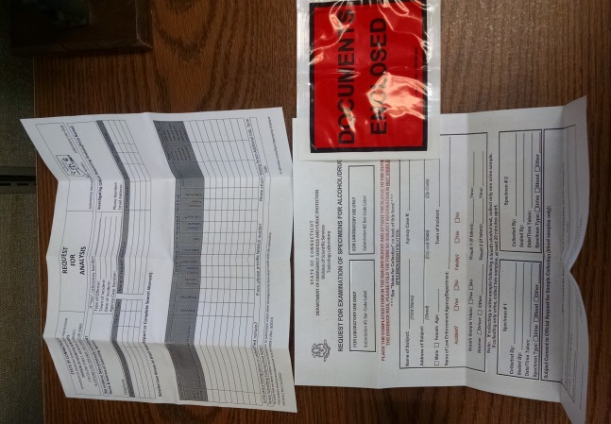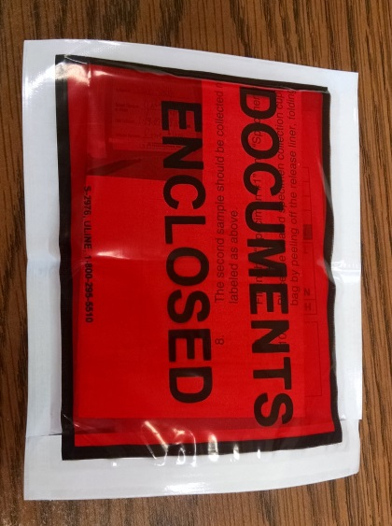
- Place the packing slip on the outside of the kit. The kit should not have to be opened to remove any paperwork.
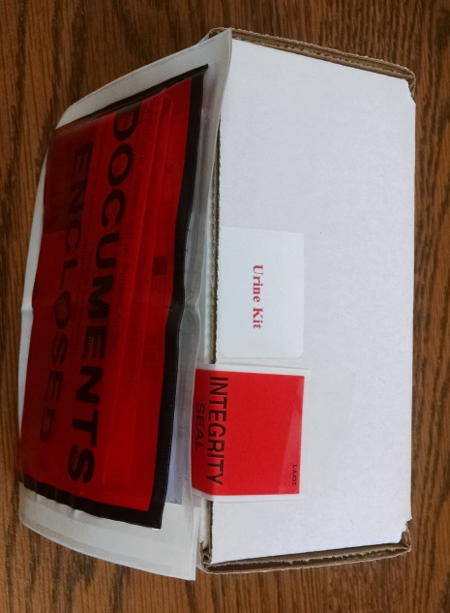
- Send the kit via Certified Mail so that it will require a signature when it is received at the lab.

