Looking for information on LTSS?

Access MyPlace CT at the following link:

<http://www.myplacect.org/>

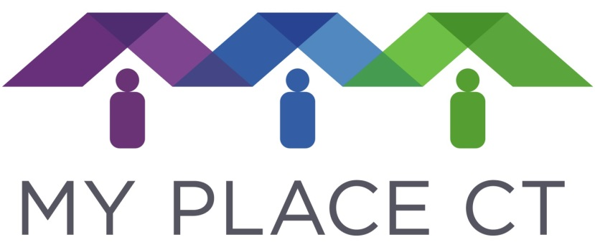

Connecticut HUSKY Health: Rebalancing of Long-Term Services & Supports

## Key Strategies:

The Department of Social Services Division of Health Services is employing diverse strategies to achieve improved health outcomes and cost efficiencies in the Medicaid program. Strategies include:

1. use of a self-insured, managed fee-for-service platform to promote efficient, cost-effective and consumer/provider responsive Medicaid medical, behavioral health, dental and non-emergency medical transportation services
2. use of data analytics to improve care
3. activities designed to improve access to and use of primary care
4. efforts to integrate health, LTSS and social services
5. **initiatives designed to “re-balance” spending on LTSS (shifting from institutional to community-based care)**
6. efforts to promote the use of health information technology

### Connecticut Department of Social Services

Rebalancing refers to reducing reliance on institutional care and expanding access to community-based long-term services and supports (LTSS). A rebalanced LTSS system gives Medicaid members greater choice in where they live and from whom they receive services. It also delivers LTSS that are integrated, effective, efficient, and person-centered. Achieving a rebalanced LTSS system requires that states examine current policies, services, access, and other systemic elements that may present challenges to rebalancing goals. In January 2013, the Governor, the Office of Policy and Management and the Department of Social Services released the state’s Strategic Plan to Rebalance LTSS.  Updated in 2019, this plan details diverse elements of a broad agenda that is designed to support older adults, people with disabilities and caregivers in choice of their preferred means, mode and place in which to receive LTSS.  Key aspects of the plan include: 1) continued support for the Money Follows the Person program; 2) activities in support of enhancing community-based services; 3) nursing home diversification; 4) housing; and 5) workforce development. The Strategic Plan also identifies “hot spots” for development of services, including medical services, by projecting demand attributed to the aging population at a town level. Consistent with the Supreme Court’s decision in *Olmstead,* the Strategic Plan supports provision of services in the most integrated setting that is appropriate for each individual.

## Why Are We Focusing Here?

Consumers overwhelmingly wish to have meaningful choice in how they receive needed long-term services and supports. Connecticut’s Medicaid spending remains weighted towards institutional settings, but rebalancing is shifting this. Continuing to build on these efforts is essential given that community supports cost half as much on average as do institutional supports, and the growth in future demand for long-term services and supports is estimated to grow as much as 25% over the next seven years.

# What is Rebalancing?

## Key Strategies:

* **Money Follows the Person.** The Money Follows the Person (MFP) initiative has led efforts toward systems change in LTSS. In addition to being the main driver behind the transition of over 5,700 individuals from nursing facilities to the community, MFP is implementing diverse strategies that support system change. These include housing development, workforce development, LTSS service and systems gap analysis/recommendations and hospital discharge planning interventions.
* **Universal Assessment and Allocation Methodology.** Connecticut received a federal grant of $72.8 million under the Balancing Incentive Program (BIP), and an additional performance-related award of $4.2 million in 2012. One significant accomplishment of the award was the development and implementation of a universal assessment across all LTSS populations. The assessment tool is linked to an algorithm which uses clinical data to develop level of need groupings. The level of need groupings and associated budget allocation methodology aims at ensuring equitable distribution of funds across all LTSS populations.
* **MyPlaceCT.** An additional accomplishment of the BIP was the establishment of a web-based platform called “MyPlaceCT.” Coordinated with 2-1-1, MyPlaceCT increases access to comprehensive information regarding LTSS.
* **Community First Choice (CFC).** Launched in July, 2015, CFC enables Medicaid members who require nursing facility or other institutional level of care to self-direct community-based services including personal care attendants under individual budgets, with the support of a fiscal intermediary.
* **Nursing Home Diversification.** Another important historical feature of rebalancing was $40 million in grant and bond funds through SFY 2017 that was dedicated to nursing facilities that were interested in diversifying their scope to include home and community-based services.
* **Waiver services.** Connecticut is continuing to expand the scope of its Medicaid “waiver” coverage. Waivers permit the state to cover home and community-based long-term services and supports using Medicaid funds. Existing waivers enable services to older adults, individuals with physical disabilities, individuals with behavioral health conditions, children with complex medical profiles, individuals with intellectual disabilities, children with autism spectrum disorder and individuals with acquired brain injury.
* **Preadmission Screening.** The Department utilizes a web-based system for the federally mandated Preadmission Screening and Resident Review (PASRR) program.  The system identifies persons who are in need of both long-term and short-term institutional care, and recommends alternatives to those whose preference is for home and community-based services options.

## What Do We Mean by Person-Centered Care?

We define person-centeredness as an approach that:

* provides the individual with needed information, education and support required to make fully informed decisions about his or her care options and, to actively participate in his or her self-care and care planning;
* supports the individual, and any representative(s) whom he or she has chosen, in working together with his or her non-medical, medical and behavioral health providers and care manager(s) to obtain necessary supports and services; and
* reflects care coordination under the direction of and in partnership with the individual and his/her representative(s); that is consistent with his or her personal preferences, choices and strengths; and that is implemented in the most integrated setting.

Re-balancing is an overarching agenda that is focused on enabling choice for consumers, optimizing use of public spending on long-term services and supports, and diversification of provider services.