MINIMUM INVENTORY REQUIREMENTS

**6 gallons any combination of gallons and/or half gallons of**

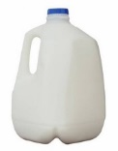 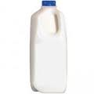

1% low-fat, Skim, Fat free/non-fat milk

**_________________________________________________________________________________________________________**

[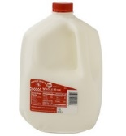](http://www.google.com/url?sa=i&rct=j&q=whole+milk&source=images&cd=&cad=rja&docid=z-d2toXHJcIYVM&tbnid=S-vxNH6GXuubsM:&ved=0CAUQjRw&url=http://www.aedairy.com/products.cfm?ProductCategoryID%3D53ee2679-65be-f4bb-adf0-0af9721d3834%26ProductID%3Dabdb49d4-65be-f4bb-a30b-498d55233f12&ei=B3oQUY3pArS40gHM_IHwCQ&bvm=bv.41867550,d.dmQ&psig=AFQjCNE27G3fz_xlBRGyXHLYy1Jwfp9ALA&ust=1360120673264568)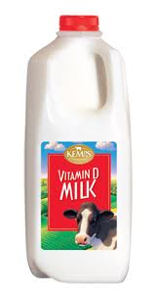

Whole milk

**3 gallons any combination of gallons and/or half gallons of m.**

_______________________________________________________________________

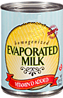 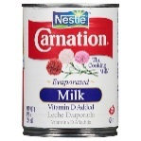**_________________________________________________________________________________________________________**

**12 cans- Evaporated milk, 12 oz. cans** only

Whole, 2%, 1%, or skim

**2 varieties of cheese, 2 Pounds of each variety-8 oz. OR 16 oz. packages only**

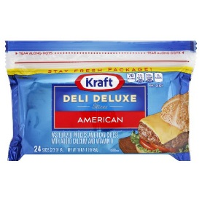 **_______________________________________________________________________________________________________**

No deli, individual wrapped slices, shredded or string cheese, cheese food, cheese product or spreads, cream cheese or cottage cheese, imported, flavored or organic allowed.

**3 varieties of cold cereal, 3 boxes of each variety, 12 oz. box or larger**

[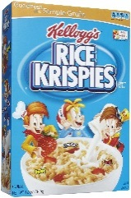](http://r.duckduckgo.com/l/?kh=-1&uddg=http://www.iamthatlady.com/wp-content/uploads/2014/04/rice-krispies.jpg) [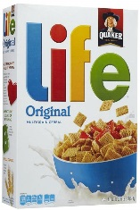](http://r.duckduckgo.com/l/?kh=-1&uddg=http://static1.squarespace.com/static/54a2d5cce4b018d3a300ad05/t/54f7841be4b0c359746c378c/1425507359862/) [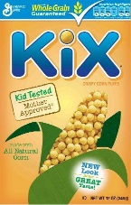](https://duckduckgo.com/l/?kh=-1&uddg=https://s-media-cache-ak0.pinimg.com/736x/93/4b/17/934b1720fe8587f2401078553bb26857.jpg) 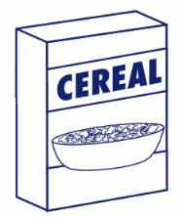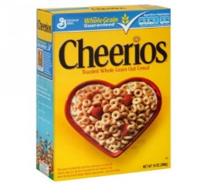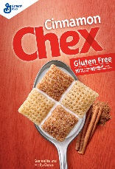 [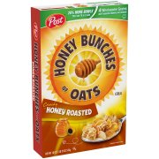](https://www.walmart.com/ip/Honey-Bunches-of-Oats-Honey-Roasted-18-Oz/16785099?wpa_bd=1513922986208&wpa_ref_id=s_1b78644e-a1b1-4bc7-a116-017859973a14&wpa_aux_info=&wpa_tag=&wpa_pos=5&wpa_plmt=1145x1145_T-C-IG_TI_1-2_HL-INGRID-LIST&wpa_aduid=35fbfce1-a9a5-4e5e-80f5-e3baa5e46944&wpa_pg_id=honey%20bunches%20of%20oats&wpa_st=honeybunchesofoats&wpa_tax=976759_976783&wpa_bucket=)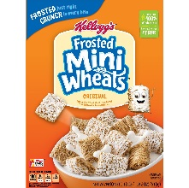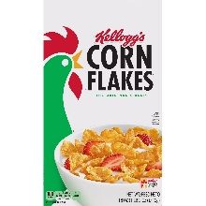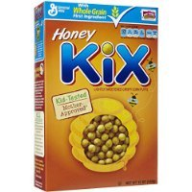

At least one variety must be whole grain 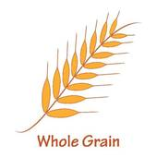

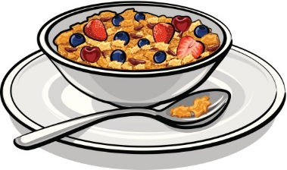

*See Connecticut WIC Approved Food Guide for brands or use the WIC Shopper

**3 Jars, 16–18 oz. Peanut Butter**

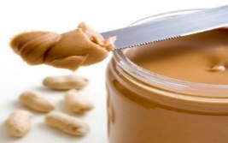_________________________________________________________

Smooth, creamy, crunchy, or chunky unflavored or natural

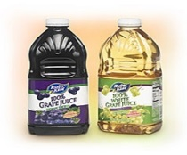K:\Boulette\Food List Project\generic orange juice half gallon.GIF **________________________________________________________________________________________________________**

**3 flavors, 12 Bottles, 64 oz. Plastic bottles only**

Must contain 100% juice, no added sugars

*May include orange juice as 1 variety

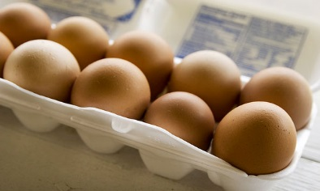 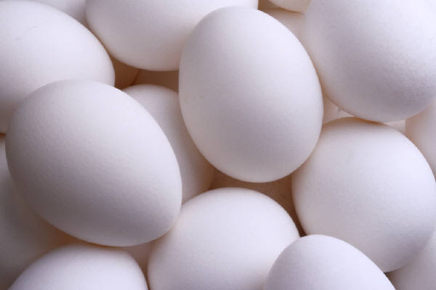

**NO ORGANIC, EXTRA LARGE OR JUMBO**

**4 dozen, white or brown eggs**

Large only, in 1 dozen cartons only

**_________________________________________________________________________________________________________**

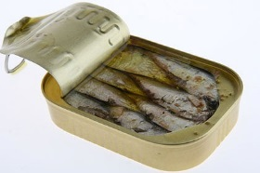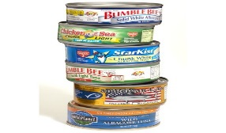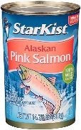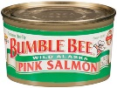

**6 cans of fish, any combination of Sardines, Tuna, and Salmon.**

No red salmon

**3.75 oz. sardines 5 oz. Tuna 5-15 oz. Pink Salmon**

**­­­­­­­­­­­­­­­­­­­­_________________________________________________________________________________________________________**

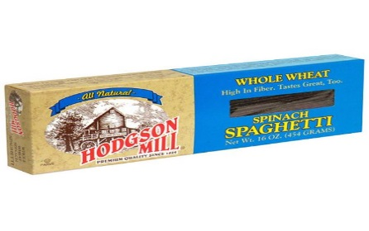 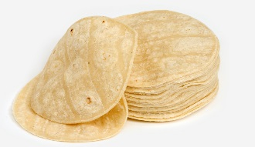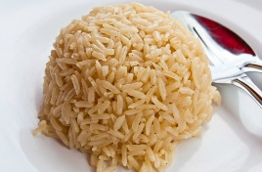 

**6 units any combination:** Whole wheat bread, Whole wheat pasta

Whole wheat tortillas, Corn tortillas (16 oz. /1 lb.), or Brown rice, 14-16 oz. package

s

2 varieties, 4 Bags, one pound, Dry Beans, Peas or Lentils

   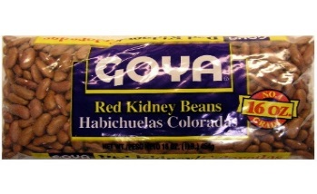

**________________________________________________________________________________________________________**

[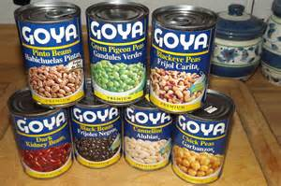](https://www.bing.com/images/search?q=canned+beans&view=detailv2&&id=7C84435CF4AC15F0D19E24A94931BD8996B0E197&selectedIndex=35&ccid=GKUTPYwp&simid=608052952492346734&thid=OIP.M18a5133d8c2968bd6e4a7304975f033fo0)

**8 cans Beans 1 variety**

15–16 oz.

**_________________________________________________________________________________________________________**

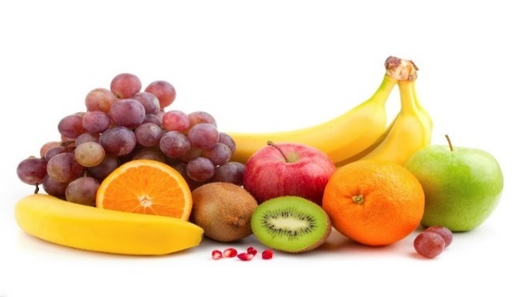Fruits-2 Types must be fresh fruits

**$25** worth of Frozen, Fresh, or Canned

**And**

[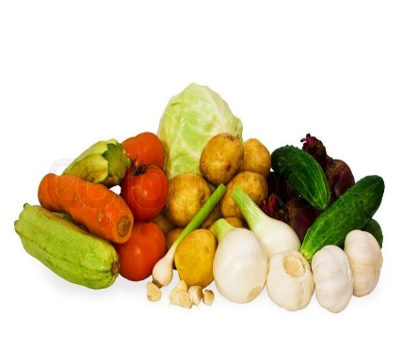](https://duckduckgo.com/l/?kh=-1&uddg=https://www.colourbox.com/preview/2662483-vegetables-cabbage-potato-beet-garlic-onion-cucumber-tomato-carrot.jpg) Vegetables-2 Types must be fresh vegetables

**$25** worth of Frozen, Fresh, or Canned

______________________________________________________________________________________________________ **24 cans: Similac Advance 12.4 oz. powder and/or 13 oz. concentrate**

[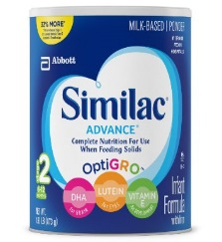](https://www.google.com/url?sa=i&rct=j&q=&esrc=s&frm=1&source=imgres&cd=&cad=rja&uact=8&ved=0ahUKEwjilZ6Nk-LNAhXLNSYKHSQMDBkQjRwIBw&url=https://www.amazon.com/Similac-Advance-Infant-Formula-Powder/dp/B001CCUJOC&psig=AFQjCNGfvogewOQrRThPOzDxkfijyLtB1w&ust=1468008270167503) 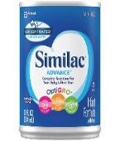

Any combination of powder or concentrate

2 varieties, 3 containers of each variety of infant cereal, 8 oz.

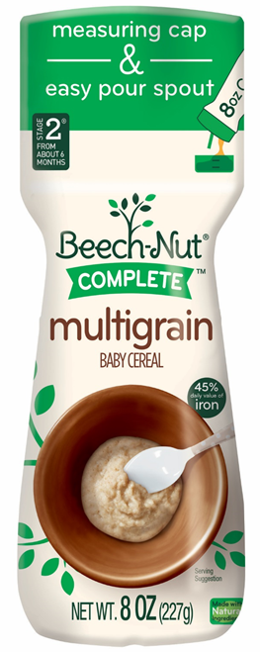 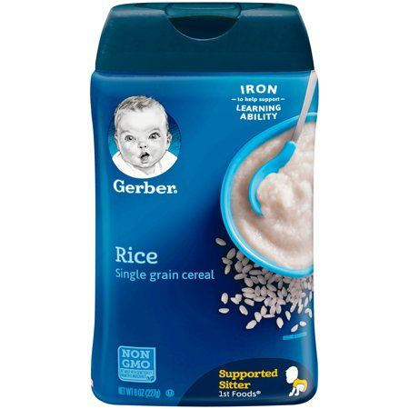 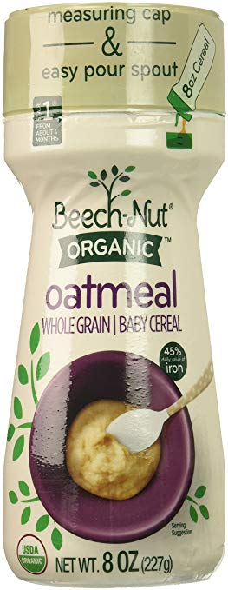 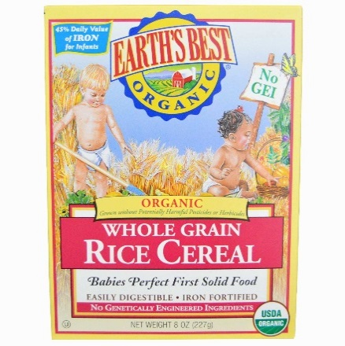 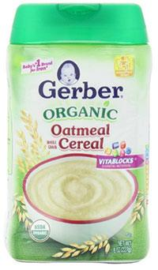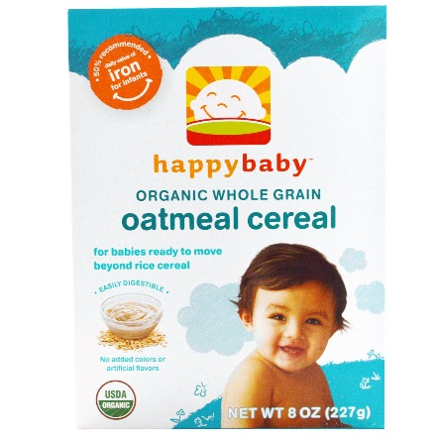

Choice of Rice, Oatmeal, Barley, Multigrain, Organic or Non-Organic, No Pouches. _**________________________________________________________________________________________________________** 2 varieties, 36 Jars or Packages of infant vegetables, 4 oz. or 8 oz. size, single ingredient or mixtures. No Pouches

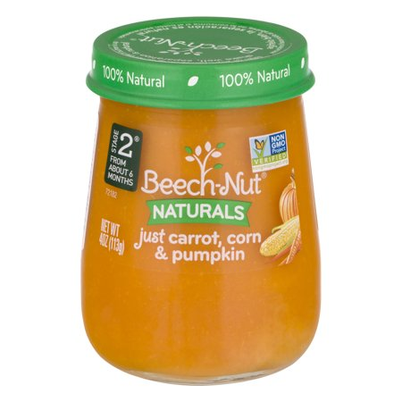 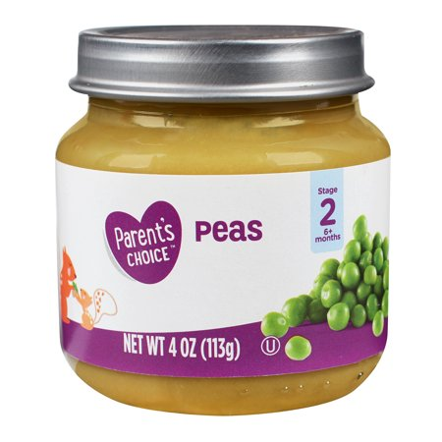 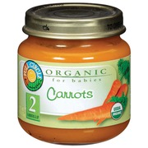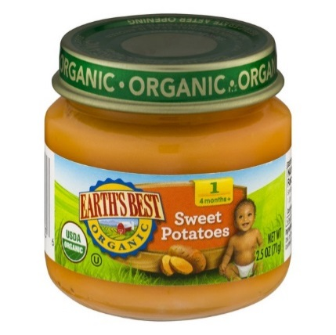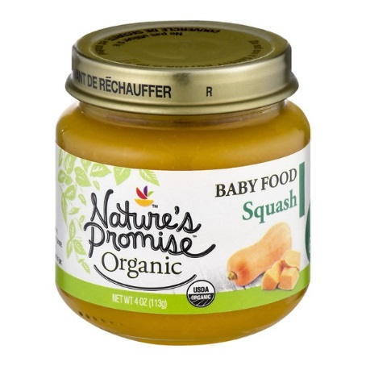**_________________________________________________________________________________________________________** 2 varieties, 36 Jars or Packages of infant fruits, 4 oz. or 8 oz. size, single ingredient or mixtures. No Pouches

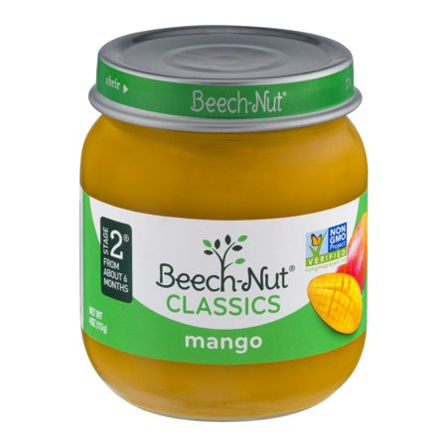 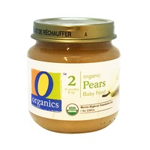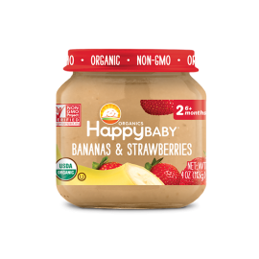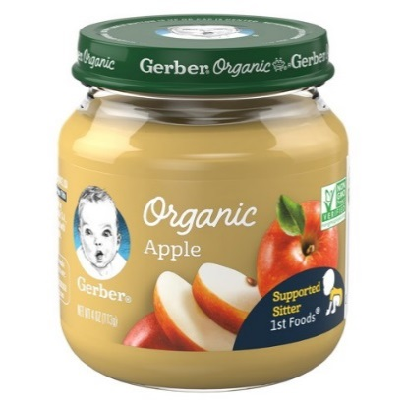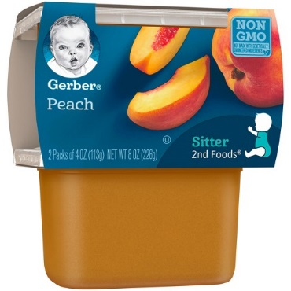

*Please refer to the Connecticut WIC Shopper app. or vendor food guide for approved WIC products.