

**S.CHOOL**

**S.ECURITY**

**C.OMPETITIVE**

**G.RANT**

**P.ROGRAM**

**Round 4 (FY2018)**

**Application Package for:**

**Non-Public Schools and Eligible Licensed Childcare Centers and Pre-schools**



**State of Connecticut**

**Department of Emergency Services and Public Protection**

Division of Emergency Management and Homeland Security

**Due: On or before Tuesday, December 4, 2018**

Contents

Section A. Application Key Points 2

Section B. Application Completion Checklist 3

Section C. Introduction and Program Summary 4

Section D. Instructions to Applicants 6

Section E. Non-Public Applicant Information And Data Sheet 8

Section F. District Information Form and Application Authorization 9

Section G: Program Narrative 10

Section H. Instructions for Budget Work Sheet 11

Section I. School Safety and Security Plan Sign off Sheet 12

Section J. Allowable Project Expenses 13

Section K. Prohibited Expenses 14

Section L. Decision Matrix 14

Section M. Safe Schools Checklist 15

Section N. Supplemental Requirements for Licensed Child Care Centers or Pre-Schools 16

# Section A. Application Key Points

* Only **Round 4 Applications** will be reviewed and scored.
* Applications submitted under prior rounds will not be reviewed. Interested schools that applied under a prior Round and were not funded must submit new Round 4 applications for consideration.
* The Safe Schools Checklist is a portion of the National Clearinghouse for Educational Facilities (NCEF) Safe Schools Facility Checklist. The Safe Schools Checklist is due at the time of application. If awarded, the full NCEF Checklist must be completed prior to reimbursement of eligible expenses.
* The Safe Schools Checklist must be completed by school/daycare center/preschool personnel and a member of local/state police. This assessment is utilized in the ranking of an application and demonstrates a school’s need for additional security.
* When completing the Safe School Checklist, please note:
  + If applying for the reimbursement of projects that have already been completed (from 1/01/2013 - present) - please fill out the checklist as if the projects have not been completed. For example: if a school recently installed a buzzer system and is applying to have those costs reimbursed, they would fill out the checklist showing the buzzers as a gap in their security.
  + If a school received funding in a prior Round for a project and is applying for Round 4 – they must complete a new checklist which considers the prior funded project, as complete and in place.
* Only projects approved as part of the application will be funded. Additional projects cannot be added once an application is approved and awarded.

# Section B. Application Completion Checklist

Section E: Applicant Information and Data Sheet

Section F: Signed District Information Form (list the schools you are applying for under this grant)

Section G: Program Narrative (with each project clearly defined).

Section H: Budget Tool (completed for each school) **A Separate File named “**[**Budget Tool**](http://www.ct.gov/demhs/lib/demhs/school_security/2017/safe_schools_checklist.xlsx)**”**

Section I: Emergency Plan Sign Off

Section M: Safe Schools Checklist - *portion of NCEF Safe Schools Facility Checklist* (complete for each school applying for under this grant). Requires the name of law enforcement officer completing survey. **Separate File named “**[**Safe Schools Checklist**](http://www.ct.gov/demhs/lib/demhs/school_security/2017/safe_schools_checklist.xlsx)**”**

Section N: Threat Listing- for licensed child care centers or preschools that have received threats

**Submission Instructions:** All documents ***MUST*** be submitted electronically and in hardcopy to DESPP/DEMHS on or before December 4, 2018.

**Hardcopy Instructions:** Documents with original signatures must be submitted to DESPP/DEMHS on or before December 4, 2018 at 4:00 pm. If hand carried the documents must be received at 1111 Country Club Road, Middletown, CT by 4:00 pm. Envelopes postmarked by December 4, 2018 will also be accepted, to the following address:

**Department of Emergency Services and Public Protection**

**Division of Emergency Management and Homeland Security**

**Attention: Grants Unit/School Security**

**1111 Country Club Road, 3rd floor North**

**Middletown, CT 06457**

**Electronic Instructions:** Please submit all documents listed above electronically to [schoolsecuritygrant@ct.gov](mailto:schoolsecuritygrant@ct.gov)**.** When submitting electronic applications and attachments to the school security email address - enter the entity applying for the grant in the email subject line. ***Example: “Applicant Name” School Security Application***

The Safe Schools Checklist & Budget Tool must be submitted electronically as Excel Workbooks. Scanned checklists and budgets will result in an incomplete application.

# Section C. Introduction and Program Summary

Public Act 18-178 establish funding for a fourth round of competitive state grants for costs incurred from **January 1, 2013 through June 30, 2021**, inclusive, to improve security infrastructure in schools, eligible child care centers and pre-schools.

Any updates to these application materials will be posted on the DESPP/DEMHS website.

**Program Highlights:**

* Under the law, ten percent of funds available under this program shall be awarded to eligible Non-Public Schools, including eligible licensed child care centers or pre-schools that have received threats. (See **Section N** for definitions and additional application requirements).
* Ninety percent of funds available under this program shall be awarded to eligible Public School Applicants which include: public schools, Regional Educational Service Centers, State Charter Schools, the State Department of Education (SDE) on behalf of Technical High Schools, and Incorporated or endowed high schools or academies approved by SDE pursuant to section 10-34 of the general statutes.
* This is a competitive grant program. If awarded, applicants will be reimbursed for eligible expenses.
* Eligible expenses can be incurred on or after **January 1, 2013**. The period of performance for Round 4 subgrants ends on **June 30, 2021**.
* Eligible Applicants and Match requirements:

Supervisory agent of a non-public school or eligible licensed childcare center and pre-schools: 50% match requirement.

* Eligible expenses include but are not limited to: installation of surveillance cameras, penetration resistant vestibules, ballistic glass, solid core doors, double door access, computer controlled electronic locks, entry door buzzer systems, scan card systems, panic alarms, or systems, real time interoperable communications and multimedia sharing infrastructure, and the training of school personnel in the operation and maintenance of the security infrastructure of school buildings purchased with school funds. In addition, the purchase of portable entrance security devices, including but not limited to metal detector wands and screening machines and related vendor training on equipment purchased/installed under this program is eligible.
* Decisions on eligibility will be made in accordance with the school safety infrastructure standards contained in the [**Report of the School Infrastructure Safety** **Council dated November 2015**](http://das.ct.gov/cr1.aspx?page=421)**.**
* If there are insufficient funds to cover grants to all non-public schools, eligible licensed child care centers and pre-schools, priority shall be given to those with the greatest need for security infrastructure based on the school building security assessments of the schools. The assessment, utilizing a portion of the National Clearinghouse for Educational Facilities’ (NCEF) Safe Schools Facilities Check List (**Section M**) shall be conducted under the supervision of the local law enforcement agency. In addition, priority will be given to applicants that did not receive funding in previous rounds of SSCGP funding.

**Prior to receiving a reimbursement under this grant, the eligible applicant must show that it:**

1. Has conducted a uniform security assessment of its school security, including any security infrastructure, using the National Clearinghouse for Educational Facilities’ Safe Schools Facilities Check List; The full assessment must be filled out and submitted for each school and that receives funding under the grant.
2. The security assessment must be conducted under the supervision of the district’s/schools’ and/or licensed daycare/pre-school’s local law enforcement agency using the Safe Schools Facilities Check List published by the National Clearinghouse for Educational Facilities. The full checklist is available on the DESPP/DEMHS website.
3. Has in place a Security and Safety Plan for the schools under its jurisdiction and periodically practices the Security and Safety Plan. A plan must be in place for each school that receives funding under the grant. Child Care Centers and pre-schools must verify that an emergency plan is in place and exercised regularly.

***PROGRAM POINT OF CONTACT:***

Please direct all questions to the Strategic Planning and Community Preparedness Unit (SPCP)/Grant Unit at the Department of Emergency Services and Public Protection’s Division of Emergency Management and Homeland Security. You may reach us by email at [schoolsecuritygrant@ct.gov](mailto:schoolsecuritygrant@ct.gov) .

# Section D. Instructions to Applicants

Below are instructions for filling out each of the forms contained in this grant application kit. Please fill out these forms completely and accurately. If you need assistance filling out this kit, please contact the DESPP/DEMHS SPCP/Grants Unit by email at [schoolsecuritygrant@ct.gov](mailto:schoolsecuritygrant@ct.gov). For all forms that require an original signature, the signature location on the form will be indicated by this tab:

**SIGN**

**H E R E**

**Section E. The Applicant Information and Data Sheet:**

The Applicant Information and Data Sheet is the form that provides DESPP/DEMHS with all of your organization’s contact and audit information. Please provide the requested information in Boxes 1 through 12 of this form. As the preparer of this document, include your name and contact information in the appropriate boxes. DESPP/DEMHS grants staff may contact you if questions arise during the review of the application.

Box 4 is intended for the person authorized to sign documents on behalf of your organization. All official documents must be signed by that authorized signatory.

**Section F. District Information and Application Authorization Form:**

Please list the name and address of each school applied for under this grant. Please indicate if a Security and Safety Plan is in place for each school. The authorized signatory should sign in Box 2.

**Section G. The Program Narrative Form:**

Use the Program Narrative form to provide an overview of your proposed project(s). Your answers to the five questions on this form should provide DESPP/DEMHS with additional detail on your proposed budget and what your organization plans to accomplish with this grant funding. If you are applying for more than one school, please include in your narrative the proposal for each school.

**Section H. Project Budget Tool: Separate attachment – (At a high level) Excel File name:** [**Budget Tool**](http://www.ct.gov/demhs/lib/demhs/school_security/2017/safe_schools_checklist.xlsx)

The Project Budget Tool allows you to select your project line items from the available dropdown menu. For example: Ballistic Glass and/or Film. Your proposed budget line items should be consistent with the allowable expenses in Section J of this package. If your project is not included in the dropdown menu, type the description under the “other” category. Please be sure to enter your municipal/organization name at the top of the sheet.

**Section I. School Safety and Security Plan Sign Off Sheet**

This form serves as documentation that each school, included within the application, has a school security and safety plan meeting the standards set forth in the [School Security and Safety Plan Standards](http://www.ct.gov/demhs/cwp/view.asp?a=4679&Q=553694&PM=1) and that the plan has been exercised.

**Section J. Allowable Program Expenses:**

Reimbursements are allowed in three areas: 1) for improvements to the security infrastructure at the school including but not limited to: installation of surveillance cameras, penetration resistant vestibules, ballistic glass, solid core doors, double door access, computer controlled electronic locks, entry door buzzer systems, scan card systems, real time interoperable communications and multimedia sharing infrastructure panic alarms, or systems; 2) the purchase of portable entrance security devices, including but not limited to metal detector wands and screening machines, and related training; 3) Vendor costs for training of school security personnel in the operation and maintenance of the security infrastructure purchased under this grant program.

**Section K. Prohibited Expenses:**

See this section for the list of prohibited items.

**Section L: Decision Matrix:**

This section outlines the process used to rank eligible projects.

**Section M: NCEF Security Assessment Check off Sheets:**

The program requires that a security assessment is completed for each school included in your Grant Application. Public Act 14-98 specifies that these assessments must utilize the National Clearinghouse for Education Facilities’ Safe Schools Facilities Checklist. For this application, a select portion of the assessment has been identified (Safe Schools Checklist). Please answer YES or NO to each of the questions. Additional comments will not be considered in the application ranking process. This is a Separate Excel File named **“Safe Schools Checklist”.**

If awarded, the full National Clearinghouse for Education Facilities’ Safe Schools Facilities Checklist must be completed prior to reimbursement

**Section N: Supplemental Requirements for Licensed Child Care Centers of Preschools that have received threats:**

This form is required as part of an application for eligible licensed private Child Care Centers and Pre-Schools. Please fill out this form in its entirety.

# Section E. Non-Public Applicant Information And Data Sheet

|  |  |
| --- | --- |
| ***Mail Completed Application To:***  *Department of Emergency Services and Public Protection*  *Attention: Grants Unit/School Security*  *1111 Country Club Road, 3rd floor North*  *Middletown , CT 06457*  ***E-mail Completed Application To:***  [*schoolsecuritygrant@ct.gov*](mailto:schoolsecuritygrant@ct.gov)  *Subject:* ***“Applicant Name”******School Security Application*** | **1. Name of Applicant:**  **2. Type of Applicant:**  Eligible Childcare Center  Eligible Pre-School  Eligible Non-Public School |
| **GENERAL INFORMATION** | |
| **3. Point of Contact (Project Director) Name & Address**  Name:       Title:  Organization:  Address Line 1:  Address Line 2:  City/State/Zip:  Phone:       Fax:  E-mail: | **4. Official Authorized to Sign for the Applicant:**  Name:       Title:  Organization:  Address Line 1:  Address Line 2:  City/State/Zip:  Phone:       Fax:  E-mail: |
| **5. Application Prepared by: (If Different than Point of Contact)**  Name:       Title:  Organization:  Address Line 1:  Address Line 2:  City/State/Zip:  Phone:       Fax:  E-mail: | **6. Financial Officer**  Name:       Title:  Organization:  Address Line 1:  Address Line 2:  City/State/Zip:  Phone:       Fax:  E-mail: |
| **7. Applicant Federal Employer Identification Number:**        **DUNS:** | |
| **AUDIT INFORMATION** | |
| **Please note that the information required for boxes 8 through 12 refers to the grantee’s audit cycle.** | |
| **8. Applicant Fiscal Year End:** | **9. Date of Last Audit:** |
| **10. Dates Covered by Last Audit:**       to | **11. Date of Next Audit:** |
| **12. Dates to be Covered by Next Audit:**       to | |

# Section F. District Information Form and Application Authorization

**SIGN**

**H E R E**

|  |  |  |  |
| --- | --- | --- | --- |
| 1. **List of School(s) and licensed Childcare or Pre-School Centers to be considered under this grant program:** | | | |
| **Name of School:** | **Address of School:** | **Funding Received under Round 2-3**  **Yes  No** | **Emergency Plan in Place :**  **Yes  No** |
| **Name of School:** | **Address of School:** | **Funding Received under Round 2-3**  **Yes  No** | **Emergency Plan in Place:**  **Yes  No** |
| **Name of School:** | **Address of School:** | **Funding Received under Round 2-3**  **Yes  No** | **Emergency Plan in Place:**  **Yes  No** |
| **Name of School:** | **Address of School:** | **Funding Received under Round 2-3**  **Yes  No** | **Emergency Plan in Place:**  **Yes  No** |
| **Name of School:** | **Address of School:** | **Funding Received under Round 2-3**  **Yes  No** | **Emergency Plan in Place:**  **Yes  No** |
| **Name of School:** | **Address of School:** | **Funding Received under Round 2-3**  **Yes  No** | **Emergency Plan in Place:**  **Yes  No** |
| **Name of School:** | **Address of School:** | **Funding Received under Round 2-3**  **Yes  No** | **Emergency Plan in Place:**  **Yes  No** |
| **Name of School:** | **Address of School:** | **Funding Received under Round 2-3**  **Yes  No** | **Emergency Plan in Place:**  **Yes  No** |
| **Name of School:** | **Address of School:** | **Funding Received under Round 2-3**  **Yes  No** | **Emergency Plan in Place:**  **Yes  No** |
| **Name of School:** | **Address of School:** | **Funding Received under Round 2-3**  **Yes  No** | **Emergency Plan in Place:**  **Yes  No** |
| **Name of School:** | **Address of School:** | **Funding Received under Round 2-3**  **Yes  No** | **Emergency Plan in Place:**  **Yes**   **No** |
| **2. Signature by Authorized Signatory:**  **I, the undersigned, for and on behalf of the named Applicant, do herewith apply for this application, attest that, to the best of my knowledge, the statements made in this application and accompanying forms are true to the best of my knowledge, and agree to any general or special grant conditions attached to this grant application form.**  **My signature further certifies that I understand the following:**   * **I have the authority to submit this grant application on behalf of the applicant.** * **That the applicant is aware that all costs must be funded up front by the applicant, and that a portion will be reimbursed based on the reimbursement rate as prescribed in the authorizing legislation.** * **The funding associated with this program is one-time in nature and that there is no obligation for additional funding from the State of Connecticut and Administering Agency.**   **SIGNATURE OF AUTHORIZED OFFICIAL: X __________________________________________ DATE: ____________________** | | | |

# Section G: Program Narrative

|  |
| --- |
| **Provide a brief overview of your grant application**: *if applying for more than one school/ child care pre-school facility please identify proposed projects at each school* |
|  |
| **Needs Statement:** *Provide a brief description of the problem or gap that will be addressed using grant funding.* |
|  |
| **Target Population:** *Identify the target school(s)/facility(ies) that will be served by this grant.(Childcare Center, Pre-School or Private School)* |
|  |
| **Goals and Objectives:** *List goals (what is this project trying to accomplish) and objectives (how goals will be achieved, including how these measures will work within your school environment).* |
|  |
| **Evaluation:** *Indicate how you will measure success of your project (through drills, testing if applicable)* |
|  |
| **Project Schedule:** *Estimated Time Line of Project* |
|  |

Section H. Instructions for Budget Work Sheet

**Provided as a Sample Only**

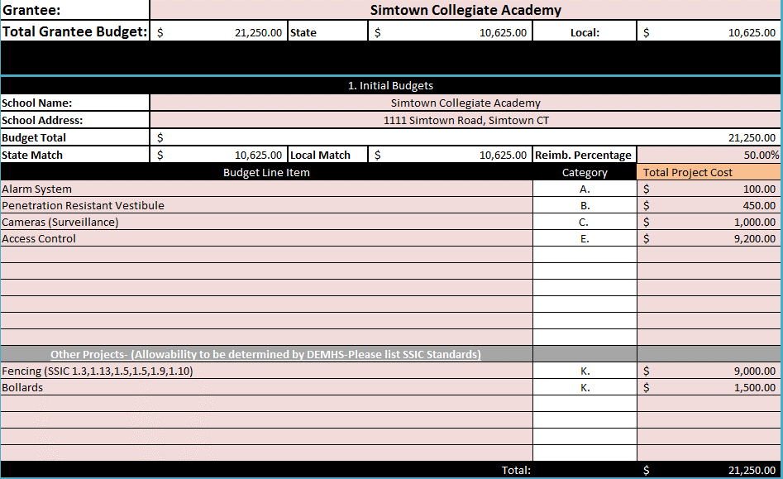

Enter project title & project totals. *Total project cost includes match*

Enter name and address of school

Please enter budget into separate Excel Spreadsheet named **“**[**Budget Tool**](http://www.ct.gov/demhs/lib/demhs/school_security/2017/safe_schools_checklist.xlsx)**”**

* Select the budget line item from the drop-down provided (category column will automatically fill out with your selection). If the Item is not included in the drop-down, list it in the “other” budget line items section (DEMHS staff will review these items for their eligibility in relation to the School Safety Infrastructure Council or SSIC standards).
* Training costs are allowable only if provided by the vendor for allowable equipment purchased with this grant. Please indicate whether training will occur in your project narrative.
* If awarded a grant, the applicant will be reimbursed for the completed items listed on the budget, no new projects will be allowed.

Section I. School Safety and Security Plan Sign off Sheet

**Please Note:**

* **This form can be submitted at the time of application or at the time of reimbursement.**
* **If one person serves multiple roles, they may sign for both roles.**
* **In lieu of this form, a signature sheet associated with this plan which includes the signatures of these officials may be submitted.**

**Applicant:** **Date Emergency Plan last exercised:**

**Note:** By signing the document, the signatory is attesting the school(s) for which reimbursement is being sought has an emergency plan in place, which meets the School Security and Safety Plan Standards developed in concert with the appropriate local first responders and officials.

If awarded, schools must submit a copy of their school security and safety plan prior to final reimbursement. School Plans must be submitted to the appropriate DEMHS Regional Coordinator in accordance with Connecticut General Statutes Section 10-292r (b).

**Signature**

**____________________________ ___________**

**Local Law Enforcement Agency Date**

**____________________________ ___________**

**Fire Chief Date**

**____________________________ ___________**

**Local Fire Marshal Date**

**____________________________ ___________**

**Local Emergency Medical Services Date**

**____________________________ ___________**

**Local Emergency Management Date**

**Director**

**____________________________ ___________**

**Local Public Health Director Date**

Section J. Allowable Project Expenses

Please note that this is a **REIMBURSEMENT ONLY** grant program. If awarded, the applicant must purchase the approved items using its own procurement and bidding processes.

If awarded funding, following project completion and payment of vendors, a reimbursement form must be submitted to DESPP**.** The Reimbursement Procedure and Forms may be found on our website.

**Equipment and equipment related training**:

The following equipment items may be purchased under this program (Dropdown in Budget Tool).

Improvements to the security infrastructure at the school including but not limited to:

* installation of surveillance cameras
* penetration resistant vestibules
* ballistic glass
* solid core doors
* double door access
* computer controlled electronic locks
* entry door buzzer systems
* scan card systems
* panic alarms or systems
* the purchase of portable entrance security devices, including but not limited to metal detector wands and screening machines
* real time interoperable communications
* multimedia sharing infrastructure
* vendor costs for the training of personnel in the operation/ maintenance of security enhancements obtained under this grant (vendor training costs should be explained in the project narrative and rolled into the project line item)

Other items may be allowable under this program, questions regarding additional eligible items may be directed to [schoolsecuritygrant@ct.gov](mailto:schoolsecuritygrant@ct.gov).

Decisions on eligibility will be made in accordance with the School Safety Infrastructure Standards contained in the [**Report of the School Infrastructure Safety** **Council dated November 2015**](http://das.ct.gov/cr1.aspx?page=421)**.**

A Frequently Asked Questions Document (FAQ) will be maintained on the DESPP/ DEMHS and SDE website. Additional items that are determined to be eligible will be added to FAQ.

Section K. Prohibited Expenses

1. Any costs and projects currently included in applications under the following funding sources including but not limited to the following:
   1. State Department of Education
   2. Department of Administrative Services, Bureau of School Construction
   3. Office of Early Childhood
   4. Office of Policy and Management (LOCIP)
   5. Other State and Federal funding sources.
2. Personnel Costs.
3. Training Costs that are not vendor costs related to training staff on equipment purchased/installed under the grant.
4. Replacement of landscaping, plantings etc.
5. Any items deemed ineligible after review by the School Security Grant Program Working Group and/or DESPP/DEMHS.
6. In-Kind Services

Section L. Decision Matrix

Of the applicants on behalf of such schools with **greatest need** for security infrastructure, **first priority** shall be given to applicants on behalf of schools that have **no security** infrastructure at the time of the school building security assessment.

New applicants will be given priority over applicants who have received funding under prior rounds.

Section M. Safe Schools Checklist

As a requirement of this application, each school seeking funding must complete an evaluation utilizing the Safe Schools Checklist. This evaluation must be completed under the supervision of a local law enforcement representative. This shortened checklist utilizes key questions from the longer NCEF Checklist which is required prior to reimbursement.

The Excel spreadsheet**,** [**“Safe Schools Checklist”**](http://www.ct.gov/demhs/lib/demhs/school_security/2017/safe_schools_checklist.xlsx) must be completed and submitted electronically in addition to submitting a printed copy with the application.

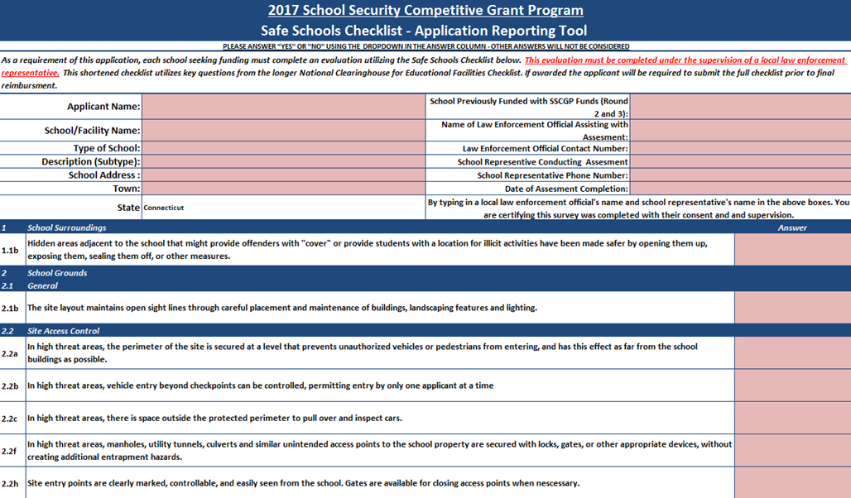

# Section N. Supplemental Requirements for Licensed Child Care Centers or Pre-Schools

**This form is ONLY required for licensed Pre-Schools and Child Care Centers applicants**

**Overview:**

Public Act **17-98** (and 18-178) enable licensed pre-schools and child care centers that have received threats to apply for this grant program. This form is designed to assist in the gathering of information to ensure the grantee meets the intent of the legislation.

**Verification:**

A subcommittee of the School Security Grant Program Working Group will be tasked with reviewing each application and ensuring that each application meets the necessary requirements. The grantee may be requested to verify reported information by providing documentation.

|  |
| --- |
| **Important Definitions**  **Threat**   * A “Threat” means an oral or written message, or physical action, which demonstrates an intent to create an imminent safety risk to person or property or to create a fear of such risk. This definition is based on a number of state statutes, including Conn. Gen. Stat. 53a-62 and Conn. Gen. Stat. 1-210(b)   **Child Care Centers**   * A “Child Care Center” is a center that offers or provides a program of supplementary care to more than twelve related or unrelated children outside their own home on a regular basis.   **Pre-Schools**   * A “Pre-school” is a facility that offers early childhood education for three (3) year to five (5) year olds. |

**This form is ONLY required for licensed Pre-Schools and Child Care Centers applicants**

**Instructions:** For the questions below, please provide information on threats received.

     

**Name of Pre-School or Licensed Child Care Center License No. (Child Care Center)**

1. **Is the Pre-School or Licensed Daycare Center a member of a broader community that has received threats or does it serve a community that has received such threats? Please explain in detail the nature of these threats.**
2. **Number of threats received at the center/ pre-school during the period from 1/01/2013 through 6/30/2018:**
3. **For each specific threat included in number 2 above please provide the following:**

|  |  |  |  |  |
| --- | --- | --- | --- | --- |
| **Date of Incident** | **Type of Threat** | **Law Enforcement/Other Agency Notified** | **# of People Potentially Affected** | **Severity of threat? Comments about threat** |
|  |  |  |  |  |
|  |  |  |  |  |
|  |  |  |  |  |
|  |  |  |  |  |
|  |  |  |  |  |
|  |  |  |  |  |
|  |  |  |  |  |
|  |  |  |  |  |

|  |
| --- |
| I, the undersigned, verify the accuracy and authenticity of the data provided above. I am aware that I may be requested to furnish further documentation and/or explanation to DESPP/DEMHS.  **SIGN**  **H E R E**  SIGNATURE OF AUTHORIZED OFFICIAL: X ___________________________ DATE: ____________________ |