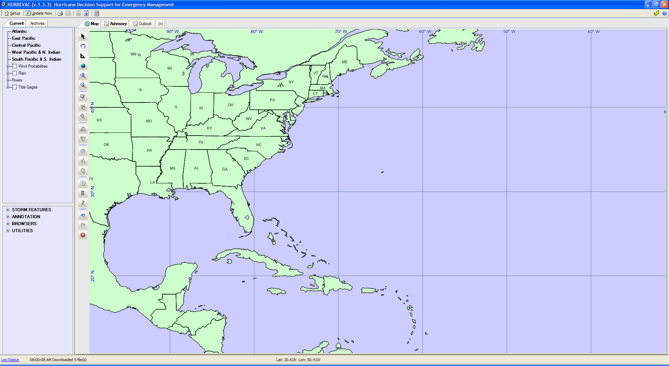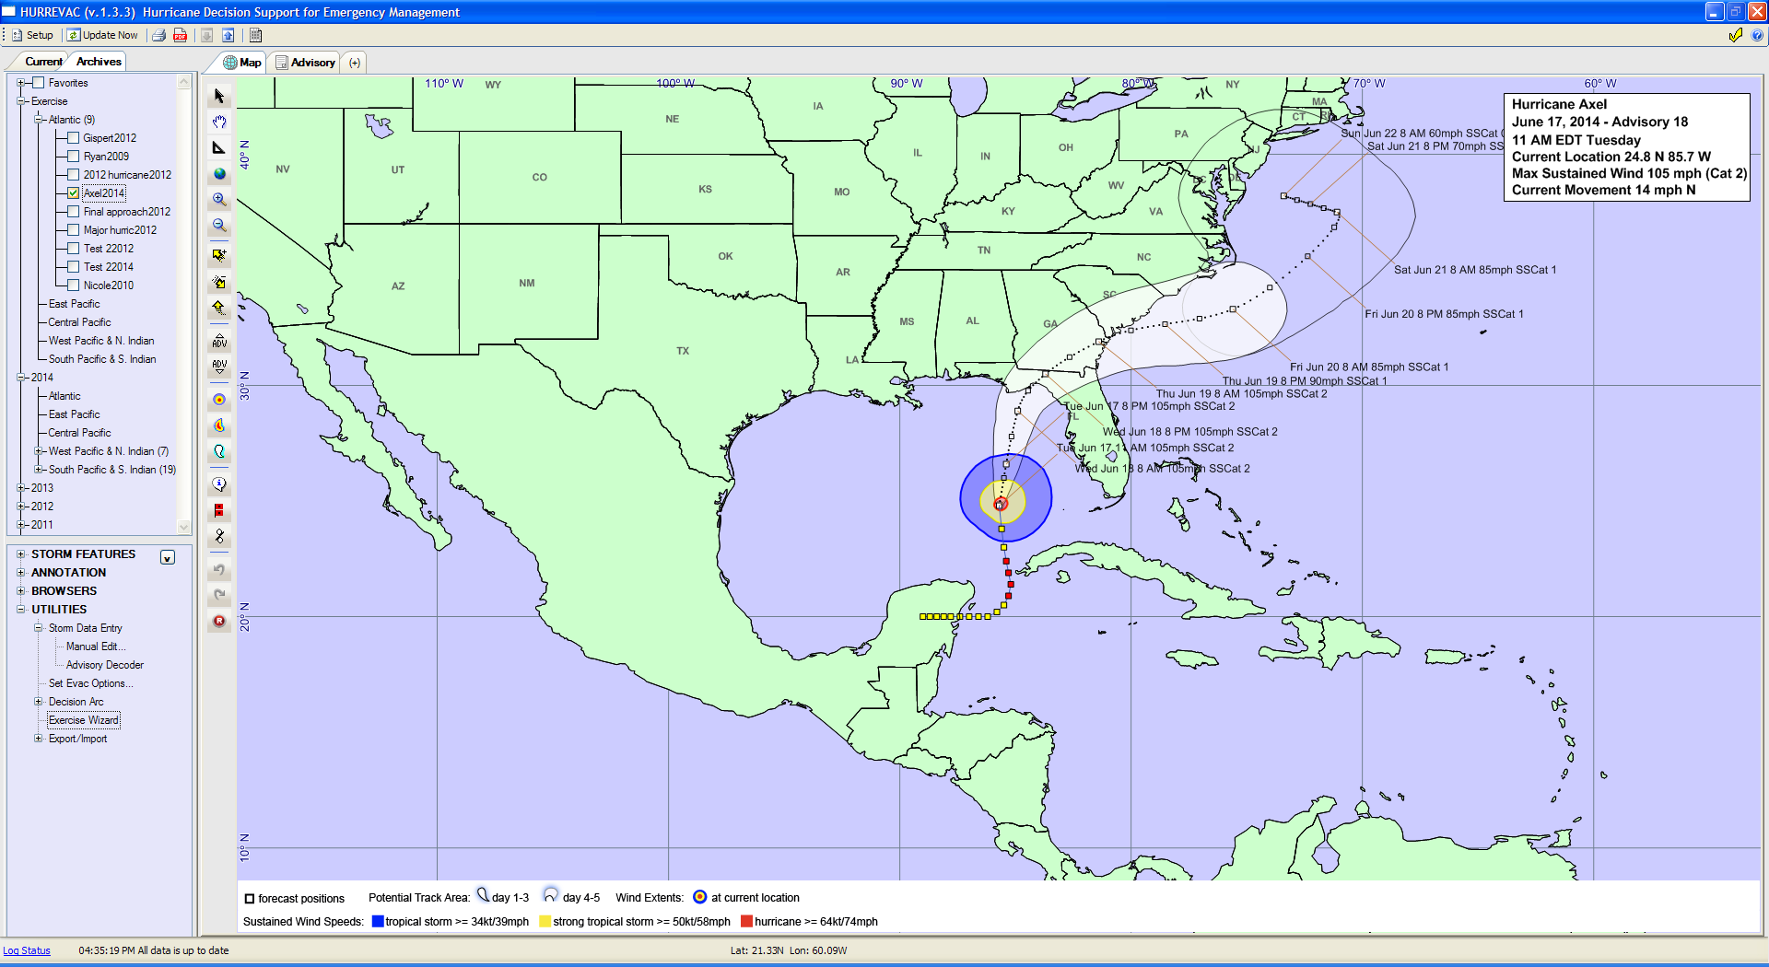

**Puerto Rico**

**Haiti Dominican**

**Republic**

Sun Jun 22 8 AM 55 mph SSCat 0

Sat Jun 21 8 PM 75 mph SSCat 1

Sat Jun 21 8 AM 80 mph SSCat 1

Fri Jun 20 8 PM 85 mph SSCat 1

Thu Jun 19 8 AM 100 mph SSCat 2

Wed Jun 18 8 PM 100 mph SSCat 2

Wed Jun 18 8 AM 90 mph SSCat 1

Tue Jun 17 8 PM 85 mph SSCat 1

Fri Jun 20 8 AM 90 mph SSCat 1

Thu Jun 19 8 PM 95 mph SSCat 1

Tue Jun 17 8 AM 80 mph SSCat 1

**Turks and Caicos Islands**

**2014 EPPI Exercise**

**Hurricane Axel**

**June 17, 2014 – Advisory #27**

**9:00 AM EDT – Tuesday**

**Current Location 21.9 N 74.5 W**

**Max Sustained Wind 80 MPH (Cat 1)**

**Current Movement 12 mph NNE**

**THIS IS AN EXERCISE**

**THIS IS AN EXERCISE - THIS IS AN EXERCISE - THIS IS AN EXERCISE**

**THIS IS AN EXERCISE**

**Belize**

**Nicaragua**

**El Salvador**

**Honduras**

**Guatemala**

**Mexico**

**Aruba**

**Cayman Islands**

**Bermuda**

**Bahamas**

**Cuba**

**THIS IS AN EXERCISE**

BULLETIN

hurricane axel adVISORY NUMBER 27

NWS NATIONAL HURRICANE CENTER MIAMI FL AL092013

900 AM EDT tues JUNE 17 2014

...hurricane warnings in effect for the southeastern bahamas...

SUMMARY OF 900 AM AST...1300 UTC...INFORMATION

----------------------------------------------

LOCATION...21.9N 74.5W

ABOUT 15 MI...25 KM Sw OF acklins island in the bahamas

MAXIMUM SUSTAINED WINDS...80 MPH...130 KM/H

PRESENT MOVEMENT...nne OR 20 DEGREES AT 12 MPH...19 KM/H

MINIMUM CENTRAL PRESSURE...984 MB...29.06 INCHES

WATCHES AND WARNINGS

--------------------

CHANGES WITH THIS ADVISORY...

THE GOVERNMENT OF CUBA HAS DISCONTINUED THE HURRICANE WARNING FOR THE EAST COAST OF CUBA...

SUMMARY OF WATCHES AND WARNINGS IN EFFECT...

A HURRICANE WARNING REMAINS IN EFFECT FOR THE SOUTHEAST BAHAMAS...

PREPARATIONS TO PROTECT LIFE AND PROPERTY IN THE HURRICANE WARNING

AREA SHOULD BE RUSHED TO COMPLETION.

FOR STORM INFORMATION SPECIFIC TO YOUR AREA...PLEASE MONITOR

PRODUCTS ISSUED BY YOUR NATIONAL METEOROLOGICAL SERVICE.

DISCUSSION AND 48-HOUR OUTLOOK

------------------------------

AT 900 AM EDT...1300 UTC...THE CENTER OF HURRICANE AXEL

WAS LOCATED NEAR LATITUDE 21.9 NORTH...LONGITUDE 74.5 WEST. THE

HURRICANE IS MOVING TOWARD THE NORTH NORTHEAST AT 12 MPH...19 KM/H. HURRICANE AXEL is forecast to GRADUALLY turn to the north during the next 12 hours with a turn to the north northWEST by 24 hours...ON THE FORECAST TRACK...THE CENTER OF THE HURRICANE is forecast to impact the southEASTERN BAHAMAS DURING THE NEXT 12 – 18 HOURS.

MAXIMUM SUSTAINED WINDS ARE NEAR 80 MPH...45 KM/H...WITH HIGHER

GUSTS. satellite imagery AND RECONNAISANCE DATA INDICATES CONTINUED INTENSIFICATION IS IN PROGRESS and ADDITIONAL STRENGTHENING IS expected. AXEL IS FORECAST TO BECOME A CATEGORY II HURRICANE IN 24 – 48 HOURS.

THE ESTIMATED MINIMUM CENTRAL PRESSURE IS 984 MB...29.06 INCHES.

NEXT ADVISORY

-------------

NEXT COMPLETE ADVISORY...1100 AM EDT.

**THIS IS AN EXERCISE**