## cid:image002.jpg@01CC37DA.2C23BE80

**Department of Energy & Environmental Protection**

# Bureau of Materials Management & Compliance Assurance

**79 Elm Street - 4th Floor**

## Hartford, Connecticut 06106-5127

**Annual Municipal Recycling Report**

## This report regarding municipal recycling activity for the previous fiscal year is required to be submitted by September 30th of each year to the Connecticut Department of Energy & Environmental Protection (DEEP) -CGS Sec 22a-220(h).

## Parts 1 through 5 can be completed and submitted to the CT Department of Energy & Environmental Protection via any *one* of the following methods

* 🕿 Fax (860) 424-4059 Attn: Solid Waste Facility Reporting- Paula Guerrera; **Or**
* **🖳** Scanned & E-Mailed To [Paula.Guerrera@ct.gov](mailto:Paula.Guerrera@ct.gov) (Do not send hard copy if sending electronically); **Or**
* **🖃** Land-Mailed to CT DEEP; Bureau of MM&CA – Recycling Office; 79 Elm Street - 4th Floor; -Hartford, CT 06106-5127; Attn: Solid Waste Facility Reporting- Paula Guerrera.
  + Must be double-sided and preferably on paper with a minimum 30% post-consumer content.
  + PLEASE CONSERVE PAPER – Do not send unused pages or sections. Indicate (at bottom of this page) the total number of pages in your report.

**Questions? Please visit the** [**CT DEEP Website**](http://www.ct.gov/dep/cwp/view.asp?a=2714&q=438534&depNav_GID=1645)**, contact** [**Paula Guererra**](mailto:paula.guererra@ct.gov) **(860) 424-3334 or** [**Peter Brunelli**](mailto:peter.brunelli@ct.gov) **(860) 424-3536**

|  |
| --- |
| 1.  ***Name of City/Town***    ***Mailing Address***: Zip Code  2. ***Recycling Contact***: Name:    Title:    Phone #:  Fax #: Email:   1. ***Reporting Period:* July 1, 20       through June 30, 20**   **Number of Pages in This Report:** |

## PART 1: Materials Recycled from *Residential* Sources

| **Materials Recycled from *Residential* Sources** | | | |
| --- | --- | --- | --- |
| **(A)**  **Recyclable Item** | **(B)**  **Name/Address - *First* Destination for *Residential* Recyclables**  (after the municipal transfer station or municipal compost site, if applicable) | **(C)**  **Amount Recycled** | **(D)**  **Units of Measure** |
| **Bottles/Cans/Cartons/Paper (BCP)**   * ***First Destination* Is a**   ***CT SW Facility***    ***Includes Res & NonRes*** | Destination Name:  Town:  State:  **Check all that apply**:  **Single Stream** **Dual Stream** **Material Collected Separately** | **NA** | **NA** |
| Destination Name:  Town:  State:  **Check all that apply:**  **Single Stream** **Dual Stream** **Material Collected Separately** | **NA** | **NA** |
| Destination Name:  Town:  State:  **Check all that apply:**  **Single Stream** **Dual Stream** **Material Collected Separately** | **NA** | **NA** |
| **Bottles/Cans/Cartons/Paper**   * **First Destination Is**   ***NOT* a CT SW Facility**  ***Tonnage Includes Res & NonRes*** | Destination Name:  Town:  State:  **Check all that apply:**  **Single Stream** **Dual Stream** **Material Collected Separately** |  |  |
| Destination Name:  Town:  State:  **Check all that apply:**  **Single Stream** **Dual Stream** **Material Collected Separately** |  |  |
| **For the materials listed below, please report quantity generated in the municipality and recycled thru a program operated by the municipally or thru a municipally contracted program** | | | |
| **Storage Batteries (vehicle batteries)**  **Tonnage Includes Res & NonRes** | Destination Name:  Town:  State: |  |  |
| Destination Name:  Town:  State: |  |  |
| **Scrap Metal –**  ***Tonnage Includes Res & NonRes*** | Destination Name:  Town:  State: |  |  |
| Destination Name:  Town:  State: |  |  |
| **Waste Oil (gallons)**    ***Includes Res & NonRes*** | Destination Name:  Town:  State: |  | Gallons |
| **Used Textiles (clothing, shoes, linens etc.)**  ***Tonnage Includes Res & NonRes*** | Destination Name:  Town:  State: |  |  |
| **Electronics**  Check Types Included:  CEDs (CT e-Waste Recycling Program)  Non-CEDs  Other- Specify:  Other- Specify:  ***Tonnage Includes Res & NonRes*** | Destination Name:  Town:  State: |  |  |
| Destination Name:  Town:  State: |  |  |
| **NiCd Batteries**  ***Includes Res & NonRes*** | Destination Name:  Town:  State: |  |  |
| **C&D Waste Recycled**  **(NOT DISPOSED)** | Destination Name:  Town:  State: |  |  |
| **Source-Separated Organics - For the materials listed below, please report quantity generated in the municipality and recycled thru a program operated by the municipally or thru a municipally contracted program**  ***If source separated organics or any products (compost, mulch, etc.) made from those organics by the municipality are sent to a CT permitted composting or recycling facility, please report the receiving facility so that the tonnage is not 2x counted. Any organic material burned (with or without energy production) cannot be counted as recycled!!!!*** | | | |
| **Incoming Leaves**  1 CY=0.25 tons  ***Tonnage Includes Res & NonRes*** | Leaves are composted at municipal compost site  **Finished compost** is used on municipal sites  **Finished compost** is given or sold to residents |  |  |
| **Finished compost** is sold or sent to a permitted composting or recycling facility  Destination:  Address: |  |  |
| **Leaves** are sent to a permitted composting or recycling facility  Destination:  Address: |  |  |
| Other – Describe  Destination:  Address: |  |  |
| **Brush (from yard waste)**  1CY(loose) = 0.15 tons  ***Tonnage Includes Res & NonRes*** | sent to a permitted composting or recycling facility  Destination:  Address: |  |  |
| chipped and used as mulch on municipal sites  chipped and given to residents  chipped and used as bulking agent in municipal compost site  Other – Describe |  |  |
| **Grass Clippings**  Tonnage Includes Res & NonRes | Grass clippings are composted at municipal compost site |  |  |
| Grass clippings are sent to a permitted composting or recycling facility  Destination:  Address: |
| **Yard Waste Mix**  Check Types Included:  Grass;  Brush;  Leaves  ***Tonnage Includes Res & NonRes*** | Mixed yard waste is composted at municipal compost site  Finished compost is used on municipal sites  Finished compost is given or sold to residents |  |  |
| Finished compost is sold or sent to a permitted composting or recycling facility  Destination:  Address: |  |  |
| Mixed yard waste is sent to a permitted composting or recycling facility  Destination:  Address: |  |  |
| Mixed yard waste - Other – Describe  Destination:  Address: |  |  |
| **Food Scraps**  ***Tonnage Includes Res & NonRes*** | Destination Name:  Town:  State: |  |  |
| Destination Name:  Town:  State: |  |  |

|  |  |  |  |
| --- | --- | --- | --- |
| **Other Materials Collected Through A Municipal Recycling Collection Program** | | | |
| **Disaster Debris Clean Wood**  ***Tonnage Includes Res & NonRes*** | Destination Name:  Town:  State: |  |  |
| Destination Name:  Town:  State: |  |  |
| **Paint**  ***Tonnage Includes Res & NonRes*** | Destination Name:  Town:  State: |  |  |
| **Mattresses**  ***Tonnage Includes Res & NonRes*** | Destination Name:  Town:  State: |  |  |
| **Other – Specify:**    ***Tonnage Includes Res & NonRes*** | Destination Name:  Town:  State: |  |  |
| **Other – Specify:**    ***Tonnage Includes Res & NonRes*** | Destination Name:  Town:  State: |  |  |

## PART 2: Materials Recycled from *NON-Residential* Sources

| ***OTHER RECYCLABLES*** - **Materials Recycled from *NON-Residential* Sources** | | | |
| --- | --- | --- | --- |
| **(A)**  **Recyclable Item** | **(B)**  **Name/Address - *First* Destination for *Other* Recyclables**  (after the municipal transfer station or municipal compost site, if applicable) | **(C)**  **Amount Recycled** | **(D)**  **Units of Measure** |
| ***Non-Residential* Bottles/Cans/Paper (BCP)**   * ***First Destination* Is a**   ***CT SW Facility*** | Destination Name:  Town:  State:  *Check all that apply*:  **Single Stream** **Dual Stream** **Material Collected Separately** | **NA** | **NA** |
| Destination Name:  Town:  State:  *Check all that apply:*  **Single Stream** **Dual Stream** **Material Collected Separately** | **NA** | **NA** |
| Destination Name:  Town:  State:  *Check all that apply*:  **Single Stream** **Dual Stream** **Material Collected Separately** | **NA** | **NA** |
| ***Non-Residential***  **Bottles/Cans/Paper**   * **First Destination Is**   ***Not* a CT SW Facility** | Destination Name:  Town:  State:  *Check all that apply:*  **Single Stream** **Dual Stream** **Material Collected Separately** |  |  |
| Destination Name:  Town:  State:  *Check all that apply:*  **Single Stream** **Dual Stream** **Material Collected Separately** |  |  |
| **Other** Specify Type of Recyclable::  Only Residential  Only Non-Residential  ***Includes Res & NonRes*** | Destination Name:  Town:  State: |  |  |
| **Other**  Specify Type of Recyclable    Only Residential  Only Non-Residential  ***Includes Res & NonRes*** | Destination Name:  Town:  State: |  |  |

**MCj03266380000[1]PART 3: Information Regarding Collectors (Haulers) of Solid Waste (SW) and Recyclables Operating Within the Borders of the Municipality**

Please list below the haulers or collectors operating in your municipality and provide their contact information- including their e-mail address:  **(Please duplicate this page if additional space is needed.)**

|  |  |  |  |  |  |  |  |
| --- | --- | --- | --- | --- | --- | --- | --- |
| **Name of Hauling Company** | **Mailing Address &**  **E-mail Address** | **Contact Name** | **Phone Number** | **Did Hauler** [**Register**](http://www.ct.gov/deep/lib/deep/reduce_reuse_recycle/haulers/hauler_recycling_summary_september_2011.pdf) **in Your Municipality in FY2018?** | **Did Hauler Submit FY2018** [**Annual Report To Your Municipality**](http://www.ct.gov/deep/cwp/view.asp?a=2714&q=468660&deepNav_GID=1645%20)**?** | **Types of SW &/or RECY Hauled by the Collector (e.g. MSW, C&D, Special, Landclearing, Yard Waste;**  **Food Scrap; Recyclables,etc.) Check all that apply.** | **Source of SW & RECY Hauled**  **(e.g. Residential, Non-Residential)**  **Check all that apply.** |
|  | **Mailing:       E-mail:** |  |  | **Yes**  **No** | **Yes**  **No** | **MSW; Recyclables; C&D;**  **Yard Waste Landclearing ;**  **Food Scraps Special Waste**  **Other – Specify-** | **Residential**  **Non-Residential** |
|  | **Mailing:       E-mail:** |  |  | **Yes**  **No** | **Yes**  **No** | **MSW; Recyclables; C&D;**  **Yard Waste Landclearing ;**  **Food Scraps Special Waste**  **Other – Specify-** | **Residential**  **Non-Residential** |
|  | **Mailing:       E-mail:** |  |  | **Yes**  **No** | **Yes**  **No** | **MSW; Recyclables; C&D;**  **Yard Waste Landclearing ;**  **Food Scraps Special Waste**  **Other – Specify-** | **Residential**  **Non-Residential** |
|  | **Mailing:       E-mail:** |  |  | **Yes**  **No** | **Yes**  **No** | **MSW; Recyclables; C&D;**  **Yard Waste Landclearing ;**  **Food Scraps Special Waste**  **Other – Specify-** | **Residential**  **Non-Residential** |
|  | **Mailing:       E-mail:** |  |  | **Yes**  **No** | **Yes**  **No** | **MSW; Recyclables; C&D;**  **Yard Waste Landclearing ;**  **Food Scraps Special Waste**  **Other – Specify-** | **Residential**  **Non-Residential** |
|  | **Mailing:       E-mail:** |  |  | **Yes**  **No** | **Yes**  **No** | **MSW; Recyclables; C&D;**  **Yard Waste Landclearing ;**  **Food Scraps Special Waste**  **Other – Specify-** | **Residential**  **Non-Residential** |
|  | **Mailing:       E-mail:** |  |  | **Yes**  **No** | **Yes**  **No** | **MSW; Recyclables; C&D;**  **Yard Waste Landclearing ;**  **Food Scraps Special Waste**  **Other – Specify-** | **Residential**  **Non-Residential** |

**Attach additional sheets if needed**

**Please note:** All collectors hauling solid waste (including recyclables) generated within the borders of your municipality **are required to: (1) register annually in your municipality and (2) report annually to your municipality – CGS Sec 22a-220a(d).**

**The collector/hauler reporting form can be found at:** [**www.ct.gov/DEEP/solidwastereporting**](http://www.ct.gov/DEEP/solidwastereporting) **or by clicking on links below:**

|  |
| --- |
| Annual ***Collector/Hauler*** Reporting Form to be **submitted to the municipalities** in which the collector/hauler operates[Word](http://www.ct.gov/deep/lib/deep/reduce_reuse_recycle/forms/collector_municipal_annual_report_form_fillable.doc)    [pdf](http://www.ct.gov/deep/lib/deep/reduce_reuse_recycle/forms/collector_municipal_annual_report_form.pdf)    [Instructions](http://www.ct.gov/deep/lib/deep/reduce_reuse_recycle/forms/collector_municipal_annual_report_form_instructions.pdf) |

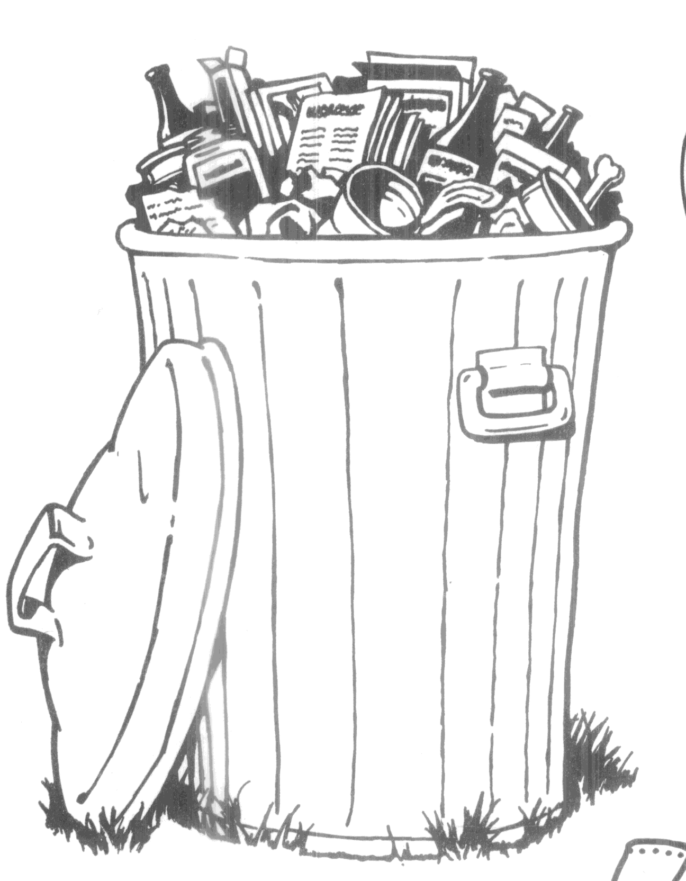 **Part 4: Solid Waste Disposed (Please Report Disaster Debris Separately From Other Material**)

Please indicate the **first destination(s)** (**landfill, resource recovery facility, or regional multi-town transfer station)** where solid waste generated in your town is received for disposal.

* If first destination is your municipal transfer station – report the first destination of waste sent out from your transfer station.
* If first destination is out-of-state, report (in Column C) the tonnage delivered to that facility.
  + If you are unable to get information regarding tonnage sent to that out-of-state facility, report information regarding the hauler who transported that waste out-of-state.

| **(A)**  **Type of Solid Waste Disposed** | **(B)**  **Name and Address of First Destination (i.e. Receiving Facility**  (after the municipal transfer station, if applicable) | **(C)**  **Tons this FY** |
| --- | --- | --- |
| **MSW****1**  **• First Destination Is a *CT SW Facility*** (after the municipal transfer station, if applicable) | Destination Name:  Town:  State: | **NA** |
| Destination Name:  Town:  State: | **NA** |
| **Oversized MSW1-** (furniture, mattresses, carpets, etc)  • **First Destination Is a *CT SW Facility*** (after the municipal transfer station, if applicable) | Destination Name:  Town:  State: | **NA** |
| Destination Name:  Town:  State: | **NA** |
| **MSW1**  **• First Destination Is *Not* a CT SW Facility** (after the municipal transfer station, if applicable)  If unable to report tonnage to this first destination (located out-of-state) –please provide Hauler Name and Contact Info | Destination Name:  Town:  State: | Tons: |
| Destination Name:  Town:  State: | Tons: |
| **Oversized MSW1-** (furniture, mattresses, carpets, etc)  • **First Destination Is *Not* a CT SW Facility** (after the municipal transfer station, if applicable)  If unable to report tonnage to this first destination (located out-of-state) –please provide Hauler Name and Contact Info | Destination Name:  Town:  State: | Tons: |
| Destination Name:  Town:  State: | Tons: |
| **CONSTRUCTION & DEMOLITION WASTE** (after the municipal transfer station, if applicable) | Destination Name:  Town:  State: | Tons: |
| **DISASTER DEBRIS** (after the municipal transfer station, if applicable) | Destination Name:  Town:  State: | Tons: |
| **LANDCLEARING DEBRIS (logs and stumps)** (after the municipal transfer station, if applicable) | Destination Name:  Town:  State: | Tons: |

1 **MSW** is solid waste from residential, commercial and industrial sources; ***excluding*** hazardous, biomedical, sludge; etc.  
2 **SPECIAL WASTE** is any waste other than hazardous or radioactive waste which requires special handling for safe disposal such as sewage treatment, water treatment, and industrial sludges; fly ash and casting sands or slag; contaminated dredge spoils, etc.

**MC900024297[1]**

**Part 5: Certification of Data Reported**

|  |
| --- |
| **Municipality:**  **Reporting Period: July 1 20 June 30, 20** |
| Certification of document. This document, which is required to be submitted to the Commissioner of Energy and Environmental Protection, shall be signed by the municipal CEO or a duly authorized representative of such CEO, and by the individual(s) responsible for actually preparing such document, and each such individual shall certify in writing as follows:  “I have personally examined and am familiar with the information submitted in this document and all attachments thereto, and I certify, based on reasonable investigation, including my inquiry of those individuals responsible for obtaining the information, that the submitted information is true, accurate and complete to the best of my knowledge and belief. I understand that any false statement made in the submitted information may be punishable as a criminal offense under §53a-157b of the Connecticut General Statutes and any other applicable law.”  Municipal Recycling Contact Signature: |
| Signature - Municipal Recycling Contact Date |
| Printed Name – Municipal Recycling Contact E-mail Address  **Municipal CEO Signature:** |
| Signature Of Municipal CEO Date |
| Printed Name - Municipal CEO E-mail Address |

**Part 6: Survey Questions re Municipal Recycling Program**

## The Part 6 survey is currently being hosted on SurveyMonkey and a unique URL will be e-mailed to municipal recycling contacts in August. This survey contains program-specific questions related to municipal solid waste program performance and municipal compliance with basic statutory recycling requirements.

## Municipalities must complete BOTH the quantitative section (Parts 1-5); AND the web-based survey section (Part 6) in order to satisfy their reporting obligation.

## 

## No Internet Access?

## Contact Peter Brunelli (860) 424-3536 or Paula Guerrera (860) 424-3334 for a paper version of Part 6.