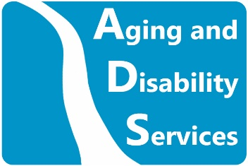
State of Connecticut, Department of Aging and Disability Services
Careers in the Education of Children who are Blind or Visually Impaired
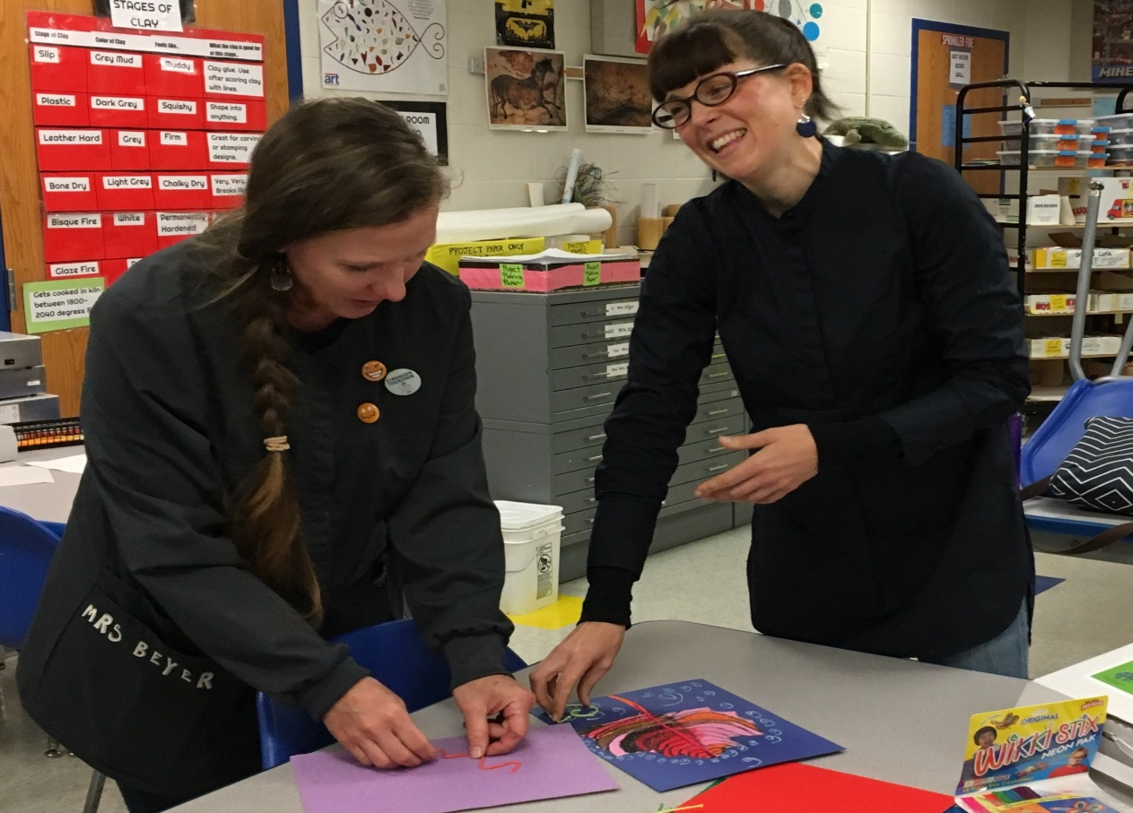
Helping to make a difference in the lives of children who are blind or visually impaired, certified Education Consultants (also known as Teachers of Students with Visual Impairments, or TVIs) from Aging and Disability Services work with children from birth through high school, providing instruction in Braille as well offering strategies to make learning accessible and fun.
Education Consultants provide direct and consultative services in homes, classrooms and community settings as well as in extra-curricular activities. Adapting equipment and materials that enable students with vision loss to participate in team sports, arts, music and after school clubs are further examples of the rewarding work performed by Education Consultants at Aging and Disability Services. Education Consultants are integral members of education teams, bringing expertise that helps to shape the overall learning experience of the child.
For more information on the rewarding field of teaching students with visual impairments as an Aging and Disability Services Education Consultant, please visit https://portal.ct.gov/AgingandDisability or contact the Human Resources unit at (860) 424- 4985.

