### [Image result for buzz bee](https://www.google.com/url?sa=i&rct=j&q=&esrc=s&source=images&cd=&cad=rja&uact=8&ved=0ahUKEwjnzoyE8pjXAhVOySYKHZeED_kQjRwIBw&url=https://www.mybeeline.co/en/p/why-do-bees-buzz-2&psig=AOvVaw0_jAnnCTU5UTUwBbY-K64v&ust=1509471581108461)THE BESB BUZZ….

A Newsletter for Families of Children who are Blind or Visually Impaired

## Volume 21 DORS_LOGO_639_LLW_TAG (2) (2) Fall 2018

## Published by the State of Connecticut

## Department of Rehabilitation Services (DORS)

Bureau of Education and Services for the Blind (BESB)

Feature Articles:

Look Who’s New, Meet a Mystic Penguin, Beardsley Zoo, Planning for the Future, Internship Leads to Career Goals for Young Man with CVI, Guiding Eyes trip, Closet Organizing with Jessie and Amazon

In an effort to provide you with faster delivery of our newsletter and program flyers, save paper, and contain printing costs, we are now posting an expanded electronic version on our website: [www.ct.gov/besb](http://www.ct.gov/besb)

(Newsletter is also available in Spanish on our website)

If you provide us with your e-mail address, we will send a copy of the newsletter directly to you by e-mail. Please give your preferred e-mail address to your child’s TVI.

Feel free to contact the newsletter’s co-editors with any suggestions at

[lisa.pruner@ct.gov or](mailto:lisa.pruner@ct.gov%20or) [adrienne.brown@ct.gov](mailto:adrienne.brown@ct.gov)

We welcome your comments and ideas for future newsletter topics.

|  |
| --- |
|  |

Look Who’s New!!!

Melissa Limberg:

Melissa joined BESB as an Education Consultant (Teacher of Students with Visual Impairments, or TVI) in May. With a background in Elementary and Special Education, she was led to the field through her experiences with her daughter, who has a visual impairment. She has five children ranging in age from 8 to 19, and spends most of her time outside of work with them at the soccer field, horse barn, and at theater rehearsals. She enjoys reading, baking, and quiet time at the beach.

Evie Furey:

“I’m happily settling into the year here at BESB. I previously worked as a TVI and Certified Orientation and Mobility Specialist with Perkins in Massachusetts. I love collaborating to get students together so let me know if you have ideas! I was a Cultural Anthropology and Spanish major in undergrad and have spent extensive time in Central and South America. Currently I live in Simsbury and am a mom to Millie (1) and Max (2).”

Hope Pardee:

As one of the “new” education consultants from DORS-BESB, I would like to tell you a little bit about myself. In high school and college I worked as an EMT and a Paramedic. I was studying to become a nurse when one day, a high school student I was tutoring in biology changed my life. He told me I should forget about nursing school and become a teacher. He said I made learning fun. It took a while for me to change my mind but eventually I realized he was right!

After 17 years of working as a classroom teacher, I am excited to start a new chapter in my teaching life as a Teacher of Students with Visual Impairments. One thing I love about working as an education consultant is the excitement: every day brings new students, new families and new teams. Nothing is more rewarding then helping a child grow in his or her knowledge and skills and therefore independence. I will always be grateful to that long-ago student—who encouraged me, to my parents—who were my greatest teachers—and to my students— who make teaching FUN!

Jennifer Prugh:

Jenn studied abroad in Belgium as a 16 year old and then in Paris while a student at Cornell. She graduated from Cornell University in 1993.  She married Douglas soon after she graduated and they just celebrated their 25th wedding anniversary.  They have two, adorable, children, Zachary and Allison Prugh (twins).  Jenn graduated from the UMass Boston TVI program in 2018 and joined DORS- BESB in October.  Jennifer grew up across the street from her maternal grandmother, who was blind.  Jennifer loves her job as a TVI and is thrilled to be a part of the DORS-BESB team.

And a fond farewell……

Happiest of retirements of John Reilly and Gail Feld, both long time preschool consultants at BESB who retired at the end of the last school year. We miss them and wish them the best in their future adventures!

Look Who’s New!!!

Melissa Limberg:

Melissa joined BESB as a Teacher of the Visually Impaired in May. With a background in Elementary and Special Education, she was led to the field through her experiences with her daughter, who has a visual impairment. She has five children ranging in age from 8 to 19, and spends most of her time outside of work with them at the soccer field, horse barn, and at theater rehearsals. She enjoys reading, baking, and quiet time at the beach.

Evie Furey:

I’m happily settling into the year here at BESB. I previously worked as a TVI and COMS with Perkins in Massachusetts. I love collaborating to get students together so let me know if you have ideas! I was a Cultural Anthropology and Spanish major in undergrad and have spent extensive time in Central and South America. Currently I live in Simsbury and am a mom to Millie (1) and Max (2).

Hope Pardee:

As one of the “new” education consultants from DORS-BESB, I would like to tell you a little bit about myself. In high school and college I worked as an EMT and a Paramedic. I was studying to become a nurse when one day, a high school student I was tutoring in biology changed my life. He told me I should forget about nursing school and become a teacher. He said I made learning fun. It took a while for me to change my mind but eventually I realized he was right!

After 17 years of working as a classroom teacher, I am excited to start a new chapter in my teaching life as a Teacher of Students with Visual Impairments. One thing I love about working as an education consultant is the excitement: every day brings new students, new families and new teams. Nothing is more rewarding then helping a child grow in his or her knowledge and skills and therefore independence. I will always be grateful to that long-ago student—who encouraged me, to my parents—who were my greatest teachers—and to my students— who make teaching FUN!

Jennifer Prugh:

Jenn studied abroad in Belgium as a 16 year old and then in Paris while a student at Cornell. She graduated from Cornell University in 1993.  She married Douglas soon after she graduated and they just celebrated their 25th wedding anniversary.  They have two, adorable, children, Zachary and Allison Prugh (twins).  Jenn graduated from the UMass Boston TVI program in 2018 and joined DORS- BESB in October.  Jennifer grew up across the street from her maternal grandmother, who was blind.  Jennifer loves her job as a TVI and is thrilled to be a part of the DORS-BESB team.

And a fond farewell……

Happiest of retirements of John Reilly and Gail Feld, both long time preschool consultants at BESB who retired at the end of the last school year. We miss them and wish them the best in their future adventures!

Preschool Staff Field Tests New APH Product

Preschool teachers have been hard at work field testing a new math product being developed by American Printing House for the Blind (APH). Five Little Speckled Frogs is a story book with props and activities designed for teaching emergent numeracy. Four preschool TVIs at BESB were selected to participate in field testing this new product, which should be available to students within the next year.

[](http://www.google.com/url?sa=i&rct=j&q=&esrc=s&source=images&cd=&cad=rja&uact=8&ved=0ahUKEwjlz-ySzNvZAhUO11MKHXY_AKAQjRwIBg&url=http://www.greennewsbd.com/?p%3D14201&psig=AOvVaw3cdu8YH1BD05DHO8cI9nHF&ust=1520559572119317) [](http://www.google.com/url?sa=i&rct=j&q=&esrc=s&source=images&cd=&cad=rja&uact=8&ved=0ahUKEwjlz-ySzNvZAhUO11MKHXY_AKAQjRwIBg&url=http://www.greennewsbd.com/?p%3D14201&psig=AOvVaw3cdu8YH1BD05DHO8cI9nHF&ust=1520559572119317) [](http://www.google.com/url?sa=i&rct=j&q=&esrc=s&source=images&cd=&cad=rja&uact=8&ved=0ahUKEwjlz-ySzNvZAhUO11MKHXY_AKAQjRwIBg&url=http://www.greennewsbd.com/?p%3D14201&psig=AOvVaw3cdu8YH1BD05DHO8cI9nHF&ust=1520559572119317) [](http://www.google.com/url?sa=i&rct=j&q=&esrc=s&source=images&cd=&cad=rja&uact=8&ved=0ahUKEwjlz-ySzNvZAhUO11MKHXY_AKAQjRwIBg&url=http://www.greennewsbd.com/?p%3D14201&psig=AOvVaw3cdu8YH1BD05DHO8cI9nHF&ust=1520559572119317)

My Experience at Space Camp (CJ and Dr. M. 2 pg)

By Lizzy Cappelli

*This past fall I had an extraordinary opportunity. I was able to attend Space Camp for Interested Visually Impaired Students (SCIVIS) at the U.S Space and Rocket Center in Huntsville, Alabama. While I was there I experienced so much and accomplished more than I thought possible. The week was designed for students with vision impairments so everything was accessible with large print and Braille. Mentors understood that you couldn't see, but that you still had a courageous vision. Everyone used a white cane, so I was not alone.*

*During my week at Space Camp I was able to try out simulations of the International Space Station (ISS), mission control, and an orbiter. For our first mission I was in the ISS where I worked as flight engineer and completed checklists based upon our flight plan. During our second mission I communicated with the ISS as Pay Com. My job was to assist the ISS when they experienced anomalies by using a manual that contained checklists on how to fix the anomalies.*

Hope Pardee:

“In high school and college I worked as an EMT and paramedic. I was studying to become a nurse when one day, a high school student I was tutoring changed my life. He told me I should forget about nursing school and become a teacher. He said I made learning fun. It took a while for me to change my mind but eventually I realized he was right!

After 17 years of working as a classroom teacher, I am excited to start a new chapter in my teaching life as a Teacher of Students with Visual Impairments. One thing I love about working as a TVI is the excitement: every day brings new students, new families and new teams. Nothing is more rewarding than helping a child grow in knowledge and skills and therefore independence. I will always be grateful to that long-ago student—who encouraged me, to my parents—who were my greatest teachers—and to my students— who make teaching FUN!”

Jennifer Prugh:

Jenn studied abroad in Belgium as a 16 year old and then in Paris while a student at Cornell. She graduated from Cornell University in 1993.  She married Douglas soon after she graduated and they just celebrated their 25th wedding anniversary.  They have two adorable children, Zachary and Allison Prugh (twins).  Jenn graduated from the UMass Boston TVI program in 2018 and joined DORS- BESB in October.  Jennifer grew up across the street from her maternal grandmother, who was blind.  Jennifer loves her job as an Education Consultant and is thrilled to be a part of the DORS-BESB team.

And a fond farewell……Happiest of retirements to John Reilly and Gail Feld, both long time preschool education consultants at BESB who retired at the end of the school year. We miss them and wish them the best in their future adventures!

Meet a Mystic Penguin!

On May 7, 2018, ten of our middle school aged BESB students visited the Mystic Aquarium for a program designed especially for them.

Students attended a class on dried and live invertebrate marine animals, which they were able to interact with and touch. Then they participated in a live penguin encounter! Each student was able to touch and interact with the penguin four separate times. They touched his flippers/wings, the feathers on his back, his feet, and also listened to his heart beat with a stethoscope.

Stay tuned this year for two more upcoming programs at the Mystic Aquarium!

More Animal Exploration!

A field trip to the Beardsley Zoo was held on September 15, 2018. This program was designed for preschool and early elementary-aged students. Nine BESB students were in attendance, as well as five siblings and 14 adult family members.

Students and their families attended several hands-on programs including an “animal encounter” which allowed them to learn about and handle a turtle and a snake, a tour of the zoo’s sensory garden (including samples of planting media for tactual exploration), a visit to the farmyard with the opportunity to interact with friendly goats and miniature horses and a visit to the wolf exhibit. The wolf exhibit featured recorded wolf sounds and the opportunity to learn about wolves and other animals with fur from a zoo employee, who happens to be blind himself. Following the planned activities, families were free to enjoy the historic carousel, picnic with new friends, and explore the zoo as a family for the rest of the day.

Leaping tiger graphic

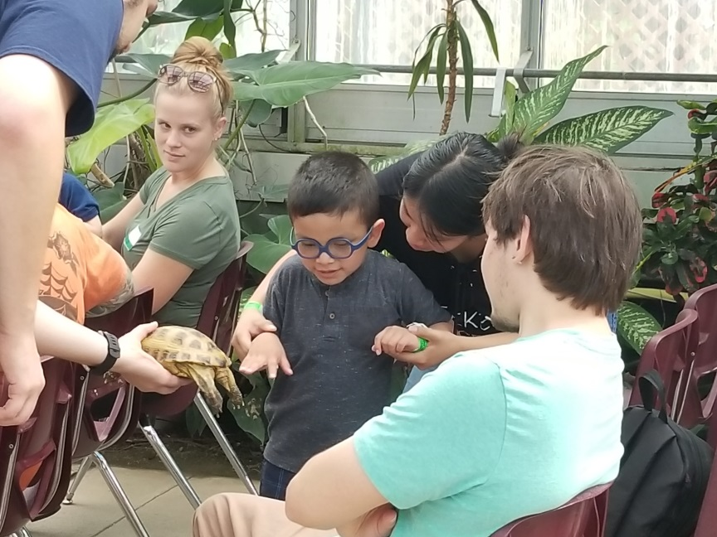 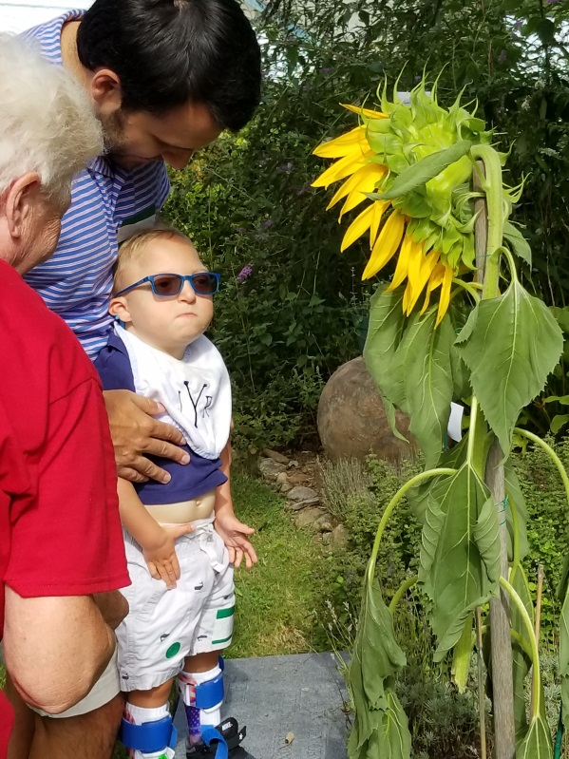

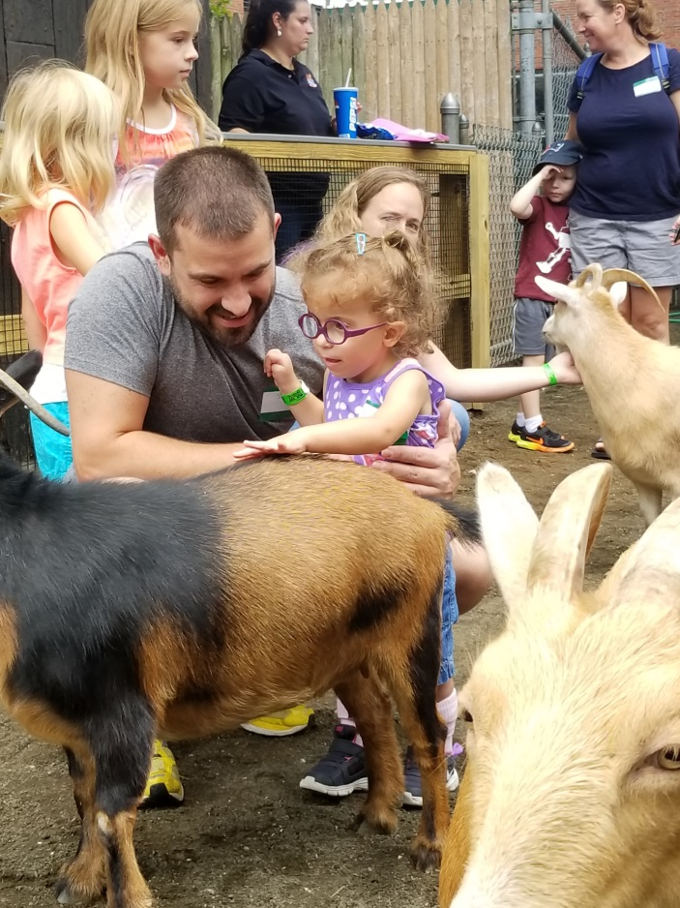 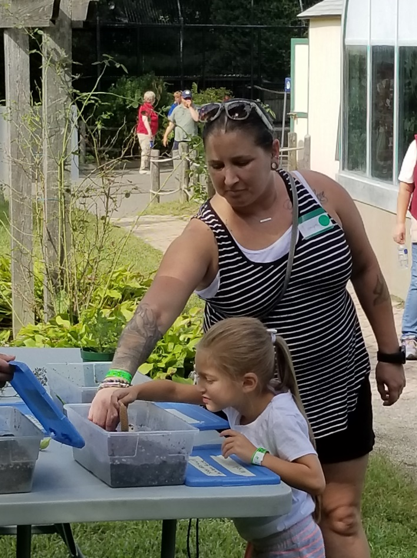

Families enjoying hands-on exploration opportunities during the September trip to Beardsley Zoo

Planning for the Future of Your Child with Special Needs

By Michele Margenau

DORS Bureau of Education and Services for the Blind recently held a workshop for parents of our clients titled, *Planning for the Future: Setting Up Lifelong Supports for Your Child.* As any parent knows, planning for your child’s future can feel overwhelming. Stress increases when the family includes a child with special needs. There are many areas for families to explore and a multitude of agencies and experts that parents should consider contacting, depending on the age and needs of their child. The following is an overview of some of the many resources available.

Department of Developmental Services: In Connecticut the Department of Developmental Services (DDS) provides assistance to individuals with intellectual disabilities and their families. Services may include case management, respite care, family support, employment, and day services, as well as help with the Social Security, Medicaid and guardianship application processes. A family should apply for services as early as possible but definitely by the age of 18. In order to qualify for services from DDS an individual will need to provide documentation of an intellectual disability. Information about DDS can be found at their website [www.ct.gov/dds](http://www.ct.gov/dds) or via the regional helplines listed on that site.

Vocational Rehabilitation: In Connecticut, an individual with a visual impairment or legal blindness may qualify for services through BESB’s Vocational Rehabilitation (VR) Program. Students may be referred to VR at the age of 14. VR will assist with planning for post-secondary education or with seeking employment. Some examples of support which may be offered are: assistance with identifying a career goal that has employment opportunities, post-secondary programs that offer degrees or certifications to prepare for employment in the chosen field, understanding and navigating the financial aid process, and finding internships. Individuals seeking employment may obtain career counseling, job coaching, and skills training. The goal of VR is for the individual to gain employment that provides competitive wages in an integrated work setting. For more information regarding CT Vocational Rehabilitation Services through BESB - Contact the Vocational Rehabilitation Supervisor at 860-602-4032 or visit the bureau’s webpage ([www.ct.gov/besb](file:///C:\Users\SigmanBr\AppData\Local\Microsoft\Windows\Temporary%20Internet%20Files\Content.Outlook\CV9JH4K6\www.ct.gov\besb)).

Legal Planning: Another important area when planning for a child’s future is legal matters. At the age of 18 children are considered adults and legally able to make health and financial decisions. If they are not able to competently do so on their own, legal documentation is necessary to allow parents to continue to make decisions. Issues of where your child will live, what long term benefits and trusts will they be able to access, and who will become their guardian once their parents have passed away are essential questions. An attorney who specializes in planning for persons with special needs can address areas such as estate planning, trusts, ABLE accounts, conservatorship, guardianship, financial gifts from relatives, SSI and SSDI. While these topics may feel overwhelming, it is essential to seek out professional assistance ahead of time. Anne Burnham of Jaconetta, Burnham & Wimer LLC in Glastonbury presented on legal concerns at the recent BESB program. You can find attorneys who specialize in special needs planning with a little internet research and networking.

Financial Planning: Financial planning can be both important and overwhelming. It is necessary to plan for your own future and retirement while also considering the future financial needs of your child. There are many areas to look at including current income and assets, goals and what obstacles you might encounter. A financial advisor can give advice about the best vehicles for savings, where to put money at different stages and tax implications of all of it. The speaker at BESB representing the financial field was Lorie Schappert, Vice President of AdviceOne LLC in Glastonbury. Consider seeking recommendations from other families when choosing a financial planner.

Infoline: There are many other types of assistance that families of children with special needs may require including respite care, mental health services, food and utilities support, issues of abuse and of advocacy. InfoLine 211 is a great starting place and is available nationwide. They can connect you to local services and can be reached 24 hours a day, 7 days a week. They are multi-lingual. In CT the website is: [www.211ct.org](http://www.211ct.org) . Nationwide, it’s [www.221.org](file:///C:\Users\brownadr\AppData\Local\Microsoft\Windows\Temporary%20Internet%20Files\Content.Outlook\OVDGT0XX\www.221.org). Or dial 211 from anywhere to be connected to local services.

Your job as a parent in planning for your child’s future is to assemble a team of resources to assist you in ensuring the best future possible for your child. The overarching takeaway advice from the recent BESB workshop was this: do your research, plan in advance, don’t put it off. It is never too early to start gaining the knowledge you will need to find your way through this process.

*Professional groups mentioned in this article are purely informational and not meant to be an endorsement.*

*\*\*\*\*\*\*\*\*\*\*\*\*\*\*\*\*\*\*\*\*\*\*\*\*\*\*\*\*\*\*\*\*\*\*\*\*\*\*\*\*\*\*\*\*\*\*\*\*\*\*\*\*\*\*\*\*\*\*\*\*\*\*\*\*\*\*\*\*\*\*\*\*\*\*\*\*\*\*\*\*\*\*\**

SAVE THE DATE – SPRING 2019

LEAP into LIFE is at it again with two exciting programs being offered this spring:

*March 9, 2019*

Speak Up - Join personal storyteller Mathew Dicks as he shares his expertise on the art of storytelling. Hear from an expert while developing the confidence to tell your own story.

*April 15 - 17, 2019*

Develop your Independence- This program will focus on skills to gain independence in the kitchen as well as incorporating some yoga and drumming for a well-balanced lifestyle.

.Additional details to follow

To submit your email address to the mailing list email

[Patricia.leonard@ct.gov](mailto:Patricia.leonard@ct.gov)

Let’s Get Moving!

By Kendra Jenness

Incorporating Orientation and Mobility skills at home

may seem like a daunting task…..But it’s as easy as 1, 2, 3!

1. Encourage Independent Movement and Exploration

* Encourage your child to reach toward interesting sounds atoys by purposefully placing a toy with a preferred sound within your child’s reach. Begin by placing the toy so that it is physically touching your child. Allow your child time to become aware of the toy and then to expit a little further away. Show your excitement when a toy isfound! Celebra
* Go for a walk around your neighborhood. How many mailboxes can your child find? How tall is your mailbox

Internship Leads to Career Goals for Young Man with Cortical Visual Impairment

C:\Program Files\Microsoft Office\MEDIA\CAGCAT10\j0305257.wmf

As a high school student with Phase 3 Cortical Visual Impairment, BESB student, CJ, participated in a study which literally changed the course of his life.

Dr. Lotfi Merabet is an optometrist-scientist who is active in clinical research relating to individuals' adaptations to blindness. As Director of the Laboratory for Visual Neuroplasticity at Massachusetts Eye and Ear/Harvard Medical School, Dr. Merabet's main research interests include the development of assistive technology for individuals who are blind and understanding how the brain adapts to the loss of sight (both from ocular and brain-related causes).

One of Dr. Merabet’s areas of research has been with people who have Phase 3 Cortical Vision Impairment (CVI). This phase is considered the stage of visual functioning where children with CVI demonstrate visual curiosity and are beginning to spontaneously use their vision for more functional activities.

When seeking students who fell into Phase 3 of the CVI Range for his study, Dr. Merabet was introduced to CJ. This dedicated student and his dad travelled to Boston to Dr. Merabet’s lab several times so that CJ could participate in Dr. Merabet’s brain scan study. CJ was fascinated by the MRI imaging used in the study, and Dr. Merabet took the time to explain the technology and to nurture CJ’s interest.

During the summer prior to CJ’s senior year of high school Dr. Merabet facilitated an internship for CJ, working with Andrew Ellison at the Boston University School of Medicine Center for Biomedical Imaging.  CJ had the support of his father who said, “Whatever it takes, I will get him there.”  CJ and his dad went to Boston to practice the route to the lab, which required CJ to use public transportation for the first time, including independent travel on the “T.”

Dr. Merabet stated, “I think this helped a lot to build CJ’s confidence. Andy was a real mentor for him.”

The summer internship ignited CJ’s interest even more, and as a senior in high school, he decided to make medical imaging his career. CJ applied to the top college for his field in the Boston area, Massachusetts College of Pharmacy and Health Sciences, where he was accepted as a freshman for the fall class of 2018!

The Mass Eye and Ear Infirmary awarded CJ a scholarship to help buy a computer and books to support his studies. The award was presented to CJ at a recognition ceremony, by Dr. Merabet.

CJ is having a successful fall semester in school studying medical imaging with a specialization in MRI studies and loves living in Boston. His interest and willingness to participate in Dr. Merabet’s research led CJ to an amazing internship and an exciting future career.

*For more information on The Laboratory for Visual Neuroplasticity, visit:* [*https://scholar.harvard.edu/merabetlab/home.*](https://scholar.harvard.edu/merabetlab/home.)

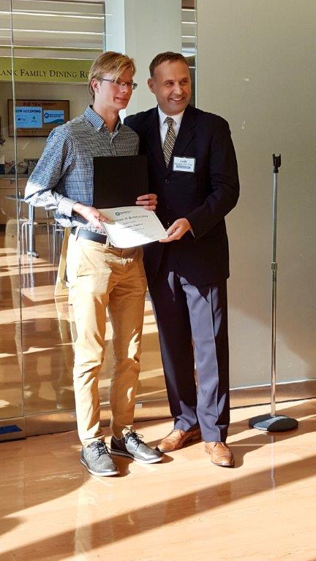

Guiding Eyes for the Blind

**Seven students had the opportunity to attend a youth group hosted by Guiding Eyes for the Blind in Yorktown Heights, NY. These students learned about many aspects of the Guiding Eyes Program including: application and home visit processes, prerequisites (independent cane travel), class schedule, timeline, breeding program, selection process, and the training that each guide dog goes through to become a service animal.**

**One student has since completed the application process and is awaiting word from the school to go for her three-week training!**

 

Closet Organization with BESB Assistive Technologist, Jessie Mabry

(And Amazon)!

By Jessie Mabry

I recently found a few neat things to help me make sense of my closet and I wanted to share! I found all of these items on Amazon, though there are likely other vendors.

* **First, I got a couple sets of Juvale, black velvet, non-slip hangers with cascading hooks. They take up less space than traditional plastic hangers, are sturdy enough to hold everything from tops to suits, and, best of all, have little hooks on the front for hanging outfits together, or multiple tops that go with the same sweater. Alternatively, you can get velvet hangers without the cascading hooks, but I find the option pretty indispensable. They come in other colors too!**
* **Then, I bought a set of House Day black plastic finger clips for hangers to put on the hanger bar for skirts and suit pants.**
* **Next? FindUWill clothing rack size dividers to separate sections from each other—e.g., coats, skirts/dresses, things matching black pants, things matching navy pants, etc. These are round with no writing on them, so you can write whatever you want to with a marking pen, or use Braille adhesive. I think there are also rectangular ones and some that come in multiple colors. I’d suggest sticking with the blank ones rather than ones with sizes or pre-written categories on them. I haven’t brailled anything on mine, but they rattle as I push clothes down the rod, so I can hear when I’ve moved into another section, and I know my closet well enough to tell which one I’m in.**
* **Finally, I’ve always used Zober open ended pants hangers, instead of draping slacks over the bottom of a standard hanger. They make it a lot easier to grab what I need. And I have a Simple Houseware over the door shoe organizer where I pair my dress shoes up. The pockets could be labeled if desired.**

I also found children’s versions of the hangers! They are narrower across than the adult ones.

All of this adds up, of course, but I think it’s more than worth the expense considering the space, convenience, and efficiency I’ve gained. I’m recommending these things as someone who wasn’t able to get them when I was young and probably could have really used them for organizing clothes independently.

