This guide is intended for use with consumers to assist with making an informed decision around the selection of a Community Rehabilitation Provider for vocational rehabilitation services



** CRPs by Catchment Areas:**

**State of Connecticut Department of Rehabilitation Services**

**Published August 2018**

Community Rehabilitation Provider (CRP)

Consumer Choice Guide

**Western Region – North_____________________________________**



Barkhamsted

Bethlehem

Bridgewater

Canaan

Cheshire

Colebrook

Cornwall

Goshen

Harwinton

Kent

Litchfield

Middlebury

Morris

Naugatuck

New Hartford

Norfolk

North Canaan

Oxford

Plymouth

Prospect

Roxbury

Southbury

Salisbury

Sharon

Thomaston

Torrington

Warren

Washington

Waterbury

Watertown

Winchester

Wolcott

Woodbury

**Western Region – South____________________________________**



Bethel

Bridgeport

Brookfield

Danbury

Darien

Easton

Fairfield

Greenwich

Monroe

New Canaan

New Fairfield

New Milford

Newtown

Norwalk

Redding

Ridgefield

Shelton

Sherman

Stamford

Stratford

Trumbull

Weston

Westport

Wilton

**Northern Region – Central_________________________________**



Andover

Avon

Berlin

Bloomfield

Bristol

Burlington

Canton

Columbia

Coventry

East Granby

East Hartford

East Windsor

Ellington

Enfield

Farmington

Glastonbury

Granby

Hartford

Hartland

Hebron

Manchester

Mansfield

Marlborough

New Britain

Newington

Plainville

Rocky Hill

Simsbury

Somers

South Windsor

Southington

Stafford

Suffield

Tolland

Union

West Hartford

Wethersfield

Willington

Windsor

Windsor Locks

**Northern Region – East____________________________________**



Ashford

Bolton

Brooklyn

Canterbury

Chaplin

Eastford

Hampton

Killingly

Plainfield

Pomfret

Putnam

Scotland

Sterling

Thompson

Vernon

Windham

Woodstock

**Southern Region – East___________________________________**



Bozrah

Colchester

East Lyme

Franklin

Griswold

Groton

Lebanon

Ledyard

Lisbon

Lyme

Montville

New London

North Stonington

Norwich

Old Lyme

Preston

Salem

Sprague

Stonington

Voluntown

Waterford

**Southern Region – Central_________________________________**



Ansonia

Beacon Falls

Bethany

Branford

Meriden

Chester

Clinton

Cromwell

Deep River

Durham

East Haddam

East Hampton

East Haven

Essex

Guilford

Haddam

Hamden

Killingworth

Madison

Middlefield

Middletown

Milford

New Haven

North Branford

North Haven

Old Saybrook

Orange

Portland

Seymour

Wallingford

West Haven

Westbrook

Woodbridge

**Map of DORS Geographical Area**

**ADDENDUM**

Northern Region - Central

Map of DORS Geographic Area

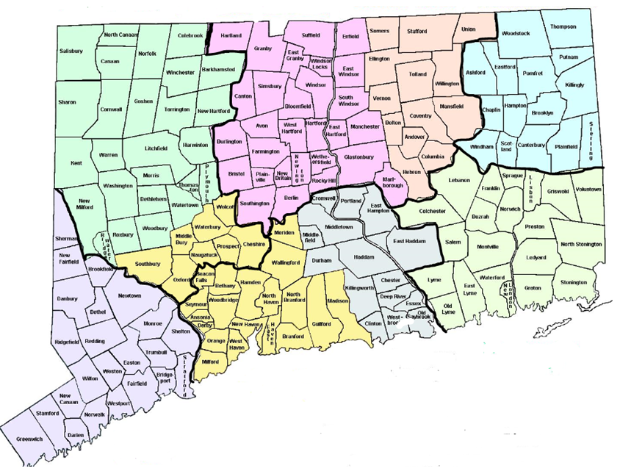

Southern Region - East

Northern Region - East

Western Region - South

Western Region - North

Southern Region - Central

  






















